Equilibrium Test (V.2003) Name:_________________

Date:__________________

Part I: Multiple Choice

1.

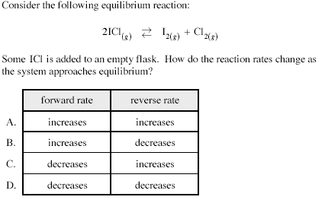

2.
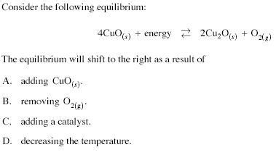

3.
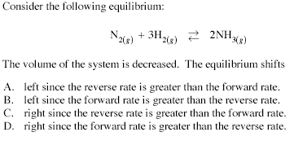

4.
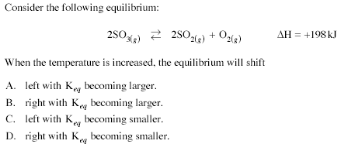

5.
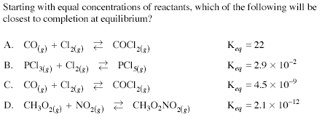

6.
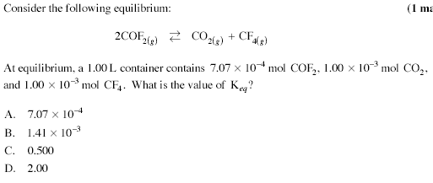

7.
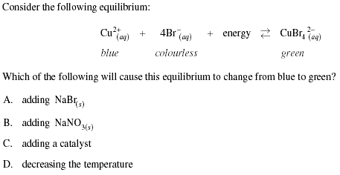

8.
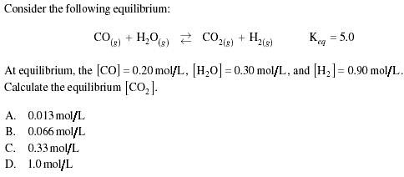

9.
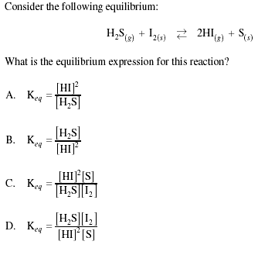

10.
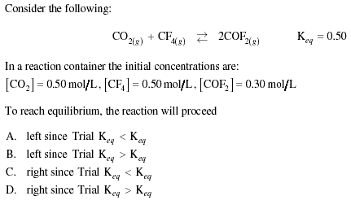

11.
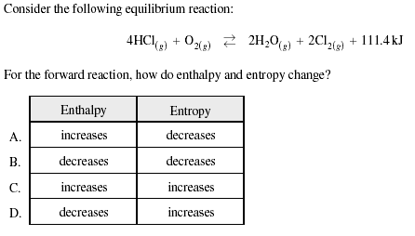

12.
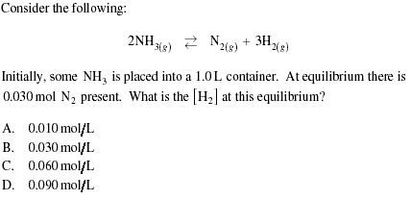

13.
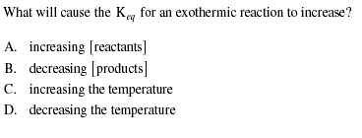

14.
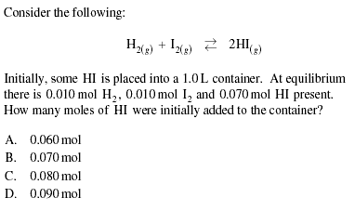

15.
Which equation has the largest value of Keq?

A. CO2(g) == CO2(s) ΔH = -45kJ
B. PbO(s) + CO2(g) == PbCO3(s) ΔH = +90kJ
C. CaCO3(s) == CaO(s) + CO2(g) ΔH = -50kJ

D. H2CO3(aq) == H2O(l) + CO2(aq) ΔH = -65kJ

16.
Consider the following equilibrium system:

AgCl(s) + 2NH3(aq) === Ag(NH3)+2(aq) + Cl-(aq)

The addition of AgCl(s) to the above equilibrium would:

- reduce the [NH3]
- increase the [Cl-] only
- increase the [Ag(NH3)+2] and the [Cl-]
- not affect any of the equilibrium concentrations.

17.
A catalyst affects a reversible reaction by:

- making the value of Keq larger
- increasing the yield of products
- decreasing the value of the ΔH for the reaction
- enabling equilibrium to be achieved more rapidly

18.
Consider the following equilibrium:

PCl5(g) + 92.5kJ ====== PCl3(g) + Cl2(g)

Which change will cause the equilibrium to shift to the right?

- add some Cl2
- add a suitable catalyst
- decrease the temperature
- increase the volume of the container

Part II: Written Section: - show all calculations leading to the correct solution
(Sig. Dig’s count)

19.

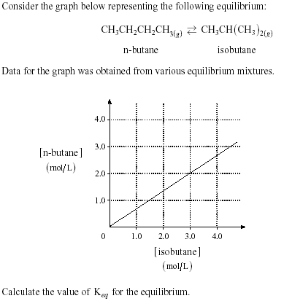(2 marks)

20.
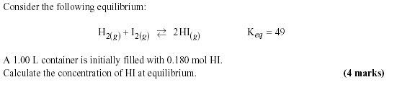

21.
Reactants A and B are mixed in a closed container, each at a concentration of 0.75M. They react slowly producing species C and D:

A(g) + B(g) ======== C(g) + D(g)

At equilibrium [D] = 0.55M. Determine Keq (3 marks)

22.
Keq = 3.1 at a certain temperature for the following system:

2SO2(g) + O2(g) ========== 2SO3(g)

If a 2.0L bulb were filled with 1.2 mol SO3, 0.7 mol SO2 and 1.6 mol of O2, indicate the equilibrium shift (if any) which will occur and explain your answer in terms of Keq.
(3 marks)

Part III: Graphing equilibrium shifts (the diagrams are on the next page).

- Consider the following equilibrium system:

N2O4(g) ======= 2NO2(g) ΔH = -150kJ

You are to draw a general graph indicating relative concentration changes for each of the following stresses placed on this equilibrium (1 mark/graph)

- Rapid removal of N2O4(g)
- Inject NO2(g)

Increase the temperature of the system
- Decrease the volume of the container
- Increase the pressure of the system by injecting Ar(g)

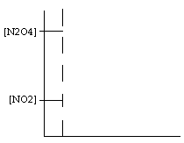

Stress A Stress B

Stress C Stress D

Stress E

