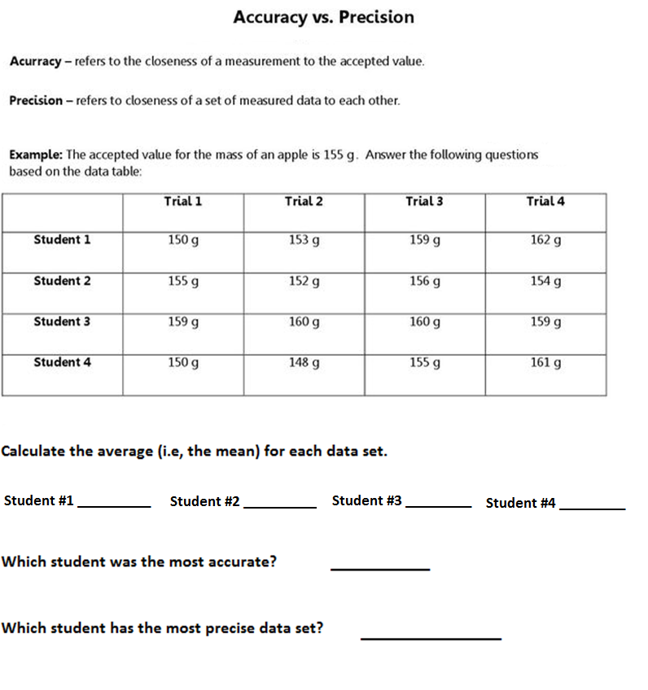

For the following examples, indicate where errors were made and correct them using proper SI unit convensions.

- Michael bought 2 kilos of hamburger.

- Jill bought 6.0 liters of gasoline.

- Trevor’s temperature dropped by .9ºC (from 39.2 degrees Celsius to 38.3).

- The car accelerated from rest to 100 Km Per hour in 10 sec.

- The weight of 1ml of water is exactly 1 gms.

- The package was marked as containing 500Gm. of spaghetti.

- The height of the solid formed in the reaction was 2 1/2 cm.

