Lesson 3 Worksheet: Zygote to fetus

- Describe a morula. How many weeks until it forms?

- Describe the parts of a blastula and what each part develops into. How many weeks until it forms?

- Describe a gastrula and what each part develops into.

- What does the term prenatal mean?

- What is a stem cell?

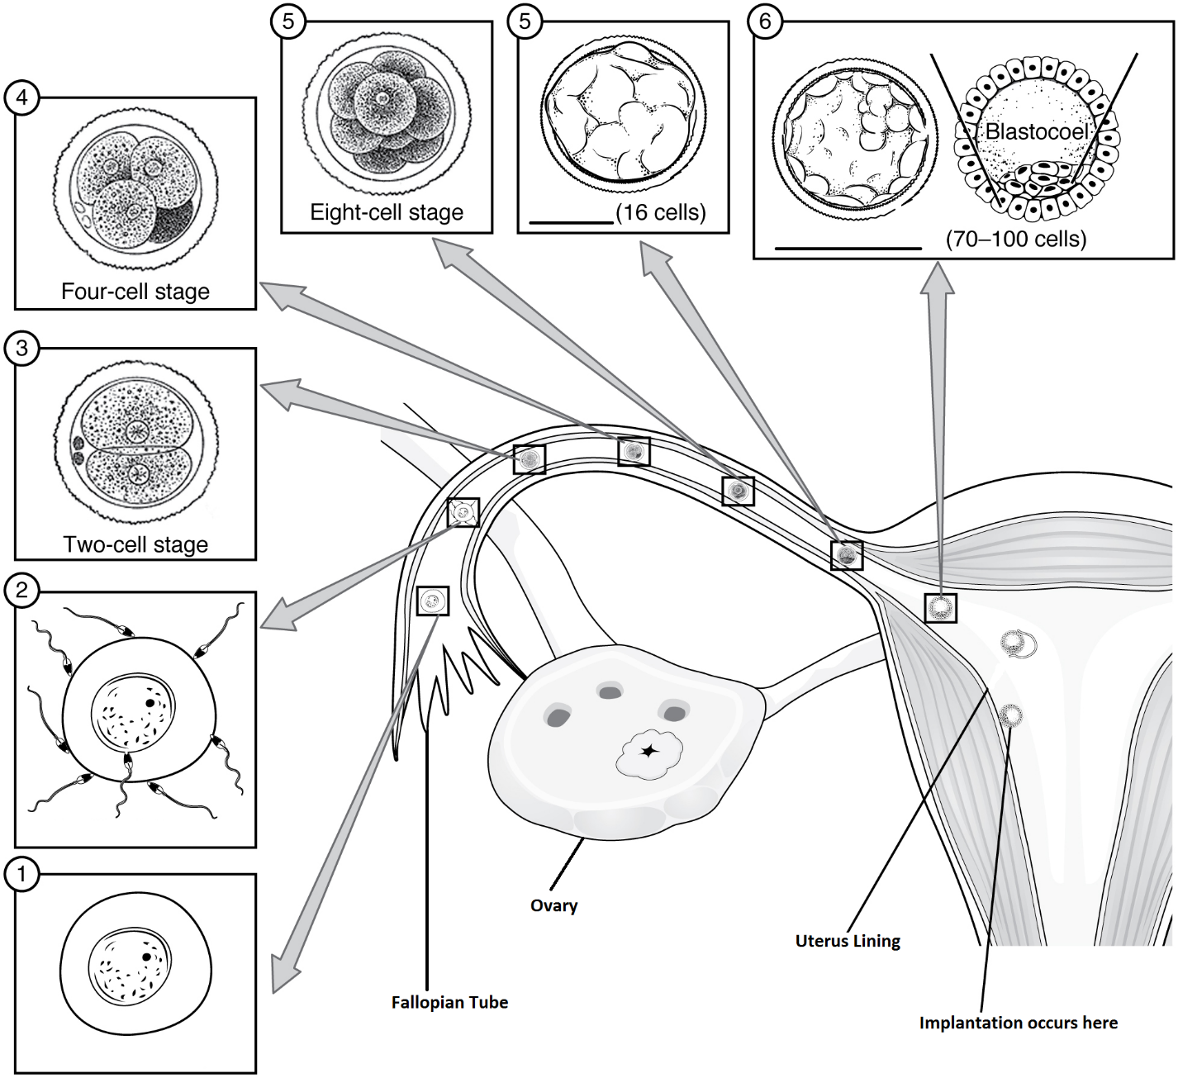

Put the number beside each term that best describes what is going on in the diagram above. You can use more than one number for each term.

Morula _________ Fertilization __________ Ovum (egg) _________

Blastula ________ Mitosis _________

- State one advantage AND one disadvantage of external fertilization.

- State one advantage AND one disadvantage of internal fertilization

