Unit 6 Linear Relations
6.0 Warm-Up
Creating a Table of Values
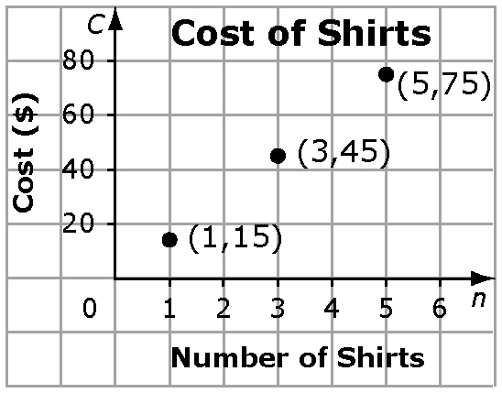
You can use the coordinate pairs on the graph to make a table of
values. Arrange the table of values horizontally or vertically. The
first row or column in a table of values has the same title as the
horizontal axis on the graph. The second row or column has the
same title as the vertical axis.

Number of Shirts, n | 1 | 3 | 5
Cost, C | 15 | 45 | 75

Number of Shirts, n | Cost, C
1 | 15
3 | 45
5 | 75

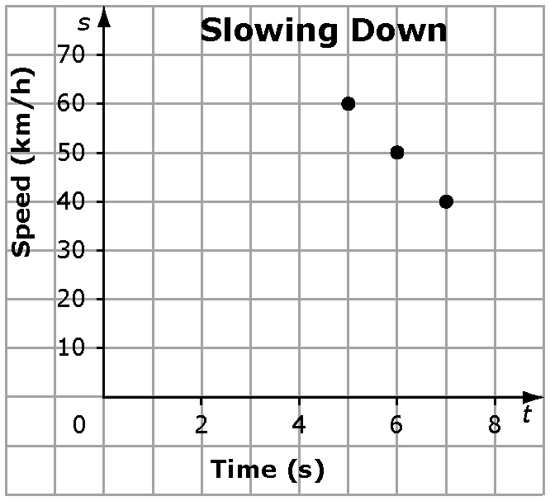
1. Create a table of values from each graph.

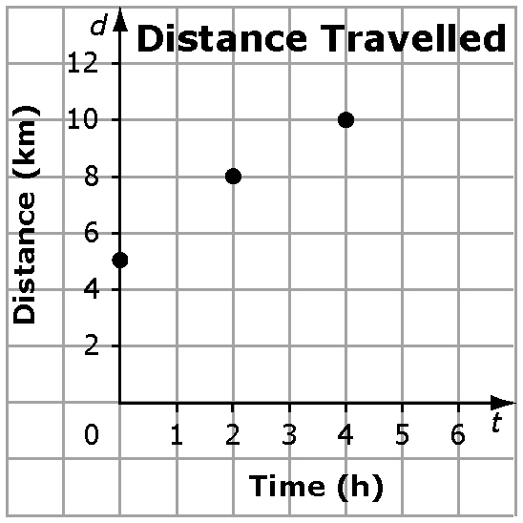
a)

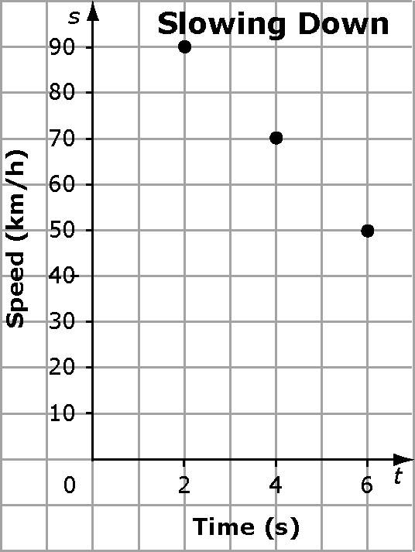
b)

Analysing Graphs of Linear Relations
A linear relation is a pattern made by a set of points that lie in a straight line. Sometimes it is possible to have points between the ones shown on a graph. Ask, “Does it make sense to have values between those on the graph?”

2. Does it make sense to have points between the ones on each graph? Explain.

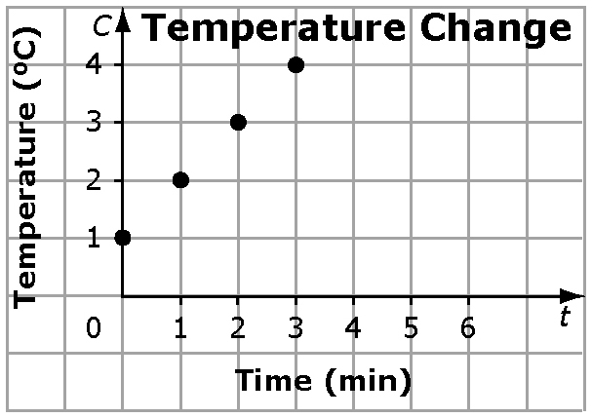
a)

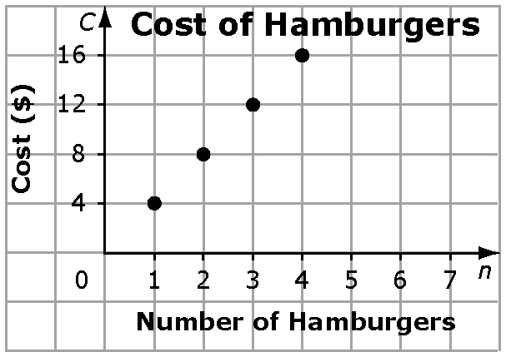
b)

Patterns in a Table of Values
Linear relations can be represented using a table of values. You can sometimes tell that a relationship in a table is linear if both of the following statements are true.
• Each consecutive value in one column changes by the same amount.
• Each consecutive value in the other column changes by the same amount.

s | t
2 | 6
4 | 12
6 | 18
8 | 24

The difference between each consecutive value for s is 2.
The difference between each consecutive value for t is 6.
You can use this information to predict the next values in
the table.
For s, the next value could be 10.
For t, the next value could be 30.

3. Determine if each table of values represents a linear relation. Explain how you arrived at your answer.
a) | Distance, d (m) | 0 | 15 | 30 | 45
 | Speed, s (m/s) | 2.1 | 4.2 | 6.3 | 8.4

b) | Time, t  (s) | Height, h  (m)
 | 5 | 10
 | 10 | 20
 | 15 | 40
 | 20 | 80

4. For each table of values in #3 that represents a linear relation, predict the next ordered pair.

Linear Relationships

Linear relationships represented by formulas or equations can be graphed by
• making a table of values, and
• graphing the ordered pairs from the table of values.

5. For each equation, create a table of values and graph the linear relation.
a) y = 3x + 2 b) t = –4n + 3


Equation Solving

To solve an equation means to find the value of the variable which satisfies the equation (ie. makes the equation true; left side equals right side).

Ex. Is $x=2$ a solution to $3x-2=-4$?

Ex. Solve & check:
- $2x+3=17$

- $3x-9=36$

- $5-4q=25$

Practice: Worksheets6.0 /WS#34 on separate sheet, show steps; WS#146/147 on sheet

