Socials 9
Course Outline


We acknowledge the Lheidli T’enneh First Nation on whose ancestral and unceded land we live, work, and learn.

Instructor: Ms. Lawrence
Room: 1104
E-mail: mlawrence@sd57.bc.ca

Social Studies 9 is designed to provide students with a comprehensive historical outlook of colonialism and revolution, as well as their impact on the development of Canada. Students will broaden their understanding of conflicts and cooperation between settlers and Indigenous peoples and its impact on Canadian colonialism and nationalism, as well as explore important revolutions in global history.

Students will learn to apply critical thinking skills that include: questioning, comparing, summarizing, drawing conclusions, and defending a position. As well, students will demonstrate effective research skills, both individually and collaboratively. Students will also be required to demonstrate skills and attitudes of active citizenship, including ethical behavior, open-mindedness, respect for diversity, and collaboration.

Textbook:
This course will use several textbooks over the course of the semester. It is your responsibility to ensure that you have your textbook ready to use daily. Textbooks can be left in the classroom, but remain the responsibility of students.

Materials Required:

- 2 inch, 3 ringed binder
- Loose leaf paper
- Pens (blue, black, red)
- White out
- Pencils
- Eraser
- Ruler
- Scissors
- Glue
- Highlights
- Pencil crayons
- Felt pens
- Other, project-specific materials may be required

Expectations
I don’t have many... mostly I expect that students will operate with a few principles in mind:
- Be responsible
- Be respectful
- Be kind
What each of these means will be explored in class at length. Students will be asked to sign our collectively developed list of expectations.

Plagiarism Policy
Students are expected to be honest in meeting course requirements. Copying, cheating or plagiarism are dishonest and are unacceptable conduct.
If you are caught copying, cheating or plagiarizing, one or more of the following consequences will be applied:
- You may receive a failing grade on the assignment/test/project
- You may be asked to resubmit the assignment/test/project for partial credit
- Parent/Guardians will be contacted and informed of the offense
- An office referral will be filed indicating the occurrence of the copying, cheating or plagiarism.
Routines
- Be prepared. Please arrive to class with a pen or pencil, paper, any work required, and your readings.
- If you miss a day, check with a friend about what we did before asking Ms. Lawrence. Extra copies of handouts can be found on Moodle.
- Please do not hand assignments directly to me. Finished work should be handed into the hand in bins at the back of the classroom. Please ensure work is submitted to the bin labelled for your block.
- If you need to go to the bathroom, please ask. Be aware that Ms. Lawrence may ask you to wait if we are in the middle of a discussion or reviewing important information. Bathroom breaks are limited to 1 person at time (at the teachers’ discretion), so be mindful of how long you are taking. Students are asks to sign out when using the bathroom.
- Basic art materials are available for you to use; however, they are shared amongst all classes in this space. If you want special or extra materials, it is expected that you provide them.
- While deadlines are provided, marks will not be deducted for late work. However, written feedback on late work will be minimal. There is one mandatory deadline, and that is the one at the end of the year.

Assessment:

- Socials 9 will be assessed based on Standards Based Grading (SBG). See attached documents for information about SBG.
- Each unit will have 2-3 pieces of assessed work. While not all work will be assessed formally, all work is necessary for success, as marked work are meant to be ways that you can show me what you’re learning through the course.

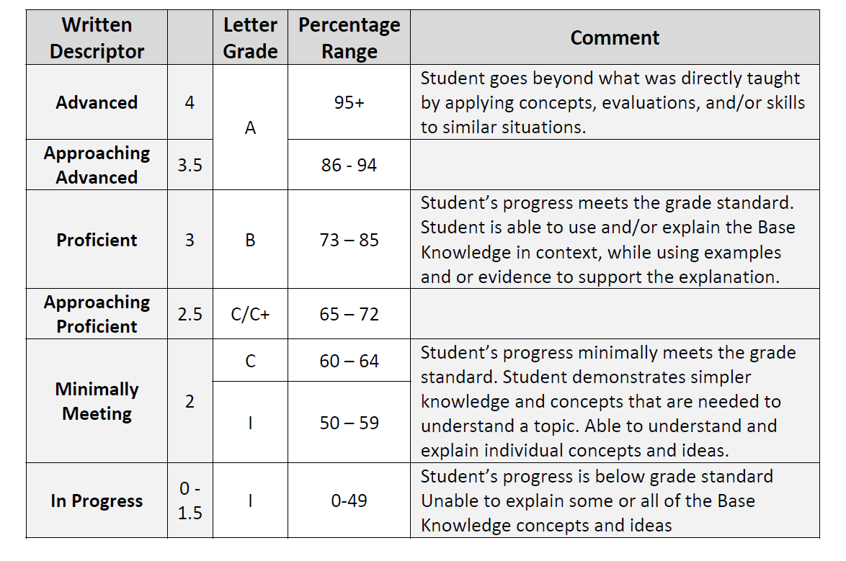

Socials 8-10 Standards (Lawrence)
Theme/Big Idea | Standards
- Environment  Human interactions are influenced by the environment, and the environment is influence by human interactions | 1.1 explore the connections between resources and economic activity  1.2 Compare physical features and climate with settlement and migration patterns, including the impact of humans on the physical environment
- Conflict and Power  Relationships in society can result in conflicts and changes in power. Conflicts and power can result in changes in society. | 2.1 explore the causes and effects of military conflicts and civil unrest, including effects of attitudes and beliefs on the treatment of ethnicities, races, genders, religions
- Cultural Identity  Cultures are not static; they are constantly changing and are influence by interactions within and between cultures | 3.1 develop an understanding of Indigenous governance and the Canadian political system and how those systems influence and are influenced by people  3.2 analyze the effects of changes in the economy on cultural identity
- Innovation  Changes in technology and ideas influence societies and are influenced by society | 4.1 analyse the effects of technology on civilizations and explore how and why technologies change over time
- Foundational Skills  Understanding, effectively interacting with, and communicating with the world around us required a core set of skills. | 5.1 develop research skills and interpret primary and secondary sources  5.2 explain the role of bias in a variety of media  5.3 communicate a position through formal writing, including using proper language conventions (e.g., spelling, grammar)

