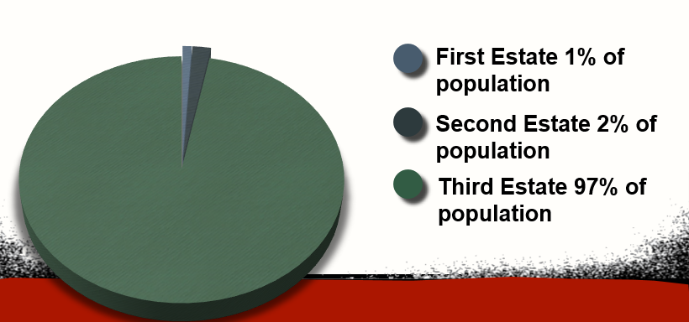
The French Revolution: Causes of the French Revolution
Notes
- French Society Divided
- The French belong to 1 of 3 _______________________________, which determined a person’s legal rights and _____________________________
A. First Estate: ___________________________
-1% of population; controlled 5-10% of land
B. Second Estate: _______________________
-2% of population; owned 25% of land. Income came from _________________________________ collected from peasants who lived and worked the land
C. Third Estate – Bourgeoisie and Peasants
-97% of population. No voice in gov’t and many ___________________________________

- Economic Problems
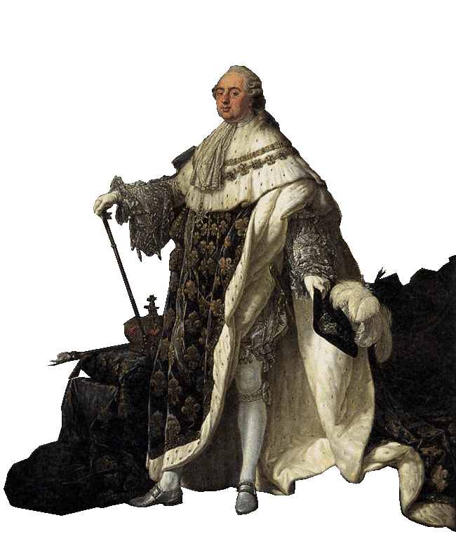
- __________________ and wasteful royal spending broke France
- French Gov _____________________________________
- Bad ________________________________________________ in late 1780s

- Call to Revolt
- King Louis XVI called the ___________________________________ to meet in 1789 at Versailles (the King’s palace in France)
- Goal: To raise taxes and pay off debt
- National Assembly: _________________________________ new name
- Demanded more __________________
- Vowed a fair constitution
- ___________________________ Oath
- Nation Assembly Locked out so held meeting on Tennis Court where delegates took the “Tennis Court Oath” – vowed to not __________________________ until there was a ____________________________
- Louis XVI stationed guards around as a response

- King tried to stop the National Assembly - led to. . .
• a mob overtook the ________________________ to steal weapons
• _________________________ - a peasant revolt, attacking landlords

