Name: ______________________________________________
French Revolution Recruitment Poster
- You will design a poster to encourage members of the Third Estate to campaign for a better way.
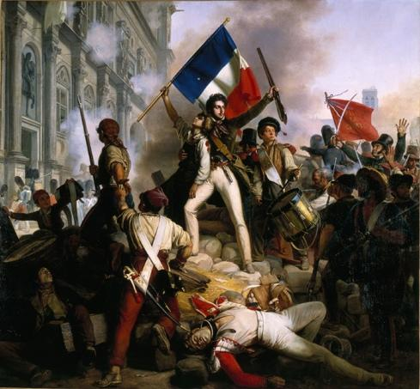
Think about what a member of the 3rd Estate would protest against…Some examples are listed below
    - Taxes
    - Food
    - Overspending by government
    - Monarchial abuses
    - 1st & 2nd Estates Special Privileges
Your Poster will require:
- have a catchy phrase or saying
    - For Example: (cannot use these)
      - We are starving When you are partying
      - Don’t be weak Let us speak
      - 1st & 2nd Estate will meet their Fate
      - We pay taxes For your Houses
- a hand drawn picture or symbol on your poster as a visual to aide your catchy phrase or saying
- at least three reasons why someone should join the revolution
- Colour and creativity!
Learning Objectives:
2.1 explore the causes and effects of military conflicts and civil unrest, including effects of attitudes and beliefs on the treatment of ethnicities, races, genders, religions
3.2 analyze the effects of changes in the economy on cultural identity
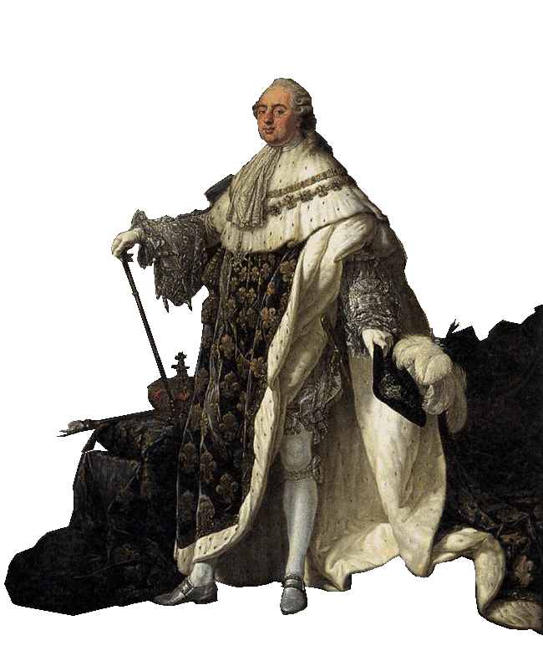
5.2 explain the role of bias in a variety of media

