The French Revolution: The French Revolution
Name: __________________________________
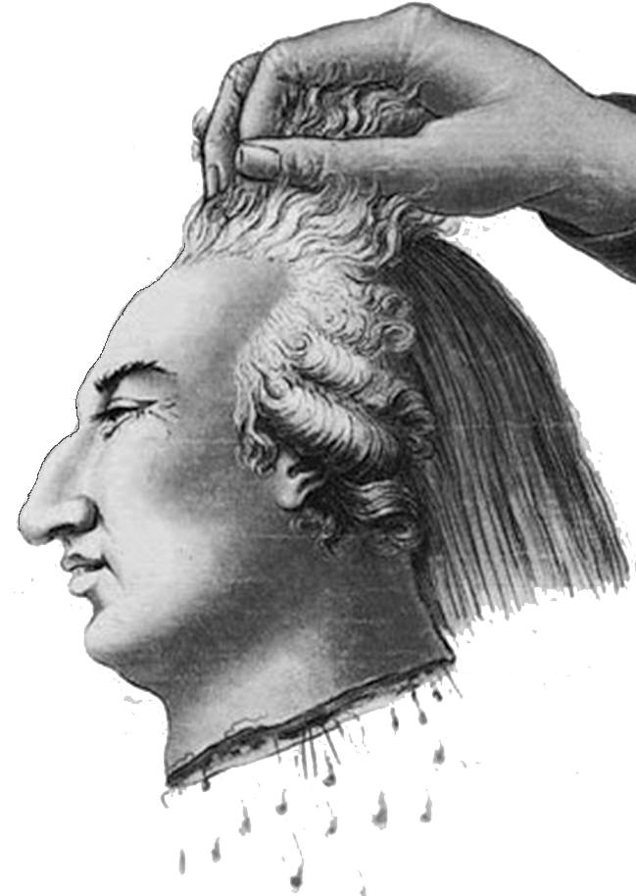
III. Constitutional Government
National Assembly - _____________________
1. All male citizens be in govt, army, or church office.

2. Declaration of the Rights of Man and of the Citizen
- equality of all __________________ & freedom of __________________, press & religion.

3. Constitutional Monarchy -
Kept king, but ___________________ his powers

- New France and the French Republic
A. National Convention
created a new govt.
- set up. . .
B. Democratic Republic ended the __________________________.
C. King Louis refused the Republic, hence – tried for ______________________ - beheaded
- Spreading the Revolution
A. Maximilien ____________________________________ (Leader)
- installs radical changes
- begins Reign of ______________________________
B. Reign of Terror - _______________________ people suspected of being traitors, were beheaded.
C. The Directory -
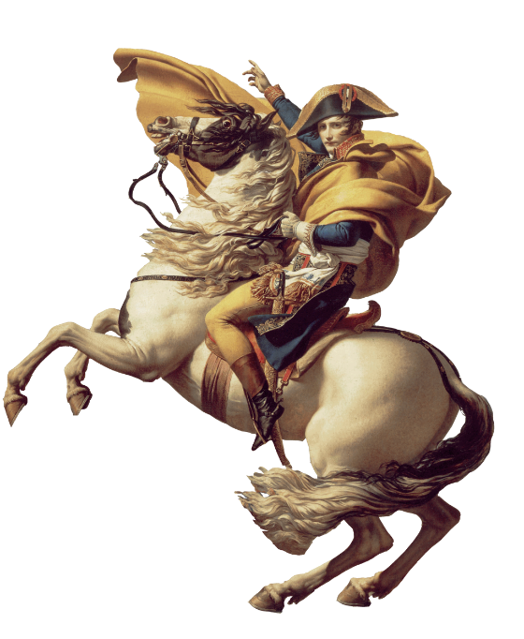
- Govt #3 (1795)
- ____________________________ & corrupt
D. War - Kings of Britain, Spain, Austria & Prussia feared the new gov.
France wanted to _________________________ the revolution by _______________________________________________________

begins war
- A. Napoleon Bonaparte
Who we will cover next time

