French Revolution: Napoleon Bonaparte
Name: _________________________________________
A. Napoleon Bonaparte -
General - defeated Austria & northern Italy.
B. His popularity allowed him to overthrow the gov.
- Proclaimed a new republic; really a dictatorship
C. French liked his strong gov. & peace & order
D. Crowns himself Emperor
E. Nearly conquered Europe
F. 1814, defeated & exiled to Islands of Elba & St. Helena
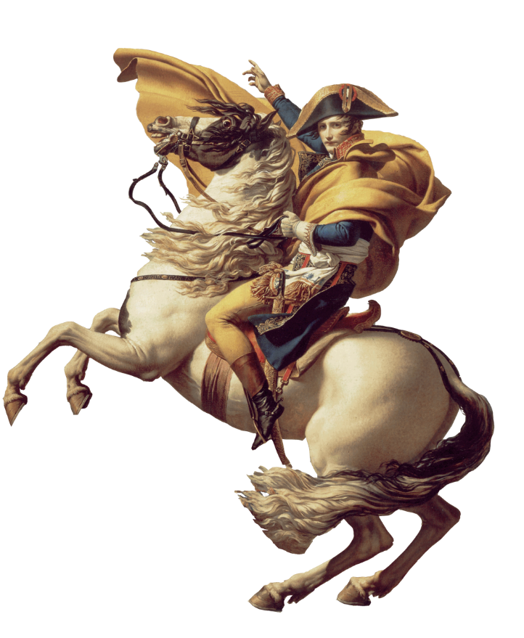
G. Napoleon’s Impact
(1) Napoleonic Code.
(2) secured the revolution in
France
(3) spread Enlightenment
around Europe

