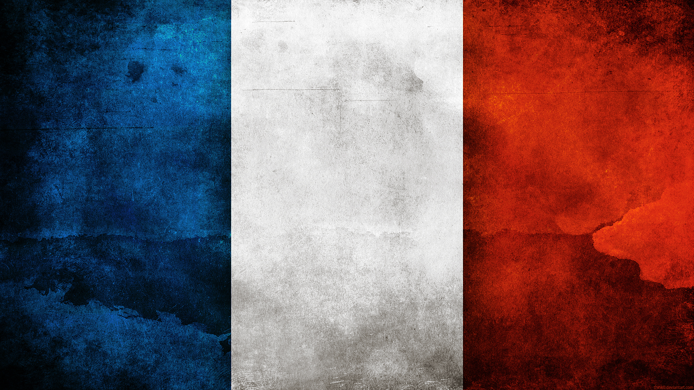

Name Date Period

Matching
____ 1. Three distinct social classes in France during A. First Estate
the 1700s: clergy, nobility, and commoners B. Versailles
____ 2. The King’s Palace of France. As many as 10,000 people lived there C. Second Estate
____ 3. One of three distinct social classes in France consisting D. Bastille
of Roman Catholic clergy & made up 1% of the population. E. Bourgeoisie
____ 4. A famous Paris prison stormed by a mob F. Estate
____ 5. This group comprised 97 percent of France’s population G. Third Estate
before the revolution H. Fourth Estate
____ 6. Consisted of the nobility class who paid little taxes

Multiple Choice
____ 7. Before the revolution in France, members of the Third Estate had
a. a smaller tax burden than the other estates
b. greater political influence than the clergy
c. a voice in government equal to that of the First and Second Estates
d. a high tax burden and little political power

____ 8. In 1789, King Louis XVI summoned the Estates-General primarily to
a. eliminate feudal dues. c. increase the influence of the peasants.
b. raise taxes to pay off growing debt. d. protect the privileges of the First and Second Estates.

____ 9. The nobility’s main source of income was
a. feudal dues collected from peasants c. taxes on the income of artisans and merchants.
b. government salaries. d. tithes collected from church members.

____ 10. Commoners-the bourgeoisie, professionals, peasants, and urban populace-made up which estate in France?
a. the First Estate c. the Third Estate
b. the Second Estate d. the aristocracy

____ 11. An estimated 40,000 people suspected of being traitors, were executed by the guillotine in one year during the French Revolution. This was known as
a. the Execution c. the Reign of Terror
b. the Horror d. the Reign of Burt

____ 12. The Declaration of the Rights of Man guaranteed all of the following EXCEPT
a. freedom of speech c. freedom of religion
b. freedom of the press d. equal rights for women

____ 13. Historians believe that one of Napoleon’s greatest impacts is
a. conquering of Austria and Prussia c. his escaping from Elba
b. the Revised. d. the Napoleonic Code

____ 14. Which of the following contributed to France’s financial crisis?
a. a drop in the gold supply c. peasant uprisings
b. an extended period of peace d. bad harvests

____ 15. The outbreak at the Bastille released a wave of peasant violence throughout France called the
a. the Execution c. Montezuma’s Revenge b. the Horror d. the Great Fear

____ 16. The Congress of Vienna
a. was responsible for democracy throughout Europe c. redrew the map of Europe, and restored the monarchy.
b. developed France after the war d. installed Napoleon back into office after Elba

____ 17. Which group made up the vast majority of French society?
a. the clergy c. the ancient regime
b. the First Estate d. the Third Estate
The French Revolution Assessment
Name Date Period
____ 18. Marie Antoinette was the wife of which French monarch?
a. Napoleon c. Louis XV
b. Louis XIV d. Louis XVI

____ 19. What did the National Assembly vow in the Tennis Court Oath?
a. to behead the king c. to draft a constitution for France
b. to prepare for war d. to revolt

____ 20. In 1792, the National Convention voted to abolish the monarchy and declare France
a. dissolved. c. a republic.
b. bankrupt. d. a nation.
____ 21. In 1793 King Louis XVI and Queen Marie Antoinette were
a. returned to the throne. c. saved from the Robespierre.
b. deported to England. d. executed.

____ 22. The leader of the Reign of Terror was
a. Marie Antoinette. c. Olympe de Gouges.
b. Maximilien Robespierre. d. Dr. Joseph Guillotin.

____ 23. Which of the following were treasonous acts committed by Louis?
a. Supporting the Revolution
b. Declaring the National Assembly unconstitutional
c. Declaring war on Austria
d. Trying to escape France
____ 24. How did the Napoleonic Code reflect Enlightenment principles?
a. It guaranteed the equality of all citizens before the law.
b. It guaranteed women equal rights.
c. It valued individual rights above all else.
d. It valued the security of the state over individual liberty.

____ 25. After his final defeat by British and Prussian forces in June 1815, Napoleon was imprisoned on the island of
a. Waterloo. b. Corsica. c. St. Helena. d. Newfoundland.

____ 26. Which of the following statements about France’s social structures is true?
a. The Third Estate was made up entirely of peasants.
b. The Second Estate was paid much of their incomes to taxes.
c. There was inequality among the three estates.
d. Most people belonged to the First Estate.

____ 27. Political body of France
a. Dumab Reichstag b. Napoleonic Code c. Lok Sabha d. Estates General

____ 28. Who created and led the Committee of Public Safety?
a. Louis XVI c. The Directory
b. Maximilien Robespierre d. The National Convention

____ 29. The French people welcomed Napoleon because?
a. they hoped he would help the collapsing French economy.
b. he completely disavowed the ideals of the Revolution.
c. he was the grandson of Louis XVI and Marie Antoinette.
d. he promised order after the chaos of the Revolution.
____ 30. Which document declared that all men are free and equal?
a. The Declaration of the Rights of Man and of the Citizen c. The Civil Constitution of the Clergy
b. The Constitution of 1791 d . The Concordat of Worms
Name Date Period

Matching
____ 1. Three distinct social classes in France during A. First Estate
the 1700s: clergy, nobility, and commoners B. Versailles
____ 2. The King’s Palace of France. As many as 10,000 people lived there C. Second Estate
____ 3. One of three distinct social classes in France consisting D. Bastille
of Roman Catholic clergy & made up 1% of the population. E. Bourgeoisie
____ 4. A famous Paris prison stormed by a mob F. Estate
____ 5. This group comprised 97 percent of France’s population G. Third Estate
before the revolution H. Fourth Estate
____ 6. Consisted of the nobility class who paid little taxes

Multiple Choice
____ 7. Before the revolution in France, members of the Third Estate had
a. a smaller tax burden than the other estates
b. greater political influence than the clergy
c. a voice in government equal to that of the First and Second Estates
d. a high tax burden and little political power

____ 8. In 1789, King Louis XVI summoned the Estates-General primarily to
a. eliminate feudal dues. c. increase the influence of the peasants.
b. raise taxes to pay off growing debt. d. protect the privileges of the First and Second Estates.

____ 9. The nobility’s main source of income was
a. feudal dues collected from peasants c. taxes on the income of artisans and merchants.
b. government salaries. d. tithes collected from church members.

____ 10. Commoners-the bourgeoisie, professionals, peasants, and urban populace-made up which estate in France?
a. the First Estate c. the Third Estate
b. the Second Estate d. the aristocracy

____ 11. An estimated 40,000 people suspected of being traitors, were executed by the guillotine in one year during the French Revolution. This was known as
a. the Execution c. the Reign of Terror
b. the Horror d. the Reign of Burt

____ 12. The Declaration of the Rights of Man guaranteed all of the following EXCEPT
a. freedom of speech c. freedom of religion
b. freedom of the press d. equal rights for women

____ 13. Historians believe that one of Napoleon’s greatest impacts is
a. conquering of Austria and Prussia c. his escaping from Elba
b. the Revised. d. the Napoleonic Code

____ 14. Which of the following contributed to France’s financial crisis?
a. a drop in the gold supply c. peasant uprisings
b. an extended period of peace d. bad harvests

____ 15. The outbreak at the Bastille released a wave of peasant violence throughout France called the
a. the Execution c. Montezuma’s Revenge b. the Horror d. the Great Fear

____ 16. The Congress of Vienna
a. was responsible for democracy throughout Europe c. redrew the map of Europe, and restored the monarchy.
b. developed France after the war d. installed Napoleon back into office after Elba

____ 17. Which group made up the vast majority of French society?
a. the clergy c. the ancient regime
b. the First Estate d. the Third Estate
The French Revolution Assessment
1. F

2. B
3. A

4. D
5. G
6. C

D

B

A

C

C

D

D

D

D

C

D
Name Date Period
____ 18. Marie Antoinette was the wife of which French monarch?
a. Napoleon c. Louis XV
b. Louis XIV d. Louis XVI

____ 19. What did the National Assembly vow in the Tennis Court Oath?
a. to behead the king c. to draft a constitution for France
b. to prepare for war d. to revolt

____ 20. In 1792, the National Convention voted to abolish the monarchy and declare France
a. dissolved. c. a republic.
b. bankrupt. d. a nation.
____ 21. In 1793 King Louis XVI and Queen Marie Antoinette were
a. returned to the throne. c. saved from the Robespierre.
b. deported to England. d. executed.

____ 22. The leader of the Reign of Terror was
a. Marie Antoinette. c. Olympe de Gouges.
b. Maximilien Robespierre. d. Dr. Joseph Guillotin.

____ 23. Which of the following were treasonous acts committed by Louis?
a. Supporting the Revolution
b. Declaring the National Assembly unconstitutional
c. Declaring war on Austria
d. Trying to escape France
____ 24. How did the Napoleonic Code reflect Enlightenment principles?
a. It guaranteed the equality of all citizens before the law.
b. It guaranteed women equal rights.
c. It valued individual rights above all else.
d. It valued the security of the state over individual liberty.

____ 25. After his final defeat by British and Prussian forces in June 1815, Napoleon was imprisoned on the island of
a. Waterloo. b. Corsica. c. St. Helena. d. Newfoundland.

____ 26. Which of the following statements about France’s social structures is true?
a. The Third Estate was made up entirely of peasants.
b. The Second Estate was paid much of their incomes to taxes.
c. There was inequality among the three estates.
d. Most people belonged to the First Estate.

____ 27. Political body of France
a. Dumab Reichstag b. Napoleonic Code c. Lok Sabha d. Estates General

____ 28. Who created and led the Committee of Public Safety?
a. Louis XVI c. The Directory
b. Maximilien Robespierre d. The National Convention

____ 29. The French people welcomed Napoleon because?
a. they hoped he would help the collapsing French economy.
b. he completely disavowed the ideals of the Revolution.
c. he was the grandson of Louis XVI and Marie Antoinette.
d. he promised order after the chaos of the Revolution.
____ 30. Government spending more money than it takes in due to borrowing? (one of the economic problems in France)
a. deficit spending c. Madam deficit
b. compound interest d. The Directory
D

C

A

D

B

D

A

C

C

D

B

D

A

