Name: _______________________________________ Period: _______

Task: You will write two to three paragraphs on the below prompts:

- Does technology benefit society? Explain. (5-10 sentences)

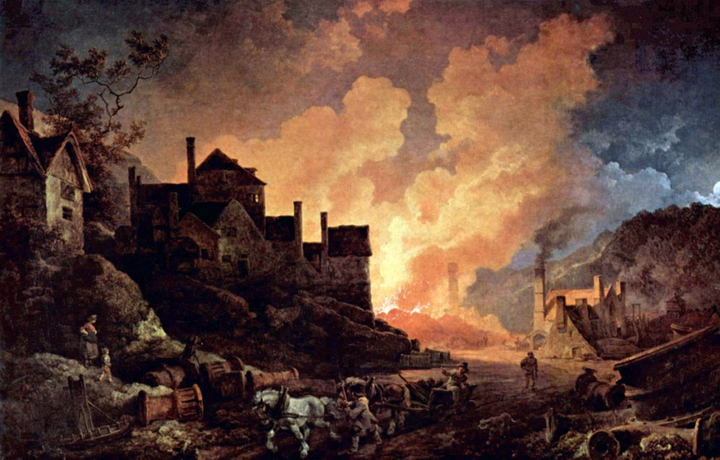
- Review the notes you have filled out and knowing what you know today, was the Industrial Revolution a blessing or a curse to society? Explain. (5 - 10 sentences)

_________________________________________________________________________________________________________________________________________________________________________________________________________________________________________________________________________________________________________________________________________________________________________________________________________________________________________________________________________________________________________________________________________________________________________________________________________________________________________________________________________________________________________________________________________________________________________________________________________________________________________________________________________________________________________________________________________________________________________________________________________________________________________________________________________________________________________________________________________________________________________________________________________________________________________________________________________________________________________________________________________________________________________________________________________________________________________________________________________________________________________________________________________________________________________________________________________________

