Name: ___________________________________ Period: _______ Score: ______/

New Economic and Social Theories

Various thinkers of the day attempted to understand and interpret the dramatic changes brought about by the Industrial Revolution. They responded with a wide range of explanations and solutions, as the documents illustrate below.
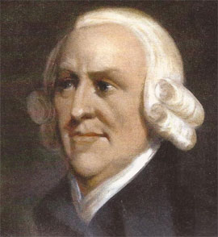
Document A: “As every individual, therefore, endeavors as much as he can both to employ his capital in the support of domestic industry, and so to direct that industry that its produce may be of the greatest value; every individual necessarily labors to render the annual revenue of the society as great as he can…by preferring the support of domestic to that of foreign industry, he intends only his own security; and by directing that industry in such a manner as its produce may be of the greatest value, he intends only his own gain, and his is in this, as in many other cases, led by an invisible hand to promote an end which was not part of his intention…every individual it is evident, can, in his local situation, judge much better than any statesman or lawgiver can do for him.”
- From The Wealth of Nations by Adam Smith, 1776

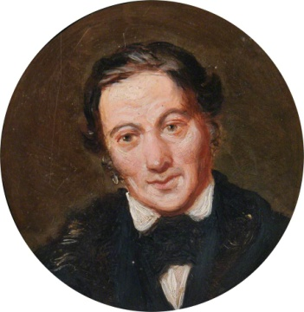
Document B: “In those characters which no exhibit crime, the fault is obviously not in the individual, but the defects proceed from the system in which the individual was trained. Withdraw those circumstances which tend to create crime in the human character, and crime will not be created. Replace them with such as are calculated to form habits of order, regularity, temperance, industry. And these qualities will be formed…Proceed systematically on principles of undeviating persevering kindness, yet retaining and using, with the least possible severity, the means of restraining crime from immediately injuring society, and by degrees even the crimes now existing in adults will also gradually disappear…”
- From A New View of Society by Robert Owen, 1816

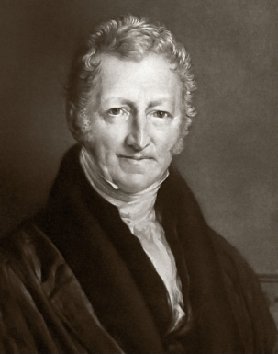
Document C: “…the power of population is indefinitely greater than the power in the earth to produce subsistence for man. Population, when unchecked, increased in a geometrical ratio. Subsistence increases only in an arithmetical ratio. A slight acquaintance with numbers will show the immensity of the first power in comparison of the second…No fancied equality, no agrarian regulations in their utmost extent, could remove the pressure of it even for a single century. And it appears, therefore, to be decisive against the possible existence of a society, all the members of which should live in ease, happiness, and comparative leisure; and fell no anxiety about providing the means of subsistence for themselves and families. Consequently, if the premises are just, the argument is conclusive against the perfectibility of the mass of mankind.”
- From An Essay on the Principle of Population 1798 by Thomas Malthus

Analyzing Primary & Secondary Sources

Use your knowledge of the new economic and social theories, the Industrial Revolution, and the Sources to answer questions below.

- _____ According to Adam Smith in Document A, individuals promote the good of society because of…

  - High ideals
  - Self interest
  - Government pressure
  - Religion

- _____ How did Robert Owen explain the fact that some people become criminals?

  - The invisible hand of fate
  - Struggles between the ruling class and the oppressed
  - The influence of problems in society
  - The power of population over production

- _____ Thomas Malthus argued that a society where all individuals enjoy happiness, comfort, and pleasure is…

  - Only possible with increased agricultural output
  - Impossible because of the base nature of human greed
  - Impossible because of the pressures of population
  - Possible when people are treated decently and fairly

- Suppose you were working as part of the Industrial working class in Britain in the year 1840. Which of the above economic philosophies would you support and why?

____________________________________________________________________________________________________________________________________________________________________________
____________________________________________________________________________________________________________________________________________________________________________
____________________________________________________________________________________________________________________________________________________________________________
____________________________________________________________________________________________________________________________________________________________________________
____________________________________________________________________________________________________________________________________________________________________________

