Excerpt from The Communist Manifesto - 1848

Background: Karl Marx and Frederick Engels wrote The Communist Manifesto in 1848. Marx and Engels believed that history was an inevitable cycle in which nations would turn to capitalism, then socialism, then communism. In the following text, a history of class warfare is described between the Proletariat (workers) and the Bourgeoisie (owners).

“THE BOURGEOISIE AND PROLETARIANS”

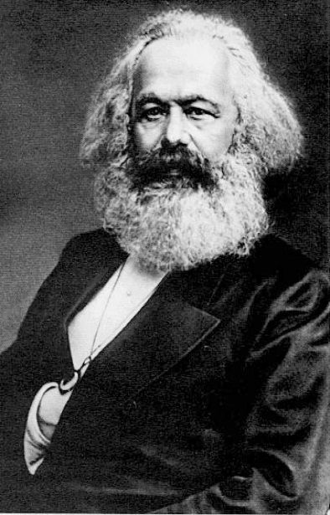
A The history of all existing societies is the history of class struggle. Freeman vs slave, patrician vs plebeian, lord vs serf, guild-master vs journeyman, or simply, “oppressor” and “oppressed”, stood in constant opposition, carried on an uninterrupted, once hidden, now open fight, that each time ended either in a revolution [or war]. In earlier history, we find almost everywhere a complicated arrangement of society into various orders, or social rank. In ancient Rome; patricians, knights, plebeians, slaves; in the Middle Ages, feudal lords, vassals, serfs…
B The modern bourgeois society that sprouted from the ruins of feudalism still has class hatred. It has established new classes, new oppressive conditions, new forms of struggle… Our age, the age of the bourgeoisie, however, has simplified class hatred: Society as a whole splitting up into two great hostile camps or classes, directly facing each other: Bourgeoisie & Proletariat.
C As the bourgeoisie, the capital is developed, so the proletariat, the modern working class developed, a class of laborers. Labor lives only if they find work, and find work only if their labor increases capital. These laborers must sell themselves as a good, like any other trade good, and are then exposed to all fluctuations of competition and of the market.
D Due to machinery and to division of labor, the work of the proletarians has lost all character and charm for the workman; he has become part of the machine, and it is only simple, monotonous, and easily acquired knacks that is required of him. Hence, the cost of production of a workman is restricted…as the wage decreases. What’s more, as machinery and division of labor increase, so does the burden of toil of the laborer, (longer working hours, faster work, etc.).
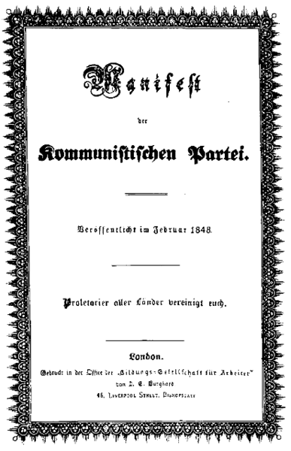
E Modern industry made the workshop of the master into the great factory of the industrial capitalist. Masses of laborers, crowded into the factory, are organized like soldiers. As troops of the industrial army they are under the command of a hierarchy of officers and sergeants. Not only are they slaves of the bourgeois class, and of the bourgeois government; they are daily and hourly enslaved by the machine, by the boss, and, by the individual bourgeois owner himself. And the more it becomes about profit, the more petty, hateful and the more embittering it is.
F But with the development of industry the proletariat not only increases in number; it becomes concentrated in greater masses, its strength grows, and it feels that strength more. The interests and lives of the proletariat become alike, as machines obliterate job distinctions and everywhere wages drop to the same low levels… The collisions between individual workmen and individual bourgeois begin more and more to represent collisions between two classes. So workers begin to form groups (trade unions) against the bourgeois; they club together in order to keep wages higher; they have permanent associations to plan for occasional revolts [or strikes].

G Often workers are victorious, but only for a time. The real fruit of their battle lies in the expanding union of workers. This union is aided by communication as those of different areas contact each other. It was this contact that centralizes all the local struggles… into one national struggle between classes. But every class struggle is a political struggle. This bond allows the proletariat to achieve in a few years what it took people of the middle ages centuries to achieve. This organization of the proletariat into a class, and then into a political party, is continually being upset by the struggle between the workers. But it ever rises up again, stronger, firmer, mightier…
H So all societies are based…on the hatred between oppressor and oppressed classes… [The Bourgeoisie] is unfit to rule because it is incompetent and allows the slaves [proletariat] to sink further into slavery, and it has to support them, instead of being supported by them. Society can no longer live under a Bourgeoisie… its existence is no longer compatible with society.
I The essential condition for the existence, and for the sway of the bourgeois class, is the formation and augmentation of capital; the condition for capitalist wage-labor. Wage-labor rests exclusively on competition between the laborers. The Bourgeoisie promotes industry, which brings together once-isolated workers. The development of Modern Industry cuts from under its feet the very foundation on which the bourgeoisie produces products. The bourgeoisie produces, above all, is its own grave-diggers. Its fall and the victory of the proletariat are equally inevitable.
Place the following terms on the correct line (6 on each):

‘haves’, labor, workers, capital, lower-class, owners, poor, rich, upper-class, wage-earners, wealthy, ‘have-nots’

- BOURGEOISIE: _______________________________________________________________________________________

- PROLETARIAT: _______________________________________________________________________________________

3) How does Marx defend his claim that history has always been about class struggle? (paragraph A) ___________________________

____________________________________________________________________________________________________________

4) Although Marx sees class struggles throughout history, what does he see as the class struggle today (in his day)? (paragraph B)

____________________________________________________________________________________________________________

5) Explain how Marx says the worker has “become part of the machine”. (paragraph D) ______________________________________

____________________________________________________________________________________________________________

____________________________________________________________________________________________________________

6) What analogy does Marx use to describe workers and industry? (paragraph E) ___________________________________________

____________________________________________________________________________________________________________

7) How is the proletariat growing in strength, according to Marx? (paragraph F, G) ________________________________________

____________________________________________________________________________________________________________

____________________________________________________________________________________________________________

8) Why does Marx say that the Bourgeoisie must be overthrown? (paragraph H) ____________________________________________

____________________________________________________________________________________________________________

9) In your own words, what point is made in the final paragraph? (paragraph I) _____________________________________________

____________________________________________________________________________________________________________

10) Based on this excerpt, why do you think Marx such a polarizing figure? Why were his ideas considered dangerous?

____________________________________________________________________________________________________________

____________________________________________________________________________________________________________
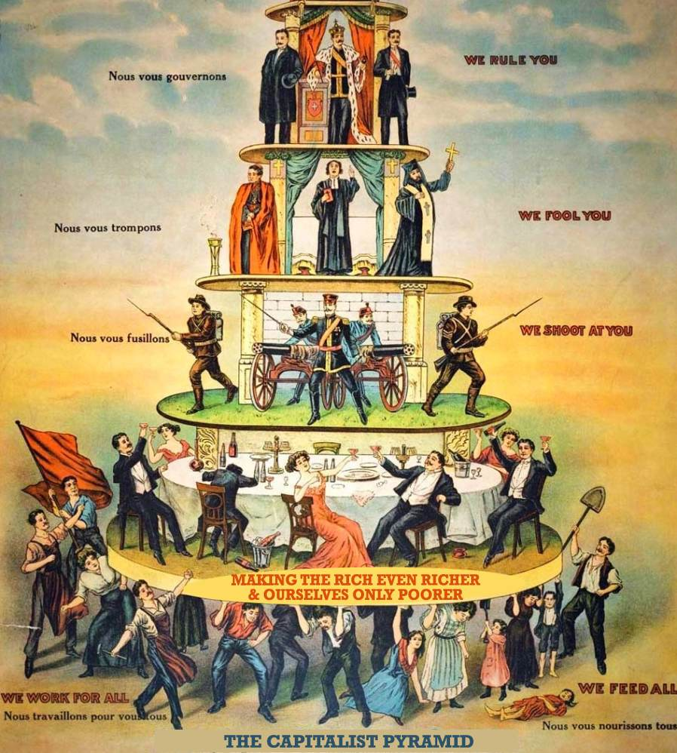
11) Why do you think the hammer and sickle has become the symbol of communism?

________________________________________________

________________________________________________

________________________________________________

12) Here is a well-known poster demonstrating a Marxist critique of capitalism. In a few sentences, explain what the message of the poster is supposed to be…

_______________________________________________

_______________________________________________

_______________________________________________

_______________________________________________

_______________________________________________

_______________________________________________

_______________________________________________

_______________________________________________

_______________________________________________

