SOCIALS 9
INDUSTRIAL REVOLUTION TEST

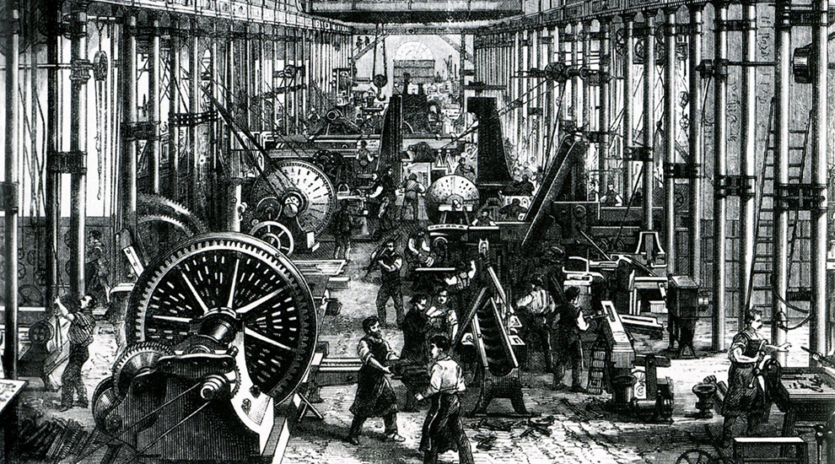
 | Your Total | Out of
Multiple Choice
Fill in the Blank
Short Answer
Long Answer
TOTAL

Good luck! Please remember to read each question thoroughly and answer to the best of your ability (guess if you have to!). Never leave a question blank!

Multiple Choice (Worth 1 Mark each)

- What was not a major change during the Agricultural Revolution?

a. Crop Rotation c. Improvement in livestock

b. People going to farms to work d. Enclosures

- He invented a machine called the spinning jenny

a. Robert Fulton c. James Watt

b. Edmund Cartwright d. James Hargreaves

- He invented the seed drill

a. Jethro Tull c. Ivan Pavlov

b. Edward Jenner d. Louis Pasteur

- What percent of the population was considered “working class”?

a. 20% c. 35%

b. 80% d. 90%

- The Industrial Revolution first took hold in what industry?

a. Lumber c. Textiles

b. Fishing d. Mining

- What source of fuel was essential in the production of iron

a. Charcoal c. Wood

b. Coal d. Oil

- Which of the following was NOT a cause of urbanization

a. Demand for Workers c. Population Growth

b. Spread of Disease d. Changes in Farming

- This social class owned and operated the new factories, mines, and railroads, among other industries

a. Industrial Working Class c. Industrial Middle Class

b. Aristocracy d. Proletariat

- Which of the following was NOT a cause of Communism failing

a. Workers gained the right to vote c. Nationalism

b. Too much industry to be controlled d. Workers could buy more

- The “Combination Act” …

a. cut children’s working hours c. made it illegal for workers to unionize

b. required factory owners to put d. allowed women to work
fences around equipment

- Secondary School (High School) became required in…
  - 1944 c. 1901
  - 1878 d. 1923
- “The 1880 Education Act”…

  - Made it so kids could
skip school to work

  - Made it so kids could go to school if they want

  - Made primary school mandatory for all kids

  - Made it so that owners had to educate their child workers

13. Which of the below is not a reason why the Industrial Revolution began in Britain.

a. Cotton could be grown easily in Britain c. Lots of rivers and canals for transportation

b. Population Growth and Urbanization d. Financial changes like banks opening

14. The worker, usually a child, who pulled carts of coal through passages by a belt around their waist, was called…

a. a puller
b. a thruster
c. a hurrier
d. a mule

15. Bonus: Who had the best beard?
Marx Engels
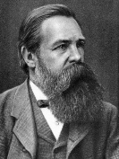
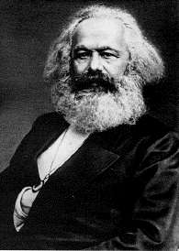

or

Multiple Choice Total: _____________/ 14

Fill in the Blank: (2 points each) Write the correct term in the space provided. Not all words will be used
Smelting Psychology Great Britain Ferdinand von Zeppelin Eli Whitney
Faster & Cheaper
Electricity Sociology United States Karl Marx Long Hours Michael Faraday Alfred Nobel Light Bulb Germany High Wages Robert Owen Slow & Expensive John Kay G. Marconi Railroads Means of Production Free-Market Capitalism

- Name one technological advance that helped trigger the Industrial Revolution

- In what country did the Industrial Revolution first begin?

- He invented the cotton gin

- Name one advantage of steam powered transportation

- Name one bad condition people had to face working in factories or mines

- He and Friedrich Engels would write their ideas on communism in their famous work, the Communist Manifesto

- Inventor of the rigid airship, or dirigible balloon

- The equipment or machines with which products are made

- When the government has little or no regulation in business it is….

Fill in the Blank Total: _____________________/18

Short Answer (Can be answered in point form)

      - Compare and Contrast the Cottage Industry and the Factory System (4 Marks)

      - What was one negative and one positive effect of Free Market Capitalism? (2 Marks)

      - Why did disease spread quickly in urban areas? (3 Marks)

      - What did the “Factory Act of 1833” change or limit? (3 Marks)

      - Why was the “Factory Act of 1833” disliked by factory owners? (2 Marks)

      - Describe why getting injured was a big deal to 18th Century workers. (2 Marks)

      - Who are the proletariat and the bourgeoisie? Who coined that term? (3 Marks)

Short Answer Total: /23
Long Answer Questions (10 Marks Each)
For the following two questions, please answer in full-sentences. Each answer should be written in paragraph form (topic sentences, support/body sentences, and a conclusion sentence). Be sure to use specific facts about the Industrial Revolution to support your answer.
            - Does the Industrial Revolution deserve to be called a “Revolution”?
________________________________________________________________________________________________________________________________________________________________________________________________________________________________________________________________________________________________________________________________________________________________________________________________________________________________________________________________________________________________________________________________________________________________________
____________________________________________________________________________________________________________________________________________________________________________________________________________________________________________________________________________________
____________________________________________________________________________________________________________________________________________________________________________________________________________________________________________________________________________________
____________________________________________________________________________________________________________________________________________________________________________________________________________________________________________________________________________________
____________________________________________________________________________________________________________________________________________________________________________________________________________________________________________________________________________________
____________________________________________________________________________________________________________________________________________________________________________________________________________________________________________________________________________________
____________________________________________________________________________________________________________________________________________________________________________________________________________________________________________________________________________________
____________________________________________________________________________________________________________________________________________________________________________________________________________________________________________________________________________________
____________________________________________________________________________________________________________________________________________________________________________________________________________________________________________________________________________________
____________________________________________________________________________________________________________________________________________________________________________________________________________________________________________________________________________________
____________________________________________________________________________________________________________________________________________________________________________________________________________________________________________________________________________________
____________________________________________________________________________________________________________________________________________________________________________________________________________________________________________________________________________________
____________________________________________________________________________________________________________________________________________________________________________________________________________________________________________________________________________________

2. If you were a worked in 19th Century Britain, which economic theory (e.g., capitalism or communism) would you support and why? (Be sure to explain what both theories are.) ________________________________________________________________________________________________________________________________________________________________________________________________________________________________________________________________________________________________________________________________________________________________________________________________________________________________________________________________________________________________________________________________________________________________________
____________________________________________________________________________________________________________________________________________________________________________________________________________________________________________________________________________________
____________________________________________________________________________________________________________________________________________________________________________________________________________________________________________________________________________________
____________________________________________________________________________________________________________________________________________________________________________________________________________________________________________________________________________________
____________________________________________________________________________________________________________________________________________________________________________________________________________________________________________________________________________________
____________________________________________________________________________________________________________________________________________________________________________________________________________________________________________________________________________________
____________________________________________________________________________________________________________________________________________________________________________________________________________________________________________________________________________________
____________________________________________________________________________________________________________________________________________________________________________________________________________________________________________________________________________________
____________________________________________________________________________________________________________________________________________________________________________________________________________________________________________________________________________________
____________________________________________________________________________________________________________________________________________________________________________________________________________________________________________________________________________________
____________________________________________________________________________________________________________________________________________________________________________________________________________________________________________________________________________________
____________________________________________________________________________________________________________________________________________________________________________________________________________________________________________________________________________________
____________________________________________________________________________________________________________________________________________________________________________________________________________________________________________________________________________________

Long Answer Total: ____+____= /20

