SOCIALS 9
INDUSTRIAL REVOLUTION TEST

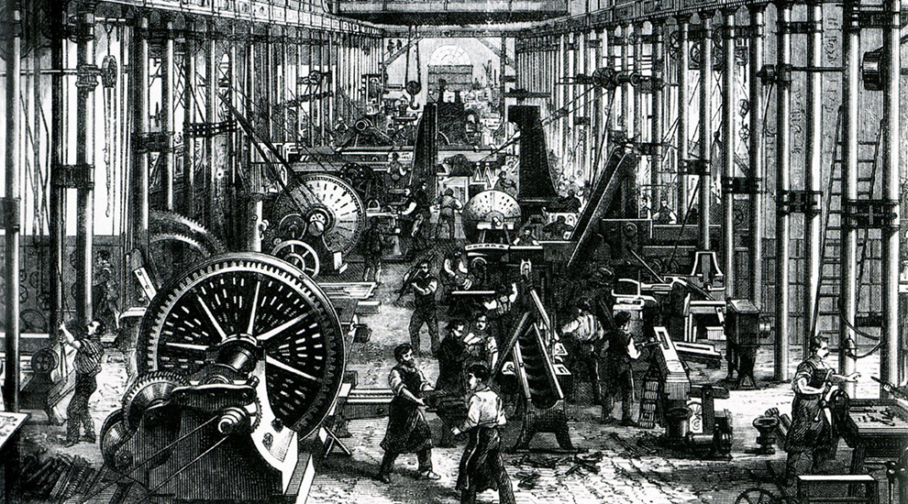
Assessment
Multiple Choice
Fill in the Blank
Short Answer
Long Answer
TOTAL

Good luck! Please remember to read each question thoroughly and answer to the best of your ability (guess if you have to!). Never leave a question blank!

Multiple Choice

- What was not a major change during the Agricultural Revolution?

a. Crop Rotation c. Improvement in livestock

b. People going to farms to work d. Enclosures

- He invented a machine called the spinning jenny

a. Robert Fulton c. James Watt

b. Edmund Cartwright d. James Hargreaves

- He invented the seed drill

a. Jethro Tull c. Ivan Pavlov

b. Edward Jenner d. Louis Pasteur

- Most working people in urban areas lived in places called…

a. Apartments c. Tenements

b. Orphanages d. Shacks

- The Industrial Revolution first took hold in what industry?

a. Lumber c. Textiles

b. Fishing d. Mining

- What source of fuel was essential in the production of iron

a. Charcoal c. Wood

b. Coal d. Oil

- Which of the following was NOT a cause of urbanization

a. Demand for Workers c. Population Growth

b. Spread of Disease d. Changes in Farming

- This social class owned and operated the new factories, mines, and railroads, among other industries

a. Industrial Working Class c. Industrial Middle Class

b. Aristocracy d. Proletariat

- Which of the following was NOT a cause of Communism failing

a. Workers gained the right to vote c. Nationalism

b. Too much industry to be controlled d. Workers could buy more

- Who developed the telegraph?

a. George Washington c. Michael Faraday

b. Jethro Tull d. Samuel Morse

- The Wright Brothers…
  - Invented the telephone c. Built the first plane
  - Founded the Ford Company d. Invented dynamite
- “The 1880 Education Act”…

  - Made it so kids could
skip school to work

  - Made it so kids could go to school if they want

  - Made primary school mandatory for all kids

  - Made it so that owners had to educate their child workers

13. Which of the below is not a reason why the Industrial Revolution began in Britain.

a. Cotton could be grown easily in Britain c. Lots of rivers and canals for transportation

b. Population Growth and Urbanization d. Financial changes like banks opening

14. The worker, usually a child, who pulled carts of coal through passages by a belt around their waist, was called…

a. a puller
b. a thruster
c. a hurrier
d. a mule

15. Bonus: Who had the best beard?
Marx Engels
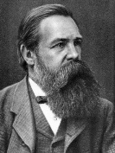
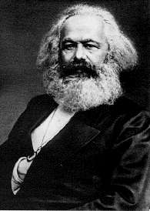

or

Multiple Choice Total: _____________/ 14

Fill in the Blank: Write the correct term in the space provided. Not all words will be used
Smelting Great Britain Ferdinand von Zeppelin Eli Whitney
Faster & Cheaper Electricity United States Karl Marx Long Hours Michael Faraday Alfred Nobel Light Bulb Germany High Wages Robert Owen
Slow & Expensive John Kay G. Marconi Railroads Means of Production Capitalism

- Name one technological advance that helped trigger the Industrial Revolution

- In what country did the Industrial Revolution first begin?

- He invented the cotton gin

- Name one advantage of steam powered transportation

- Name one bad condition people had to face working in factories or mines

- He and Friedrich Engels would write their ideas on communism in their famous work, the Communist Manifesto

- The equipment or machines with which products are made according to communism

- When the government has little or no regulation in business it is….

- Man who was called a “Utopian”

Short Answer

      - Compare and Contrast the Cottage Industry and the Factory System

      - Why did disease spread quickly in urban areas?

      - What did the “Factory Act of 1833” change or limit?

      - Describe why getting injured was a big deal to 19th Century workers.

      - Who are the proletariat and the bourgeoisie? Who coined that term?

Long Answer Questions
CHOOSE ONE
Answer in full-sentences. Each answer should be written in paragraph form (topic sentences, support/body sentences, and a conclusion sentence). Be sure to use specific facts about the Industrial Revolution to support your answer.
            - Does the Industrial Revolution deserve to be called a “Revolution”?
________________________________________________________________________________________________________________________________________________________________________________________________________________________________________________________________________________________________________________________________________________________________________________________________________________________________________________________________________________________________________________________________________________________________________
____________________________________________________________________________________________________________________________________________________________________________________________________________________________________________________________________________________
____________________________________________________________________________________________________________________________________________________________________________________________________________________________________________________________________________________
____________________________________________________________________________________________________________________________________________________________________________________________________________________________________________________________________________________
____________________________________________________________________________________________________________________________________________________________________________________________________________________________________________________________________________________
____________________________________________________________________________________________________________________________________________________________________________________________________________________________________________________________________________________
____________________________________________________________________________________________________________________________________________________________________________________________________________________________________________________________________________________
____________________________________________________________________________________________________________________________________________________________________________________________________________________________________________________________________________________
____________________________________________________________________________________________________________________________________________________________________________________________________________________________________________________________________________________
____________________________________________________________________________________________________________________________________________________________________________________________________________________________________________________________________________________
____________________________________________________________________________________________________________________________________________________________________________________________________________________________________________________________________________________
____________________________________________________________________________________________________________________________________________________________________________________________________________________________________________________________________________________
____________________________________________________________________________________________________________________________________________________________________________________________________________________________________________________________________________________

2. If you were a worked in 19th Century Britain, which economic theory (e.g., capitalism or communism) would you support and why? (Be sure to explain what both theories are.) ________________________________________________________________________________________________________________________________________________________________________________________________________________________________________________________________________________________________________________________________________________________________________________________________________________________________________________________________________________________________________________________________________________________________________
____________________________________________________________________________________________________________________________________________________________________________________________________________________________________________________________________________________
____________________________________________________________________________________________________________________________________________________________________________________________________________________________________________________________________________________
____________________________________________________________________________________________________________________________________________________________________________________________________________________________________________________________________________________
____________________________________________________________________________________________________________________________________________________________________________________________________________________________________________________________________________________
____________________________________________________________________________________________________________________________________________________________________________________________________________________________________________________________________________________
____________________________________________________________________________________________________________________________________________________________________________________________________________________________________________________________________________________
____________________________________________________________________________________________________________________________________________________________________________________________________________________________________________________________________________________
____________________________________________________________________________________________________________________________________________________________________________________________________________________________________________________________________________________
____________________________________________________________________________________________________________________________________________________________________________________________________________________________________________________________________________________
____________________________________________________________________________________________________________________________________________________________________________________________________________________________________________________________________________________
____________________________________________________________________________________________________________________________________________________________________________________________________________________________________________________________________________________
____________________________________________________________________________________________________________________________________________________________________________________________________________________________________________________________________________________

