Letter to the Editor
Learning Goal: We will understand the text form of a letter so that we can better understand the power of writing letters for important causes.

What is a “Letter to the Editor”
A very short (less than 200 words) piece with a strong, personal position written by a reader usually in response to an article or editorial, or occasionally a very timely issue. It is published in the Opinion section of a newspaper or towards the front of a magazine. Considered the “comment” section before the age of the internet, it requires a fresh idea or angle, a criticism, or an extension of the main idea in the original written piece. Often the piece opens with a reference to the original article or issue and closes with a meaningful thought, rhetorical question, or a call to action.

Why develop this style of writing?
The ability to develop and then very succinctly articulate one’s unique thinking on a specific topic or another’s writing may seem like a natural talent, but it absolutely can be practiced and perfected. It’s the outside of the box thinkers, the devil’s advocates, the active and always thinking readers with that creative flair who define entrepreneur success in the 21st centry.

Task:
- Read the example article from the “Toronto Star” from December 1, 2021: “Canadians still continue to slumber when it comes to our First Nations”

- Review the parts of a letter to the Editor

- Review the other sample letters

- Write your own letter to the editor based on a current Indigenous issue. To review Indigenous issues read this article: 8 Key Issues For Indigenous Peoples In Canada

Success Criteria
- An appropriate Indigenous issue has been chosen
- Header is clear and has appropriate information
- The body paragraphs are included, written professionally and with the necessary information
- Conclusion leaves the reader with a final thought
- Appropriate font and length have been achieved
- Attention has been made to spelling and grammar

Parts of a Letter to the Editor

Header
Provide all the information requested by the publication
- Include full name, city
- Ensure letter length is contained within the word count limit

Introduction
Lead with a clear reference to the original article or widely known issue.
- Include the name of article or columnist, date of publication, and location in newspaper.
  - Assertive: “I couldn’t agree more with Elizabeth Hendrix’s “We must fix the school tax distribution issue,” column on Monday (April 5, Metro) that we need to…
  - Parenthetical: “I am floored that our province’s university 4-year graduation rate is 48% (“Graduation rates at all time low, October 22, front page)
  - Current event: What a shame our politicians feel it’s necessary to spend time debating…

1 to 2 Very Short Paragraphs
State your angle, insight, expertise, criticism, wondering, or rhetorical question.
- Make your thoughts very clear, yet respectful
- Create a strong and passionate voice (editors want to publish those ones the most)
- Develop, yet contain, your idea within a few sentences

Conclusion
Offer an original final thought
- Leave with a call to action, a rhetorical question, or a thought for moving forward
- Funny, witty, critical, firm, hopeful, or congratulatory – make it memorable!

Example from the “Toronto Star” from December 1, 2021: “Canadians still continue to slumber when it comes to our First Nations”
Canadians still continue to slumber when it comes to our First Nations
Wed., Dec. 1, 2021 1 min. read
Jim Crow? Apartheid? Let’s look closer to home, Nov. 27 Letter to the Editor

I wish I shared letter writer Chris Faiers’ optimism that “we’re waking up as a nation to the incredible continuing brutal treatment of our First Nations peoples.”
While I completely share their realization that “our national shame is much ... (worse) than previously thought,” I don’t feel that our personal epiphanies apply to Canada as a whole. Instead, I would compare our country’s citizens to hibernators. We might occasionally wake because of a bad dream or pain about our Indigenous peoples, but we soon roll over and resume our slumber because, tragically, we don’t care enough.
I was certain we would start to see better treatment of First Nations peoples after the discovery of thousands of children’s bodies, but really, what has changed for the majority of Indigenous? Not their drinking water quality or treatment by the police and RCMP, not their disproportionate incarceration rates, not their overall presence and treatment in the media, not the dangers they face from climate change they largely did not create.
And there has certainly not been respectful recognition of significant, long overdue events like the first National Day for Truth and Reconciliation by our political leaders.
Craig Leach, Scarborough
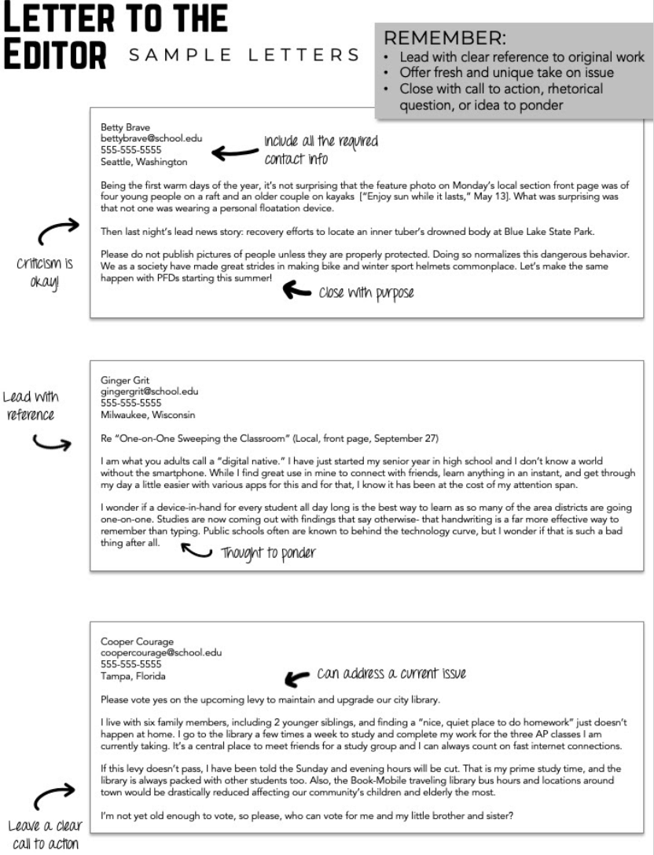

8 Key Issues For Indigenous Peoples

In Canada
April 26, 2019

Eight of the key issues that are of greatest concern for Indigenous Peoples in
Canada are complex and inexorably intertwined - so much so that government,
researchers, policy makers and Indigenous leaders seem hamstrung by the
enormity. It is hard to isolate just one issue as being the worst. The Indian Act
greatly contributes to these eight issues and more. Be sure to read this article 21
things about the Indian Act, if you want to know the intent and extent of the
Act.

1) Poorer health outcomes
The World Health Organization's investigation into health determinants now
recognizes European colonization as a common and fundamental underlying determinant of Indigenous health. There have been strides made on the part of
many Indigenous communities to improve education around health issues, but
despite these improvements, Indigenous people remain at higher risk for illness
and earlier death non-Indigenous Peoples. Chronic diseases such as diabetes
and heart disease are on the increase. There are definite links between income,
social factors, and health. There is a higher rate of respiratory problems and
other infectious diseases among Indigenous children than among non-
Indigenous children - inadequate housing and crowded living conditions are
contributing factors. Read: A Snapshot of On-Reserve Clean Water Issues

2) Lower levels of education
Colonialism accounts for many bitter, demoralizing legacies, the most pervasive
of which is education - the root of this particular legacy is that ultimate national
experiment in assimilation - the Indian Residential School system. According to
the 2016 Canadian Census, 33.65 per cent of those who identified as an
Aboriginal person have no secondary (high) school or equivalency certificate,
compared to 18.3 per cent of the rest of the Canadian population.

3) Inadequate housing and crowded living conditions
Three words - Attawapiskat First Nation. In 2011, the conditions in this
community drew national and international media attention - as well as the
attention of the United Nations - to a housing situation that far too many
Indigenous communities struggle with. Of those First Nations people living onreserve,
44.2 per cent lived in a dwelling that was in need of major repairs,
compared to 6 per cent of the non-indigenous population living in such a
dwelling. To learn more about on-reserve housing issues, read 8 Things You
Need to Know About On-Reserve Housing Issues

4) Lower income levels
The average total income of Indigenous Peoples was 75 per cent that of non Indigenous people in 2015 - that's a 25 percent income gap. It is a slight improvement from the 27 per cent gap in 2005.

5) Higher rates of unemployment
Indigenous Peoples have historically faced higher unemployment rates than non-
Indigenous people. The employment rates of Indigenous Peoples in Canada did not
increase between 2006 and 2016.

6) Higher levels of incarceration
In 2015/2016, Indigenous adults were over represented in admissions to
provincial and territorial correctional services. They accounted for 26 per cent of
admissions, while representing only about 3 per cent of the Canadian adult
population. In federal correctional services, Indigenous adults accounted for 28
per cent of admissions to custody. Aboriginal adults in federal correctional
services accounted for 28% of admissions to custody and 26% to community
supervision in 2015/2016. Read: Nearly half of youth incarcerated across
Canada are Indigenous: Statistics Canada
and: Prison Watchdog Ivan Zinger: Proportion Of Indigenous People In
Federal Custody A ‘National Travesty'

The over representation of Indigenous adults was more pronounced for females
than males. Indigenous females accounted for 38 per cent of female admissions
to provincial and territorial sentenced custody, while the comparable figure for
Indigenous males was 26 per cent. In the federal correctional services,
Indigenous females accounted for 31 per cent of female admissions to
sentenced custody, while the figure for Indigenous males was 23 per cent. [2]
Read: What are Gladue Reports?

7) Higher death rate among children and youth due unintentional injuries
Children in Indigenous families also have high rates of unintentional injuries and
early deaths from drowning and other causes. According to Health Canada statistics, Indigenous children are three to four times more likely to die from
unintentional injury than non-Aboriginal children of the same age.

8) Higher rates of suicide
And the most tragic of all is the higher rate of suicide among First Nation, Métis
and Inuit youth. A 2016 Statistics Canada report found that more than one in five
off-reserve First Nations, Métis and Inuit adults reported having suicidal
thoughts at some point in their lives. Suicide rates are five to seven times higher
for First Nations youth than for non-Aboriginal youth, and for Inuit youth, the
rate is among the highest in the world - 11 times the national average. “Suicide
and self-inflicted injuries are the leading causes of death for First Nations youth
and adults up to 44 years of age.” (A Statistical Profile on the Health of First
Nations in Canada for the Year 2000, Health Canada, 2003)

Letter to the Editor Template
Header (Title of Article):
Your Name:
City:

Introduction – explain your issue, reference an article if necessary.

1 to 2 short paragraphs on your issue. Be specific, use data, use a professional voice and word choice
Conclusion – End with a call to action. A memorable quote. A rhetorical question.

