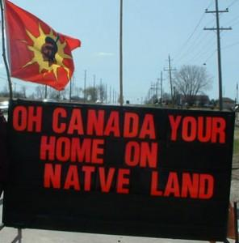
Indigenous Land Claims - Oka, Ipperwash, & Caledonia
Background:
- When the numbered treaties were signed, there were misunderstandings due to _____________________ and some of the __________________ made by the government were ______________________
- In 1973, the Supreme Court of Canada ruled that Indigenous Nations who had _____________________ still had some ___________________________
Types of Land Claims:
- There are ____________ of land claims that Indigenous groups can file, depending on whether they _____________________ with the government:
- ____________________ can be made when a _________________, but Indigenous Nations feel the government (federal or provincial) has ____________ treaty rights
- _________________________ can be made in areas were treaties were ______________
The Land Claim Process
- If for any reason the federal government decides a land claim is ____________, the claims process ends without the possibility of __________ (except though the ___________)
- If the process reaches the _______________________, the federal government still controls the _______ of negotiation
- In successful land claims, the parties usually agree to __________ of specified amounts of cash and land from the government to _________________________

Case Study #1: Oka
- In 1959, the town of ______ (in Quebec) built a 9-hole golf course on _________________ along the Ottawa River
  - _________ had given this land to ______________________ in 1717
- In 1977, the Mohawk filed an ______________________ in an attempt to ________ the land
- The Office of Native Land Claims ____________ the Mohawk’s claim, saying that the Indigenous people couldn’t ______________________
- In 1989, the mayor of Oka announced that the golf course was going to be _____________ to 18-holes and that luxury condos were also going to be built on the site
- The town prepared to take ______________________, levelling an important forest known as “The Pines” and _______________________________________________
- In March 1990, Mohawk and their allies began _____________ the Pines, protecting their trees and graveyard
- Five months later in July, the _____________________________________
- ______________________________ were sent in, storming the ______________ the Mohawk and their allies had set up with ______________________________________
- Shots were fired (no one knows who shot first)
- An ________________________________, and a Mohawk elder suffered a fatal heart attack
- The QPP was reinforced by members of the ________, and around 2500 members of the ____________________ – who came with jets, _______, and armored personnel carriers
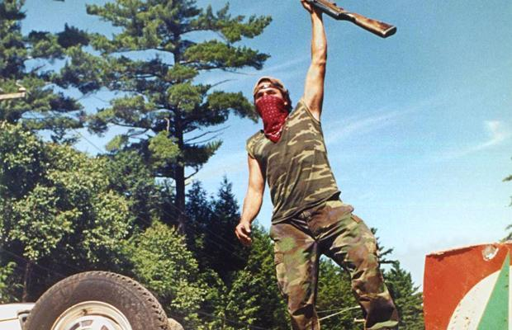
- The Mohawk were ________________________ and for __________ the 2 sides were locked in a standoff
- Despite ________________, no further shots were fired
- The crises eventually _________ and the golf course _______________________________
- The crisis cost well over ________________ and was the first ___________________ between the Mohawk and the government in the ________________________
- In 1997, the Department of Indian Affairs ____________________ the disputed land for $5.2 million and _________________________________

Case Study #2: Ipperwash
- In 1942, during WWII, the Canadian government went looking for a place to set up a military-training base and settled on the Stoney Point ________________________________, Ontario
- The government offered the band _____________________, but the _________________
- Instead, the government ________________ the land with the promise to _______________ ____________________________
- Because the land had been used as a military range, there were ________________________ in the ground
- The army claimed they did not have _________ in the budget to _________________
- In Sept, 1996, about 35 Indigenous people _____________________________________ to the long-standing claim
- The protest ______________________________________ – an OPP cruiser had its window smashed and a band councilor had a rock thrown at his car
- The confrontation came to a head with ____________ on a car and a school bus, wounding two of the defenders and _______________________________________________________
- According to police officers, there was __________ from these vehicles but First Nations protesters have _____________________________________ in the park that night
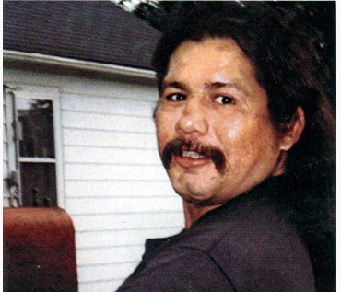
- The __________ who shot George was later ______________ of criminal negligence causing death
- In 2007, the _______________ of Ontario announced its plans to _________________- the settlement was finalized on April 14, 2016
- Along with a ________________________, the land was signed over to the Kettle and Stony Point First Nation

Case Study #3: Caledonia
- In 2006, at Caledonia, Ontario, Mohawks took over a ________________________ to protest the building of new homes on what they considered to be _____________________
- During the dispute, the provincial government announced it had _______________________ from the developer and would __________________ until negotiations settled the claim
- Protests included a _________________________________, damage to a power station resulting in an area blackout and more than $1 million in repairs, and ___________________ ____________________
- In 2011, the Ontario government agreed to a _________________________ – but not for the Mohawks, __________________________________ affected by the 6-week _____________
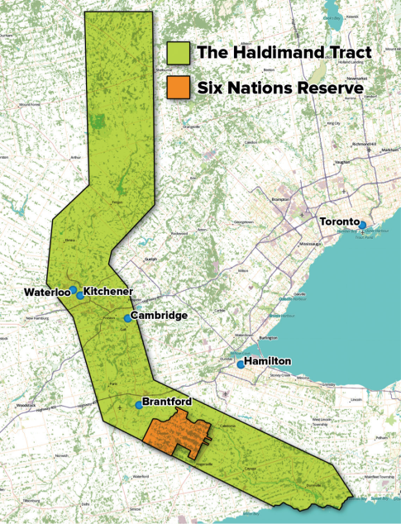
- Caledonia is part of a plot of land originally known as the ______________________
- ___________ granted the land to the _____________ in 1784 for their help during the ________________________
- The Mohawk maintain that their _____________________ was ___________________________
- The land claim remains __________________________________ ___________

