
Social Justice 12
Course Outline

We acknowledge the Lheidli T’enneh People on whose ancestral lands we live, work, and learn.

Instructor: Ms. Lawrence
E-mail: mlawrence@sd57.bc.ca

Social Justice 12 asks you to both think critically about the issues facing the world and your relation to them, reflect on what you can do about those issues, and take action to improve your communities. Social Justice explores how equity can be created outside the law or when the law fails.

Students will learn to apply critical thinking skills that include: questioning, comparing, summarizing, drawing conclusions, and defending a position. As well, students will demonstrate effective research skills, both individually and collaboratively. Students will also be required to demonstrate skills and attitudes of active citizenship, including ethical behavior, open-mindedness, respect for diversity, and collaboration.

(Possible) Social Justice 12 Content:

- Identity, privilege, oppression
- Gender Equity
- SOGI (sexual orientation and gender identity)
- Economic Justice
- Environmental Activism
- Genocide and peace
- Indigenous Activism
- Racism
- Disability Studies
- Labour Studies

Textbook:
There is no textbook for the class; this course relies on articles, primary documents, and videos. Because there is no textbook, it is difficult to catch up if an extended number of classes are missed. This course was not designed to be a distance education course. To get all the information, you need to be in class.

Expectations
I don’t have many... mostly I expect that students will operate with a few principles in mind:
- Be responsible
- Be respectful
- Be kind

Content Warning
Throughout this course, there will be many opportunities for engaging with diverse experiences and ideas; however, some of these experiences may be hard to hear. Also, due to the nature of the course, we will be covering topics such as physical and sexual assault, murder, suicide, abortion, and other issues that may make students uncomfortable. While I try to give explicit warnings while these subjects are being directly taught, sometimes they may come up in classroom discussions. Please let me know if any of these topics may cause harm so that alternative arrangements can be made. However, be aware that there is a difference between feeling uncomfortable and feeling unsafe.

In a Social Justice 12 course, it’s important to distinguish between being "uncomfortable" and "unsafe" in discussions or situations, especially when dealing with sensitive topics.

Uncomfortable refers to emotional or psychological discomfort that arises from challenging or confronting difficult issues, like discrimination, inequality, or privilege. Feeling uncomfortable is often a natural response to learning about these injustices or reflecting on one's own beliefs and biases. While uncomfortable, it doesn't necessarily pose a threat to one's well-being; it is often a key part of growth and awareness in social justice.

Unsafe, on the other hand, refers to situations where a person's physical or emotional well-being is at risk. This could include experiencing harm, harassment, or the possibility of harm during discussions. An unsafe environment can impede learning and create fear or trauma, which is different from simply feeling challenged or uncomfortable. Ensuring everyone is safe is crucial in any classroom to foster open, respectful, and constructive dialogue.

In the context of Social Justice 12, students are encouraged to explore uncomfortable ideas, but they must also know that their safety—emotionally and physically—will always be a priority. In turn, it is expected that students will behave in a way that ensures the safety of others.

Plagiarism Policy
Students are expected to be honest in meeting course requirements. Copying, cheating or plagiarism are dishonest and are unacceptable conduct. Using AI to write assignments falls under the plagiarism policy.
If you are caught copying, cheating or plagiarizing, one or more of the following consequences will be applied:
- You may receive a failing grade on the assignment/test/project
- You may be asked to resubmit the assignment/test/project for partial credit
- Parent/Guardians will be contacted and informed of the offense
- An office referral will be filed indicating the occurrence of the copying, cheating or plagiarism.

Cell Phone Policy
The Province of British Columbia has mandated that cell phones not be used during instructional time. STKR has adopted the following policy for enforcing this throughout our building for consistency:
  - First Offence: Student will be asked to put phone away and be reminded of cell phone policy.
  - Second Offence: Student will be asked to put their phone in a locked cabinet or drawer and parent/guardian will be contact.
  - Third Offence: Student will be asked to take their phone to the office to be picked up later. Parent/guardian will be contacted.
  - Fourth Offence: Student will be sent to the office for further follow up with Vice-Principals.

Routines
- Be prepared. Please arrive to class with a pen or pencil, paper, and any required work.
- If you miss a day, check with a friend about what we did before asking Ms. Lawrence. Extra copies of handouts can be found in the files on the self to the side of the room by the hand in bins.
- Please do not hand assignments directly to me. Finished work should be handed into the hand in bins at the back of the classroom. Please ensure work is submitted to the bin labelled for your block.
- If you need to go to the bathroom, please ask. Be aware that Ms. Lawrence may ask you to wait if we are in the middle of a discussion or reviewing important information. Bathroom breaks are limited to 2 people at time (at the teachers’ discretion), so be mindful of how long you are taking. Students are asks to sign out when using the bathroom and take a hall pass with them.
- Basic art materials are available for you to use; however, they are shared amongst all classes in this space. If you want special or extra materials, it is expected that you provide them.
- While deadlines are provided, marks will not be deducted for late work. However, written feedback on late work will be minimal. There is one mandatory deadline, and that is the one at the end of the year.

Assessment:

- Social Justice 12 will be assessed based on Standards Based Grading (SBG). This means that there is a list of skills that the teacher will be assessing throughout the course. These skills are listed on the next page. Most assignments will cover multiple learning standards and each standard will be assessed, which means something you will have multiple marks for one assignment.
- Each unit will have 2-3 pieces of assessed work. While not all work will be assessed formally, all work is necessary for success, as marked work is meant to be ways that you can show me what you’re learning through the course.
- Many (but not all) assignments are done in journaling or personal essay format. This will be covered in more detail when the first journal assignment is introduced.
- British Columbia is transition to using a Proficiency Scale to assess student learning. This scale uses descriptors (Emerging, Developing, Proficient, Extending) to describe how a student is meeting learning standards. If there is not enough learning demonstrated to show understanding, a mark of “In Progress” will be assigned until student adds more information to demonstrate understanding.

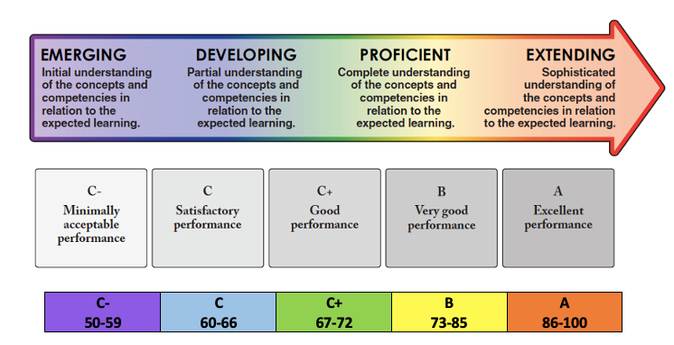

Social Justice Standards

Standard | Includes
- Foundational Skills: understanding that interacting with the world around us requires core skills | - develop research skills, form opinions, and gain understanding from data and evidence (i.e. analyse primary and secondary sources for reliability, bias, validity and point of view)  - demonstrate historical empathy (putting yourself in someone else's shoes) & make ethical judgments about social issues  - explain cause and consequence in relation to social justice issues
- Intersectionality: Understanding the interconnected of Social Justice issues | - apply definitions, frameworks, and interpretations of social justice  - recognize that social justice issues are connected
- Personal Identity and Positionality: Understanding your own identity and how it shapes your view of the world, and recognizing the same in others | - recognize and express how identity shapes personal worldview for both myself and others  - describe the perspective of groups and people other than those you belong to, and recognize why those perspective may different, including historical perspectives
- Social Justice as Transformative Action: Understanding how social justice initiatives can transform individuals, systems, and societies | - recognize continuities and changes different groups experienced over time  - make reasoned ethical judgements about various organizations and approaches addressing issues of social justice and injustice and evaluate their success.

