Social Justice 12: Identity
Part 1: Identity Collage
- Go to canva.com, sign in using the information below, and click on the “poster” option.
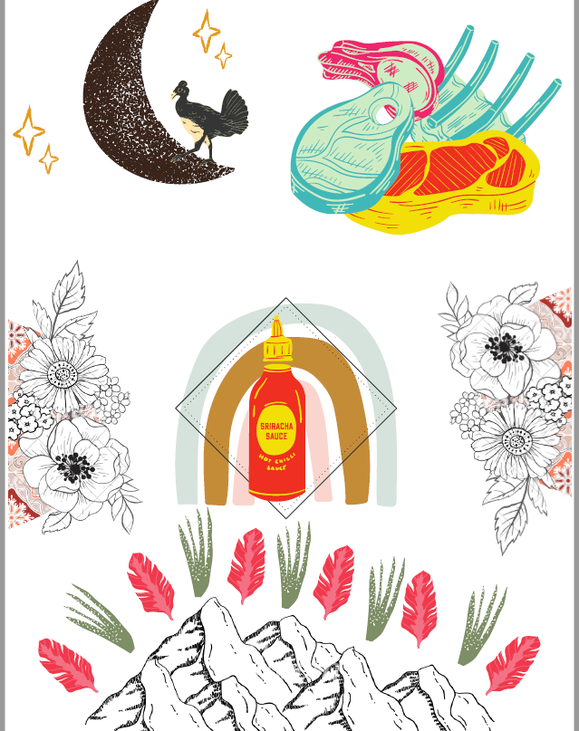
  - Log in:
    - Username: mlawrence
    - Password: STKR2021
- Canva allows you to create a digital collage using art, photos, and uploaded media. Using this website, create a visual image that you feel represents you. You can make this literal (e.g., posting imaged of things you like or people you know), or abstract (use images to artistically represent how you see yourself). Here is my abstract example (I really love siracha and meat so that part isn’t abstract)
- When you are ready to download your image. Click on this icon in my upper right corner: 
- If you used “premium” or “donate” images click “download a free watermarked draft”; if not, you just have to click “Download”
Tips:
- To delete an image, right click on it.
- You can use “premium” or “donate” images but they will have watermarks on them when you download them.
Part 2: Write up
Create a one page write up explaining your image. Include what pictures you included and what they represent. For example, in my image, I could talk about the mountains and my love of solitude and nature. The feathers and aloe represent my mom (who loves travelling and gardening). I chose to include flowers because of their femininity and the represent growth to me, which is something I always try to focus on. The rainbow represents the LGBTQ+ community. The pile of meat represents dad, who I have always referred to as a “steak and potatoes kind of guy” and who thought every meal should always include a hunk of meat. Finally, my favorite image is the bird and the moon, because the moon and stars represent my love of constellations and how they tie the world together, and the bird is me (a weirdo floating around aimlessly in space).

And I seriously love siracha.

When you are finished, email your image and write up to mlawrence@sd57.bc.ca

