Social Justice 12: Three Approaches to Social Issues
In either a writing response of a one-page visual summary, demonstrate your understanding of the following: 1) Definition and examples of social issues, 2) social responsibility, 3) social Service, and 4) social justice.
Written Response
Choose one social issue and explain how each of the three approaches apply in four carefully constructed paragraphs.
If you choose this option, you should have:
- an opening paragraph that explains what a social issue is and introduces the one you chose
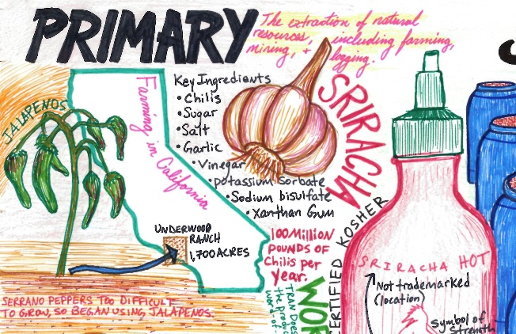
- A paragraph for each other topics (Social Responsibility, Social Service, and Social Justice) that includes the following:
- A definition of the approach
- An example of how it applies to your social issue
- A positive thing about this approach
- A negative thing about this approach
One-Page Visual Summary
Choose one social issue and explain how the three approaches apply to it using visuals and text.
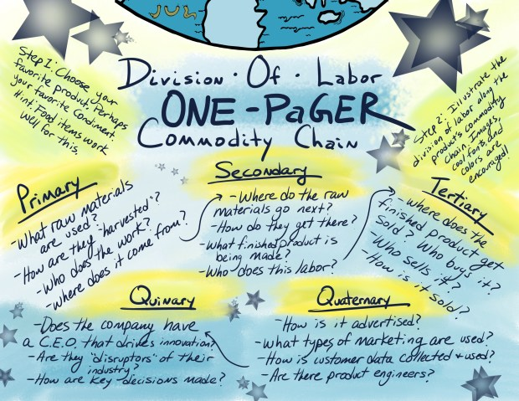
If you choose to do this option, you should use visuals, organizing elements (like subheadings, colour, space), and short text to explain the four topics required for this assignment.
For each topic, you must include:
- A definition of the approach
- An example of how it applies to your social issue
- A positive thing about this approach
- A negative thing about this approach
If you choose this option, you should take care if your work and plan ahead so you have a neat final product.
Learning Standards
This assignment will be assessed on the following learning standards:
2. Intersectionality: Understanding the interconnected of Social Justice issues
4. Social Justice as Transformative Action: Understanding how social justice initiatives can transform individuals, systems, and societies

