Social Identity Notes
Name: ____________________________
Social Identity
An individual’s social identity indicates who they are in terms of the ______________________ to which they belong. Social identity groups are usually defined by some ______________________, ______________________, and mental characteristics of individuals. Examples of social identities are race/ethnicity, gender, social class/socioeconomic status, sexual orientation, (dis)abilities, and religion/religious beliefs.
Race and Ethnicity
Race is a ______________________ ______________________ concept that refers to groups of people who are categorized by ______________________ ______________________ (e.g., skin color/complexion, facial features). Individuals may racially identify with a single race or as bi- or ______________________. It is important to note racial groups are not ______________________ (which means “all the same”) and that the significance and meaning of race varies across individuals within each racial group.
Ethnicity, a related socially-constructed concept often used interchangeably with race, refers to a group of individuals who share characteristics such as ______________________ /heritage, country of origin, ______________________, religion, forms of dress, and food.
Gender and Sex
Gender identity refers to an individual’s ______________________ ______________________ as a man, a woman, a combination of both, or neither and influences how individuals think and act according to their gendered selves
Sex typically refers to ______________________ and is often categorized and male, female, or intersex
______________________ refers to people whose gender identity matches their sex
______________________ refers to people whose gender identity does not match their sex
Socio-Economic Status
Socioeconomic status is a position in a ______________________ ______________________ system determined by an individual’s ______________________, income, and occupation/occupational prestige. A student’s socioeconomic status is usually linked to their parent(s)/guardian(s) level of education, income, and occupational prestige.\

Sexual Orientation
The Human Rights Campaign defines sexual orientation as an “______________________ or immutable enduring emotional, romantic or sexual attraction to other people.” When people think of sexual orientation it is often in relation to the lesbian, gay, bisexual, queer, and other non-heterosexual identities (__________________________________________) community. However, sexual orientation also refers to the attraction between individuals of the opposite sex and/or gender (i.e., heterosexual/straight individuals).
(dis)ability
According to the U.S. Department of Education, a person with a disability has a ______________________ or mental ______________________ that substantially ______________________ one or more major life activities of that person; has a record of such an impairment; or is regarded as having such an impairment.
Disability can refer to physical, mental, learning, or ______________________ limitations
If you do not have a disability you’re “______________________” (physical) or ______________________ (mental)
Religion
Religious identity is one’s sense of group membership and attachment to a religion and the ______________________ of this membership to one’s self-concept
Certain religious beliefs may include wearing certain items of clothing or having certain routines/traditions/ceremonies
Other social identities
- Age (young, middle aged, elderly)
- Relationship to land (Indigenous, settler)
- Citizenship status
- Language
- Marital status
- Body size
The social groups people belong to influence how other people see them and how they are treated by society at large. Much of this treatment is based in stereotypes and prejudice.
For example, if we think about someone who believes Indigenous people, how could that impact the way he treats Indigenous people?

On a Plate by Toby Morris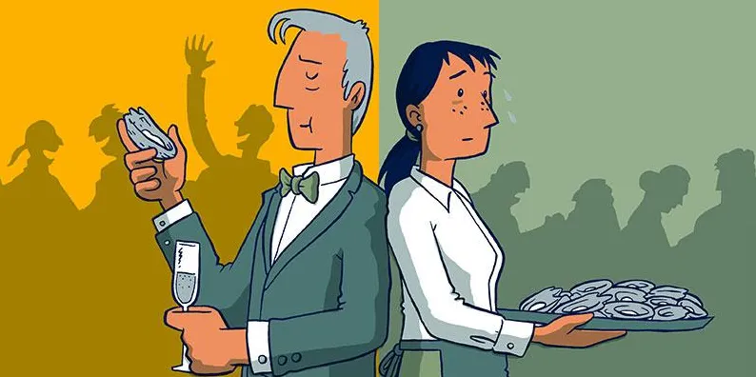
https://www.rnz.co.nz/news/the-wireless/373065/the-pencilsword-on-a-plate
Richard | Paula
Privilege
- A special right, advantage or immunity granted only to a particular person or group
- Privilege can be earned, or unearned
- Privilege is often invisible (or hard to see) for those who have it
  - A fish does not always notice all the time that it is in water
  - We humans often times don’t notice that we are in air
What privilege is not…
- An “on/off” switch: nobody is completely privileged and nobody isn’t privileged at all.
- Everyone will have different areas in their life where they have privilege and where they don’t. For example, we live in Canada, and that’s a privilege. However, most of our parents have to work for a living.
- Something that makes you a bad person. Very few people can control what privileges they have.
- Something that means you have never struggled or have had everything come easy for you. Everyone works hard in their lives.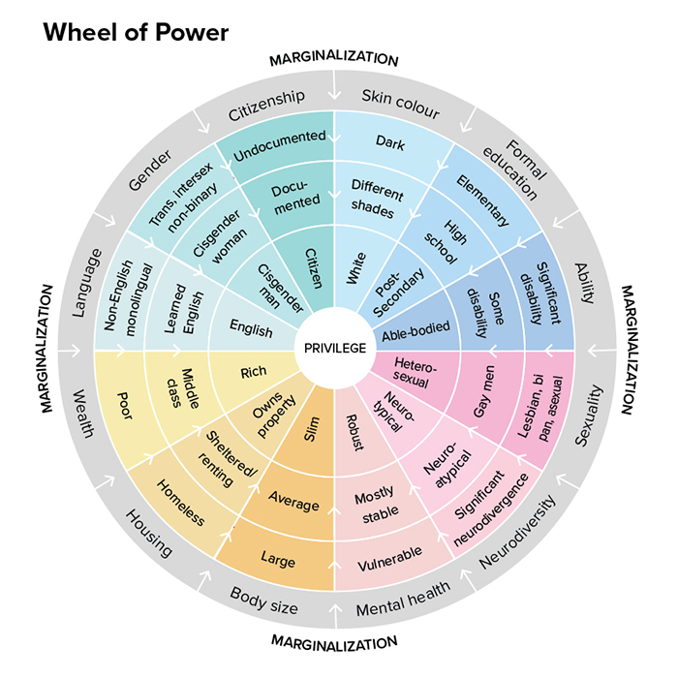
For each of the following situations, think about how the two people’s opinions may differ on the issue and why.
Issue 2: Police Brutality against BIPOC people
Person 1: A young Black man in Toronto
Person 2: A middle aged white woman in Kelowna

Issue 3: Access to reproductive healthcare
Person 1: A cisgender 25 year old woman
Person 2: a elderly cisgender man

Issue 4: Support for students with learning disabilities in public school
Person 1: The parent of a student diagnosed with dyslexia; struggles with reading
Person 2: The parent of a student who reads one grade about her grade level

Issue 5: Mills shutting down in northern BC
Person 1: A lawyer in Kamloops
Perosn 2: A teacher in Mackenzie

Issue 6: Inclusive sexual health education
Person 1: An gay student whose parents are unsupportive of their relationship
Person 2: A straight student whose mother is a nurse

Ticket out the door (rip this page off and hand it in please – don’t forget your name!)
Name: ___________________________________________
What I’m looking for: Can you recognize how social position and social privileges influence thoughts and feelings about the world?
Thinking back to Richard and Paula and their experiences growing up, how may their views differ when it comes to using tax money to help those living in poverty? Remember to explain your thinking!

