Name: ____________________ Date: __________________

8 Stages of Genocide
By Gregory H. Stanton
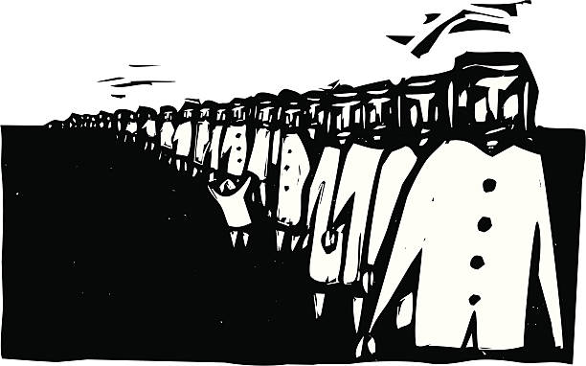
Gregory H. Stanton is the James Farmer Professor of Human Rights, The University of Mary Washington, Fredericksburg, Virginia; President, Genocide Watch; Chairman, The International Campaign to End Genocide; Director, The Cambodian Genocide Project; Vice President, International Association of Genocide Scholars.
Definition:
"In the present Convention, genocide means any of the following acts committed with intent to destroy, in whole or in part, a national, ethnical, racial or religious group, as such:

(a) Killing members of the group;
(b) Causing serious bodily or mental harm to members of the group;
(c) Deliberately inflicting on the group conditions of life calculated to bring about its physical destruction in whole or in part;
(d) Imposing measures intended to prevent births within the group;
(e) Forcibly transferring children of the group to another group."

Intent:
Intent can be directly proven from statements or orders by the perpetrators. But more often, it must be deduced from the systematic pattern of their acts, a pattern that could only arise out of specific intent.

Criminal law distinguishes intent from motive. A murderer may have many motives - gaining property or eliminating a rival for power. But his intent is determined by the purpose of his act: Did he purposely kill the victim? Genocidal intent is determined by the specific purpose of the act: Did the killer purposely kill the victim as part of a plan to destroy a national, ethnic, racial, or religious group, at least in part?

The motive of the killer to take the victim's property or to politically dominate the victim's group does not remove genocidal intent if the victim is chosen because of his ethnic, national, racial, or religious group.

A plan for genocide doesn’t need to be written out. An act of genocide may arise in a culture that considers members of another group less than human, where killing members of that group is not considered murder. This is the culture of impunity characteristic of genocidal societies. In Burundi, Tutsis who kill Hutus have seldom been convicted or even arrested. Massacres are ethnic, intended to destroy parts of the other ethnic group.

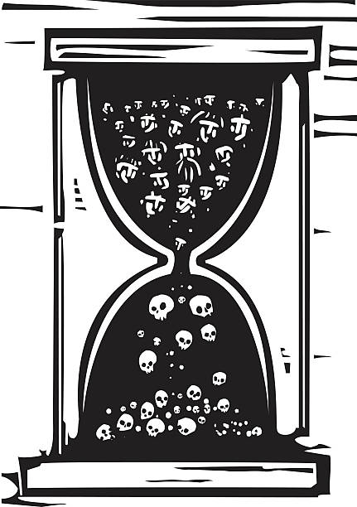
Leo Kuper calls such mass killings genocidal massacres. They are acts of genocide even if only a part of a group (the intellectuals, officers, leaders) is targeted.

Process:
Prevention of genocide requires a structural understanding of the genocidal process. Genocide has eight stages or operational processes. The first stages precede later stages but continue to operate throughout the genocidal process. Each stage reinforces the others. A strategy to prevent genocide should attack each stage, each process. The eight stages of genocide are classification, symbolization, dehumanization, organization, polarization, preparation, extermination, and denial.
- Classification:
All languages and cultures require classification - division of the natural and social world into categories. We distinguish and classify objects and people. All cultures have categories to distinguish between “us” and “them,” between members of our group and others. We treat different categories of people differently. Racial and ethnic classifications may be defined by absurdly detailed laws -- the Nazi Nuremberg laws, the "one drop" laws of segregation in America, or apartheid racial classification laws in South Africa. Racist societies often prohibit mixed categories and outlaw miscegenation. Bipolar societies are the most likely to have genocide. In Rwanda and Burundi, children are the ethnicity of their father, either Tutsi or Hutu. No one is mixed. Mixed marriages do not result in mixed children.
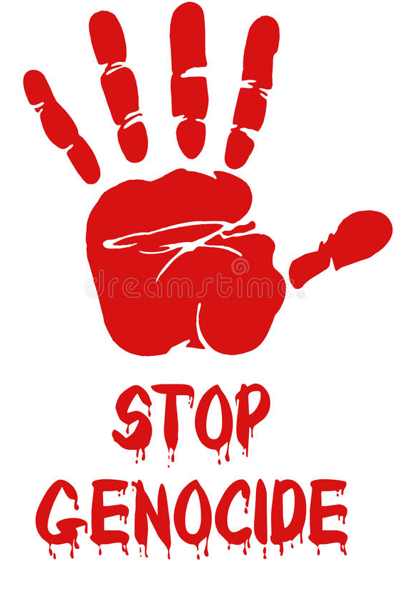
- Symbolization:
We use symbols to name and signify our classifications. We name some people Hutu and others Tutsi, or Jewish or Gypsy, or Christian or Muslim. Sometimes physical characteristics - skin color or nose shape - become symbols for classifications. Other symbols, like customary dress or facial scars, are socially imposed by groups on their own members. After the process has reached later stages (dehumanization, organization, and polarization) genocidal governments in the preparation stage often require members of a targeted group to wear an identifying symbol or distinctive clothing -- e.g. the yellow star. The Khmer Rouge forced people from the Eastern Zone to wear a blue-checked scarf, marking them for forced relocation and elimination.

- Dehumanization:
Classification and symbolization are fundamental operations in all cultures. They become steps of genocide only when combined with dehumanization. Denial of the humanity of others is the step that permits killing with impunity. The universal human abhorrence of murder of members of one's own group is overcome by treating the victims as less than human. In incitements to genocide the target groups are called disgusting animal names - Nazi propaganda called Jews "rats" or "vermin"; Rwandan Hutu hate radio referred to Tutsis as "cockroaches." The targeted group is often likened to a “disease”, “microbes”, “infections” or a “cancer” in the body politic. Bodies of genocide victims are often mutilated to express this denial of humanity. Such atrocities then become the justification for revenge killings, because they are evidence that the killers must be monsters, not human beings themselves.

- Organization:
Genocide is always collective because it derives its impetus from group identification. It is always organized, often by states but also by militias and hate groups. Planning need not be elaborate: Hindu mobs may hunt down Sikhs or Muslims, led by local leaders. Methods of killing need not be complex: Tutsis in Rwanda died from machetes; Muslim Chasm in Cambodia from hoe-blades to the back of the neck ("Bullets must not be wasted," was the rule at Cambodian extermination prisons, expressing the dehumanization of the victims.) The social organization of genocide varies by culture. It reached its most mechanized, bureaucratic form in the Nazi death camps. But it is always organized, whether by the Nazi SS or the Rwandan Interahamwe. Death squads may be trained for mass murder, as in Rwanda, and then force everyone to participate, spreading hysteria and overcoming individual resistance. Terrorist groups will pose one of the greatest threats of genocidal mass murder in the future as they gain access to chemical, biological, and even nuclear weapons.

- Polarization:
Genocide proceeds in a downward cycle of killings until, like a whirlpool, it reaches the vortex of mass murder. Killings by one group may provoke revenge killings by the other. Such massacres are aimed at polarization, the systematic elimination of moderates who would slow the cycle. The first to be killed in a genocide are moderates from the killing group who oppose the extremists: the Hutu Supreme Court Chief Justice and Prime Minister in Rwanda, the Tutsi Archbishop in Burundi. Extremists target moderate leaders and their families. The center cannot hold. The most extreme take over, polarizing the conflict until negotiated settlement is impossible.

- Preparation:
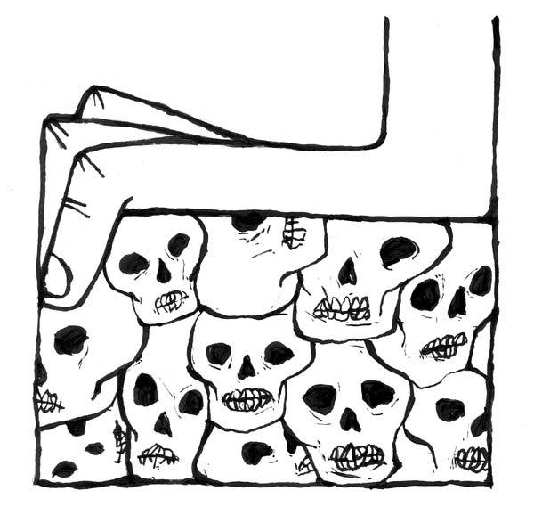
Preparation for genocide includes identification. Lists of victims are drawn up. Houses are marked. Maps are made. Individuals are forced to carry ID cards identifying their ethnic or religious group. Identification greatly speeds the slaughter. In Germany, the identification of Jews, defined by law, was performed by a methodical bureaucracy. In Rwanda, identity cards showed each person's ethnicity. In the genocide, Tutsis could then be easily pulled from cars at roadblocks and murdered. Throwing away the cards did not help, because anyone who could not prove he was Hutu, was presumed to be Tutsi. Hutu militiamen conducted crude mouth exams to test claims of Hutu identity.

Preparation also includes expropriation of the property of the victims. It may include concentration: herding of the victims into ghettos, stadiums, or churches. In its most extreme form, it even includes construction of extermination camps, as in Nazi-ruled Europe, or conversion of existing buildings – temples and schools – into extermination centers in Cambodia. Transportation of the victims to these killing centers is then organized and bureaucratized.

- Extermination:
The seventh step, the final solution, is extermination. It is considered extermination, rather than murder, because the victims are not considered human. They are vermin, rats or cockroaches. Killing is described by euphemisms of purification: “ethnic cleansing” in Bosnia, “ratonade” (ratextermination) in Algeria. Targeted members of alien groups are killed, often including children. Because they are not considered persons, their bodies are mutilated, buried in mass graves or burnt like garbage.

- Denial:
Every genocide is followed by denial. The mass graves are dug up and hidden. The historical records are burned or closed to historians. Even during the genocide, those committing the crimes dismiss reports as propaganda. Afterwards such deniers are called “revisionists.” Others deny through more subtle means: by characterizing the reports as “unconfirmed” or “alleged” because they do not come from officially approved sources; by minimizing the number killed; by quarreling about whether the killing fits the legal definition of genocide (“definitionalism”); by claiming that the deaths of the perpetrating group exceeded that of the victim group, or that the deaths were the result of civil war, not genocide. In fact, civil war and genocide are not mutually exclusive. Most genocides occur during wars.

