Women in Media

Data and Stats

Representation in Film
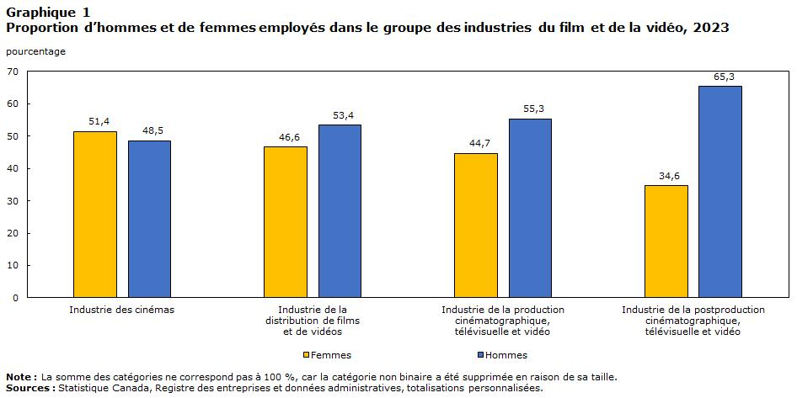
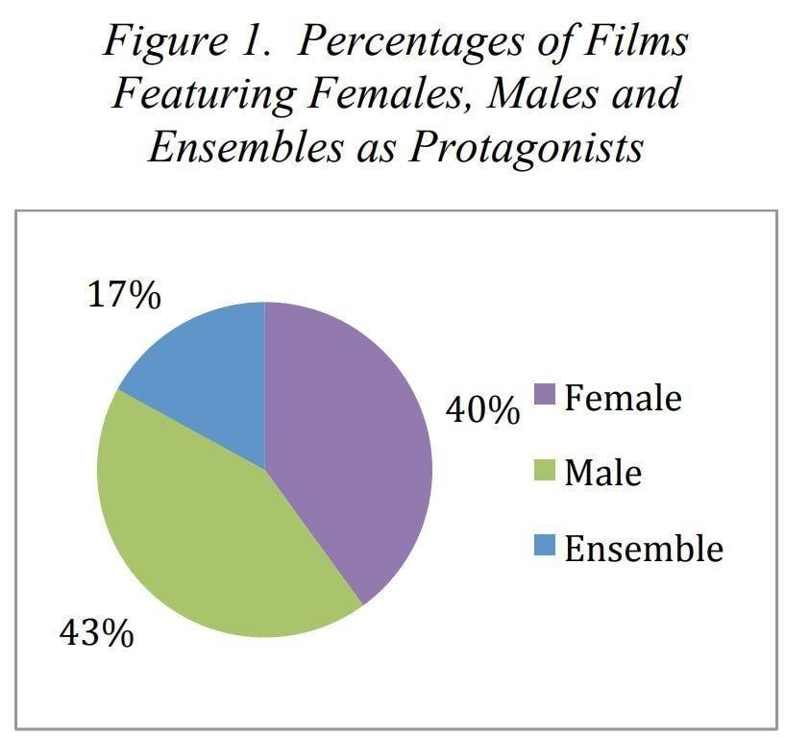
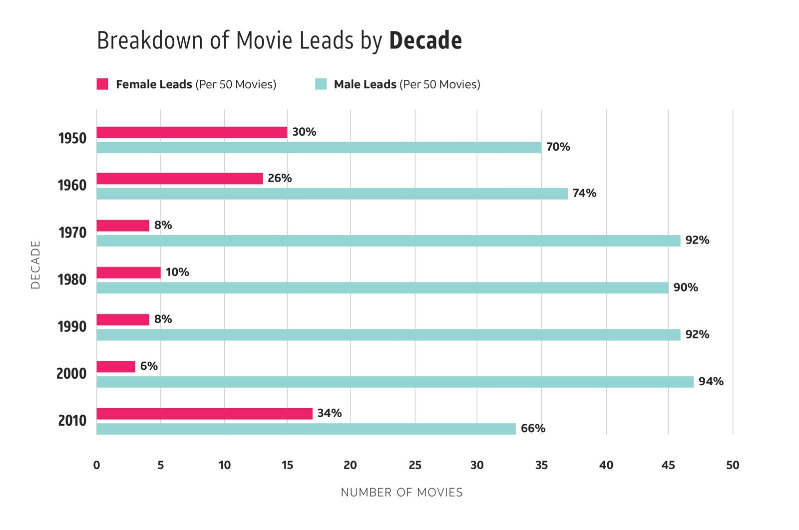
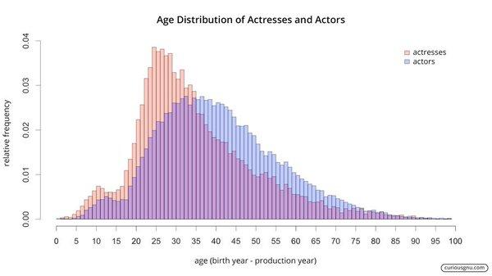
- Women are ~37% of major characters in top films (2023)
- Only ~34% of speaking characters are women
- Just ~12% of films have gender-balanced casts
- Male characters get more screen time and dialogue overall
- Women are more likely to be portrayed as parents or romantic partners, while men are more often shown as leaders or professionals
- Women aged 40+ make up a very small share of roles, while men continue to be cast across age groups

Behind the Camera (Power & Control)
- Only ~16–18% of directors of top films are women
- Women of colour make up less than 5% of directors
- Films with at least one woman director have significantly higher female representation on screen
- Women are underrepresented in cinematography (under 10%), one of the most influential roles visually

TV & Streaming (Where Change Is Happening)
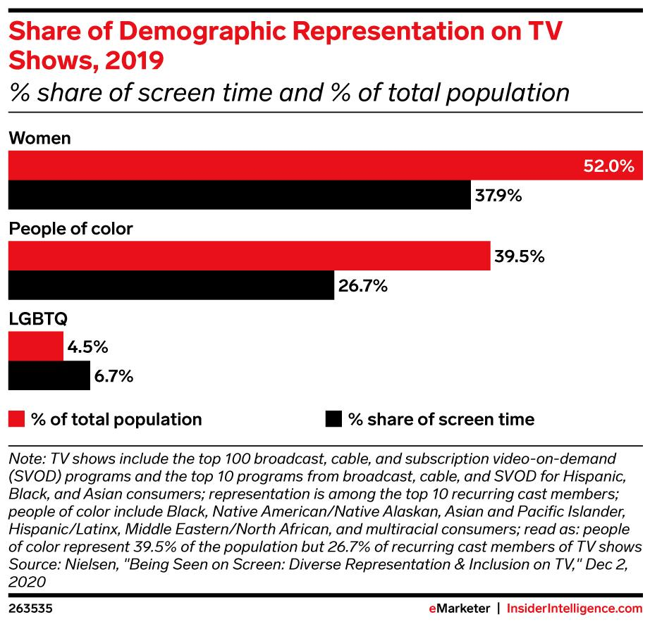
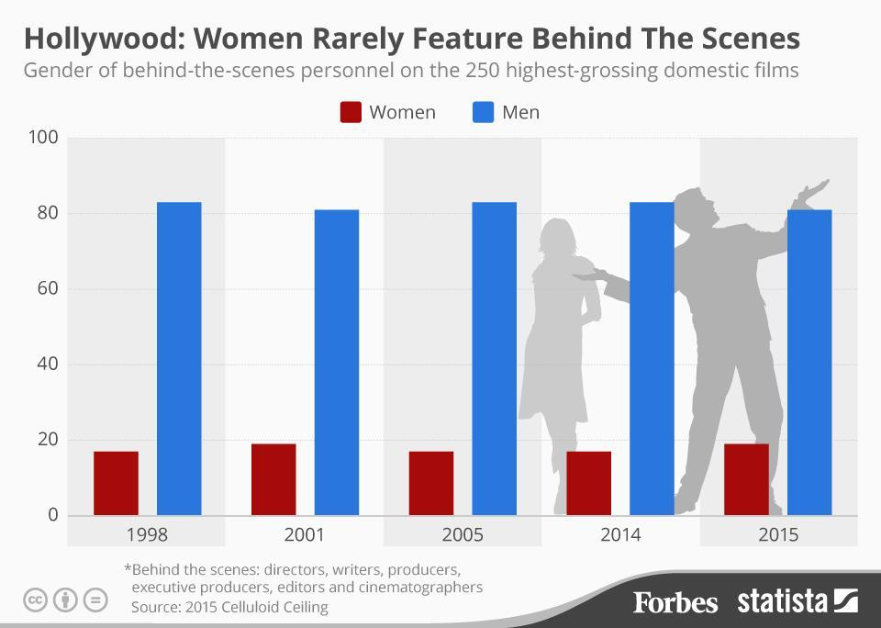
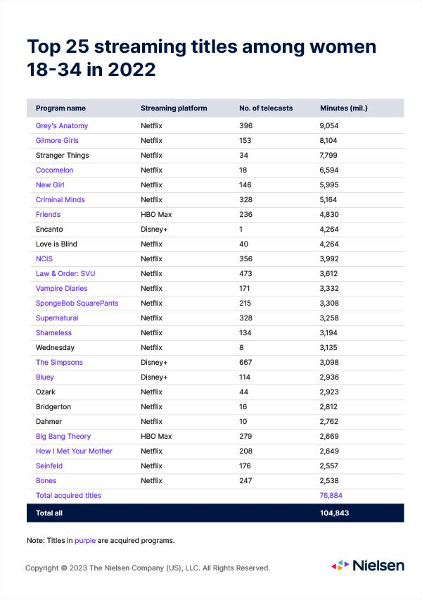
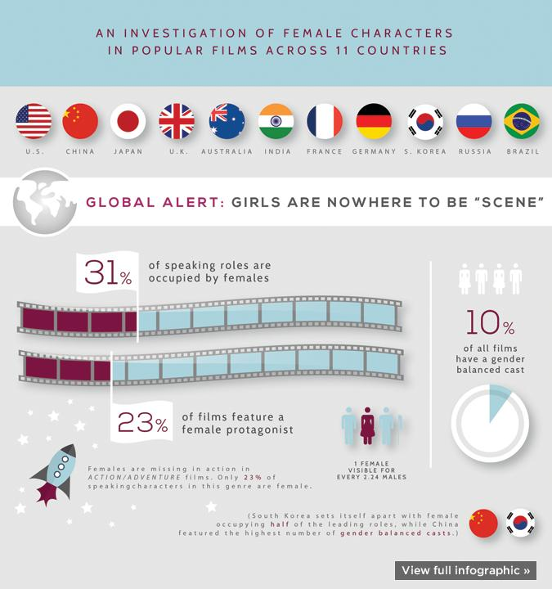
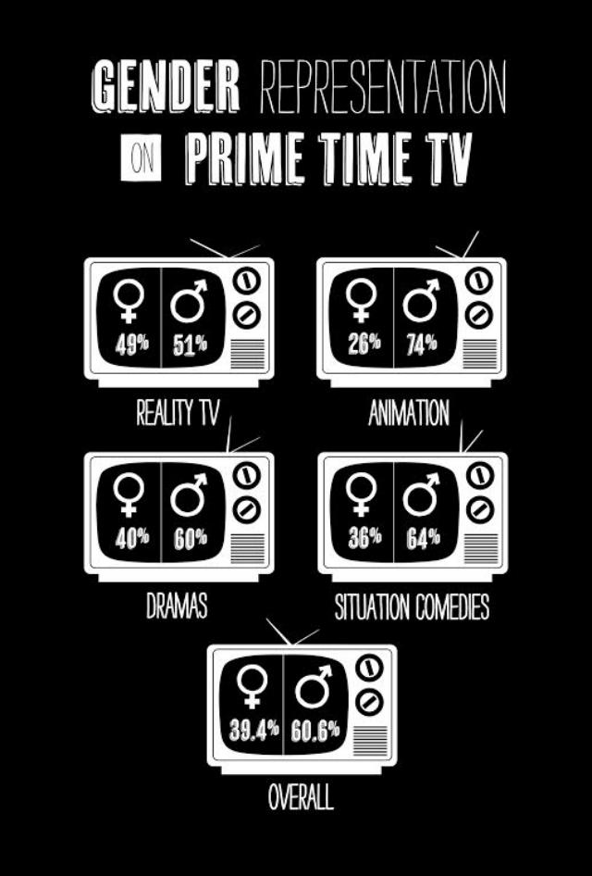
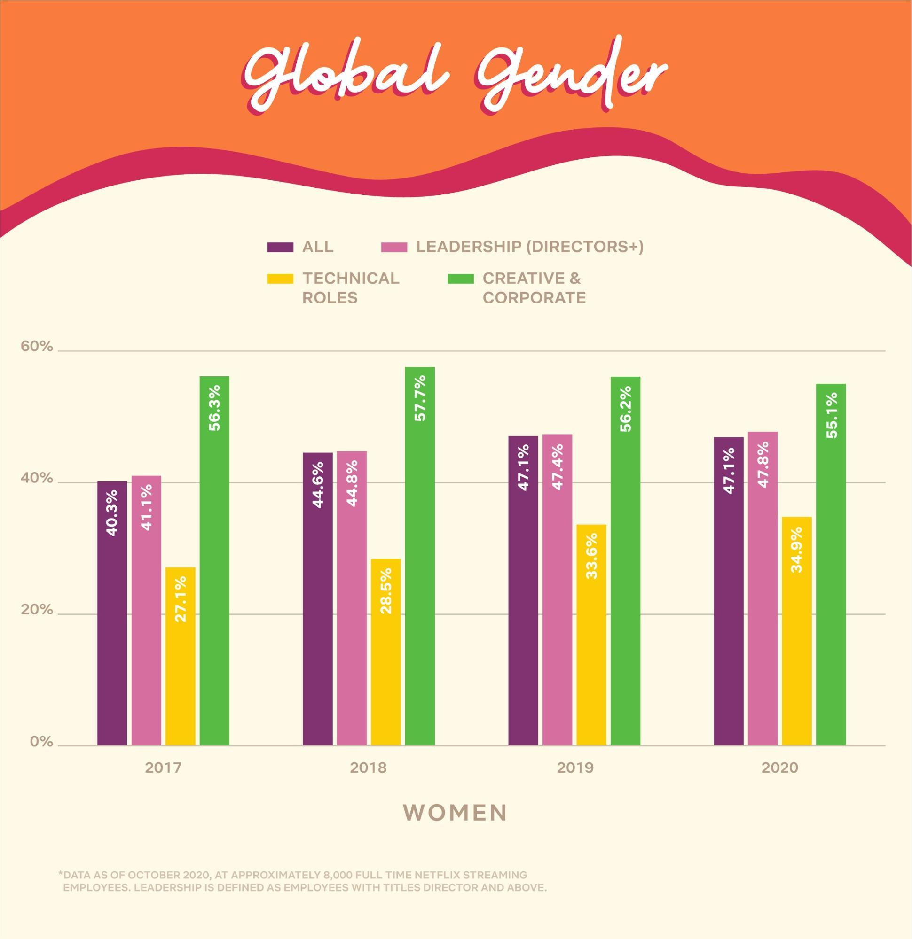
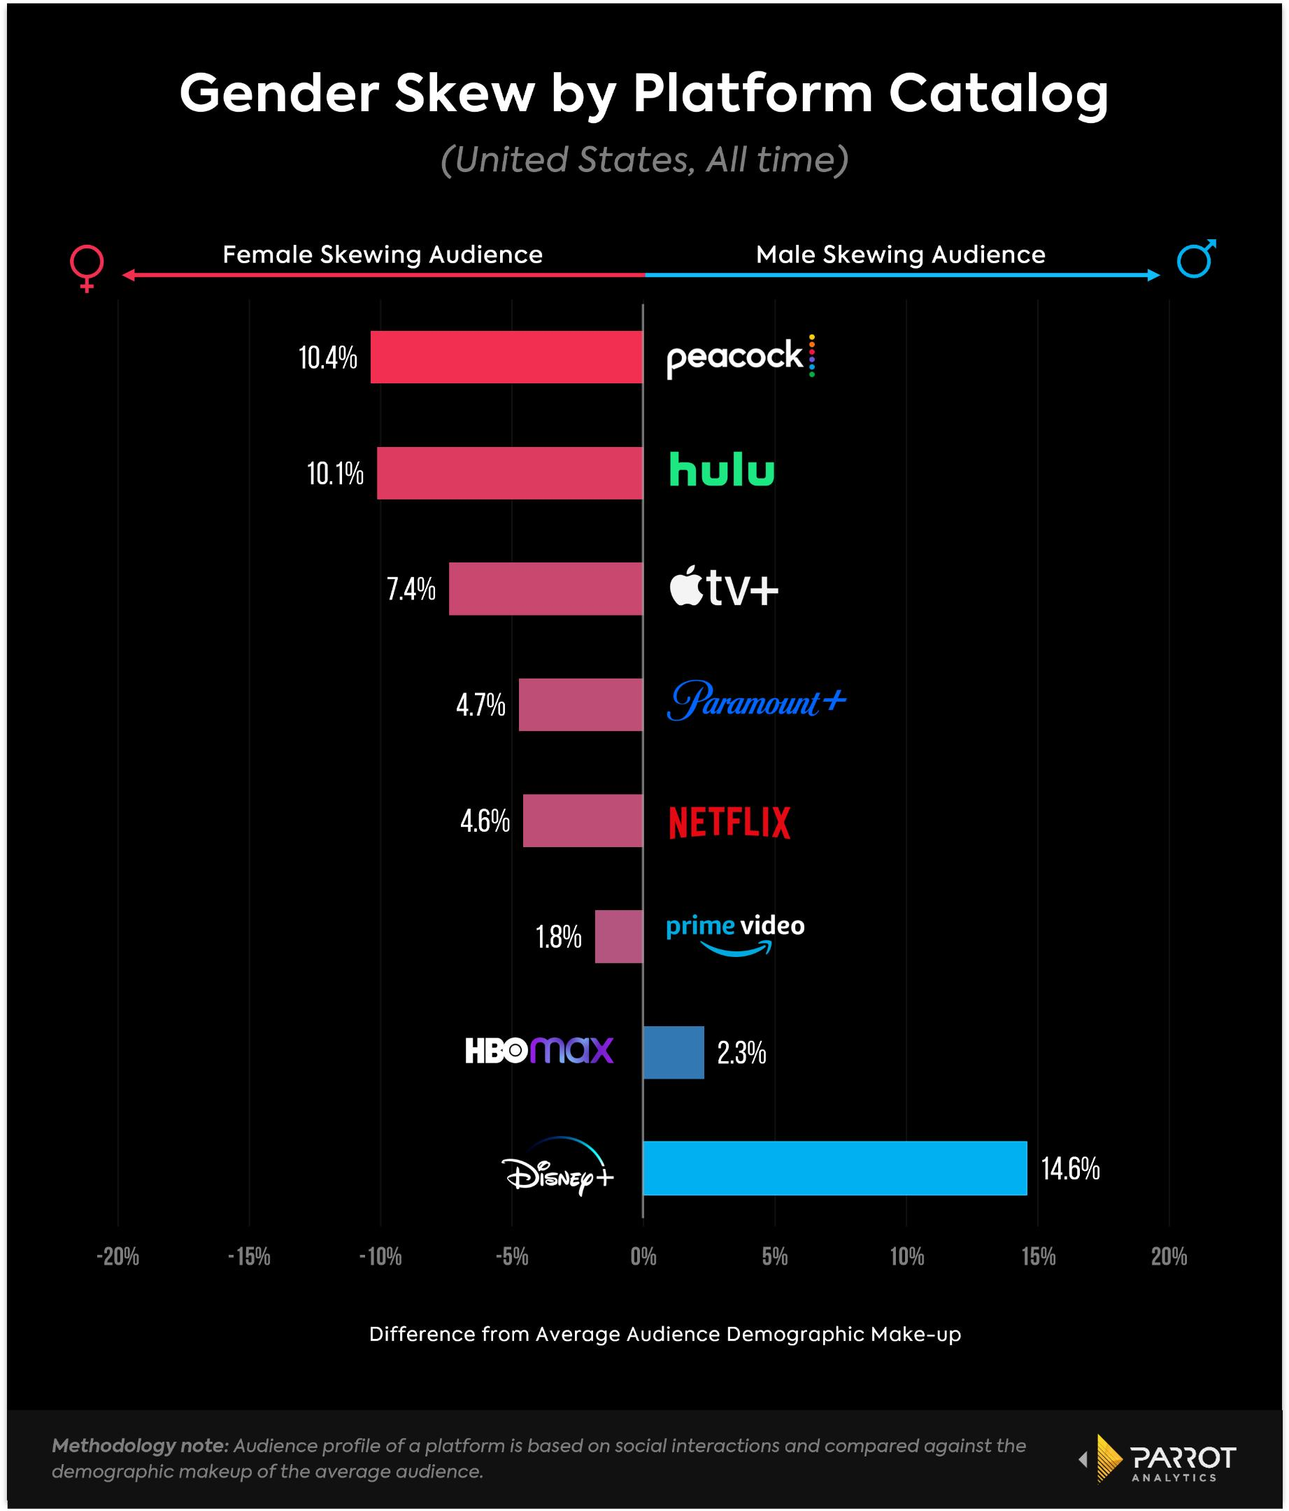
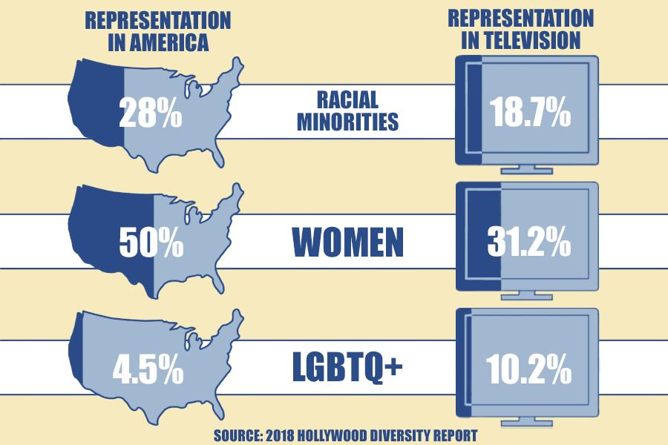
- Women make up ~45% of major characters on TV, closer to parity than film
- Streaming platforms have more female-led shows than traditional film studios
- Around 30–35% of showrunners are women
- Shows created by women tend to include more diverse female characters

Social Media & Digital Culture

This graph shows the percent of Boys and Girls who see themselves as being “too thin,” “too fat,” or “about right”
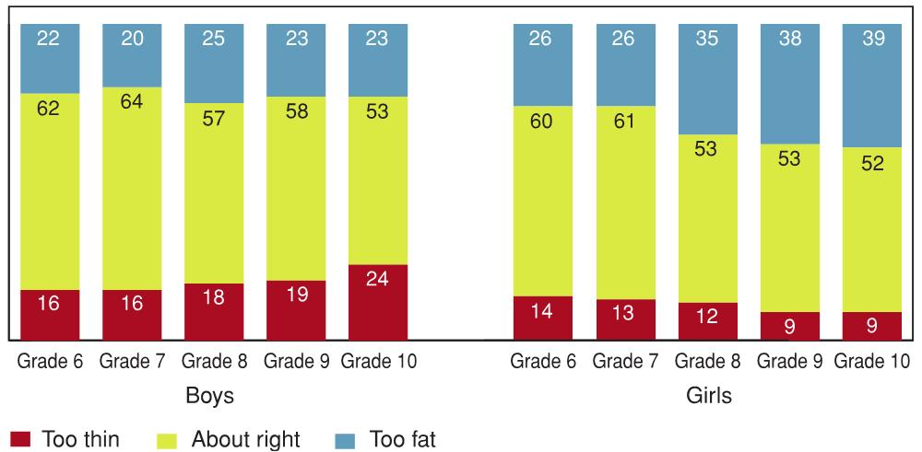
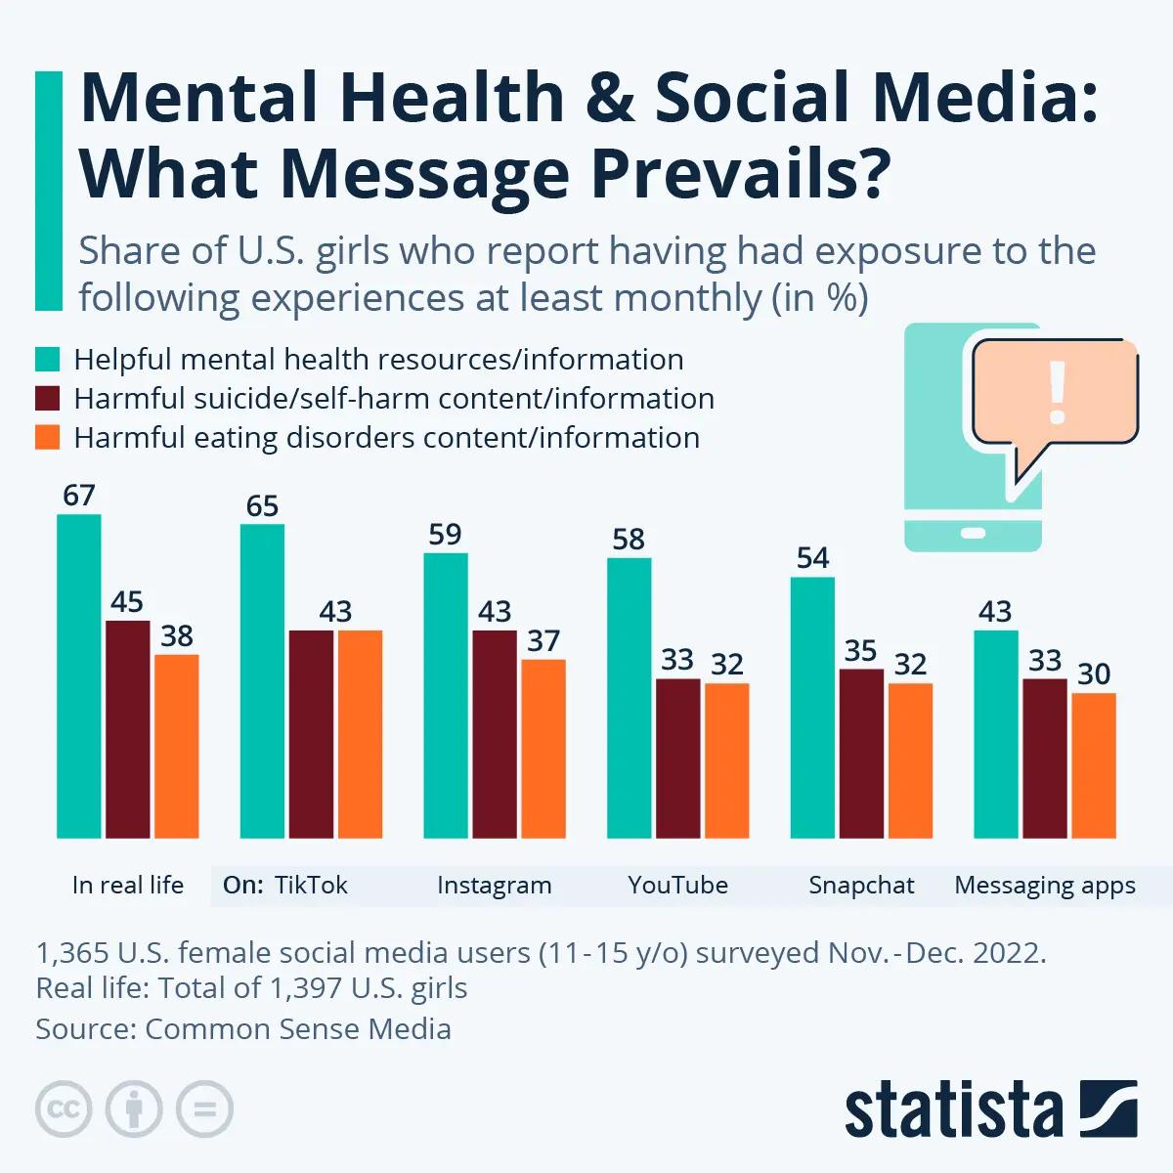
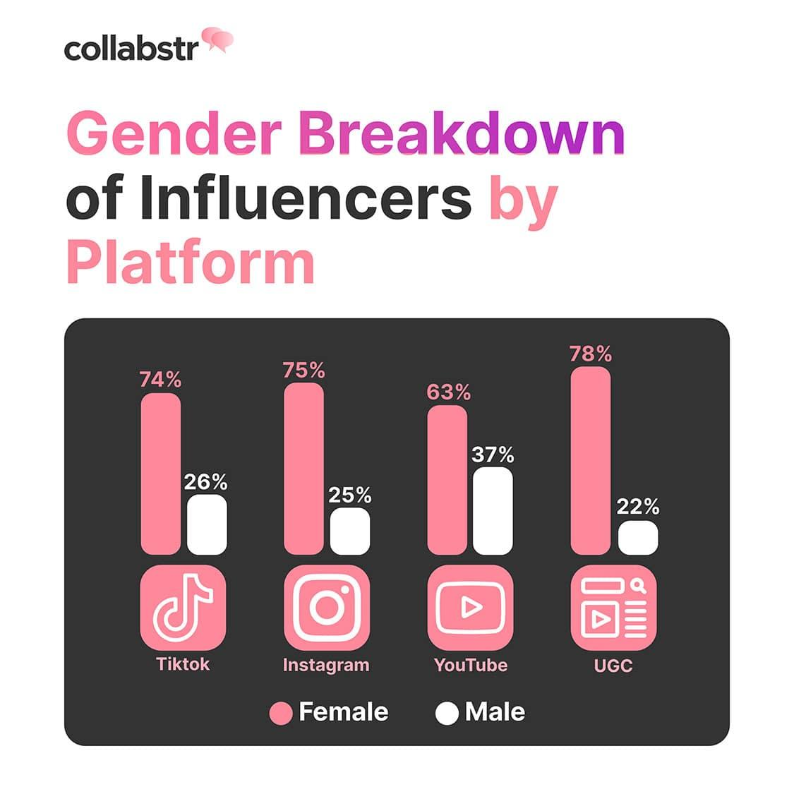
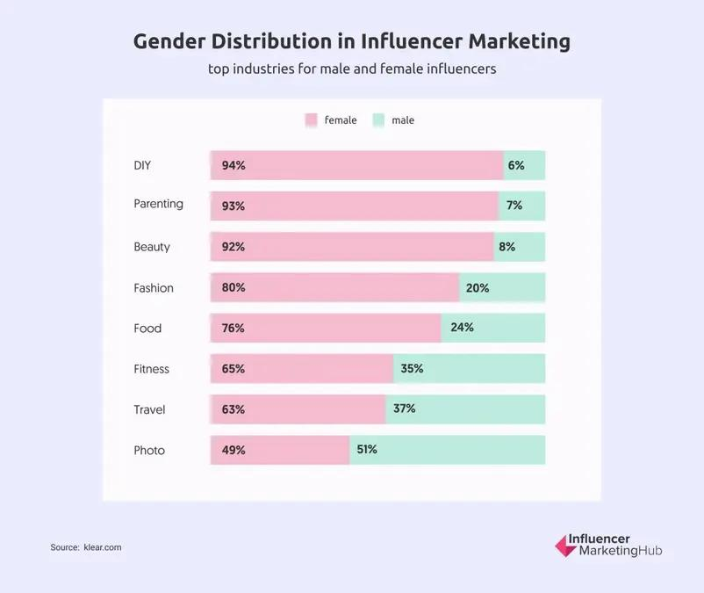
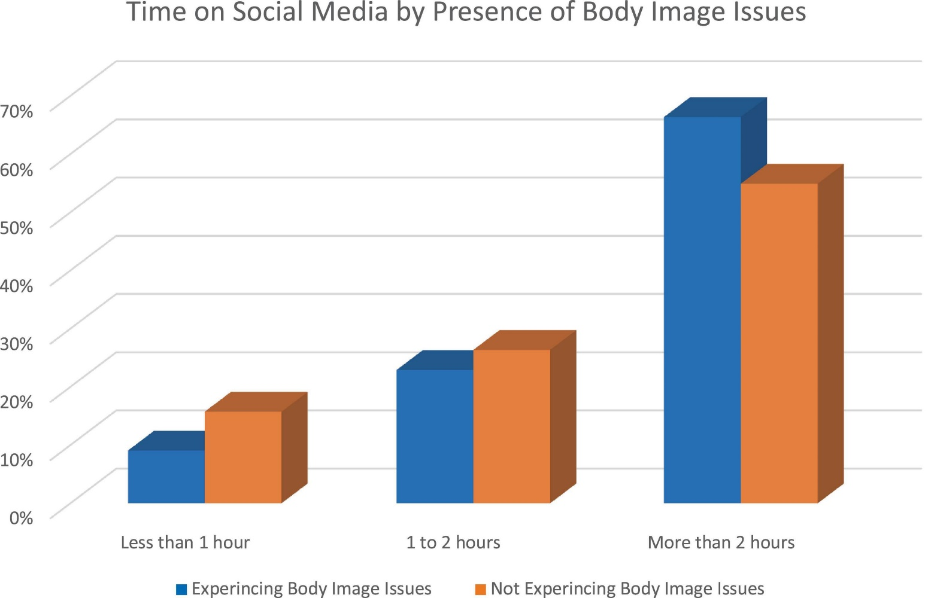
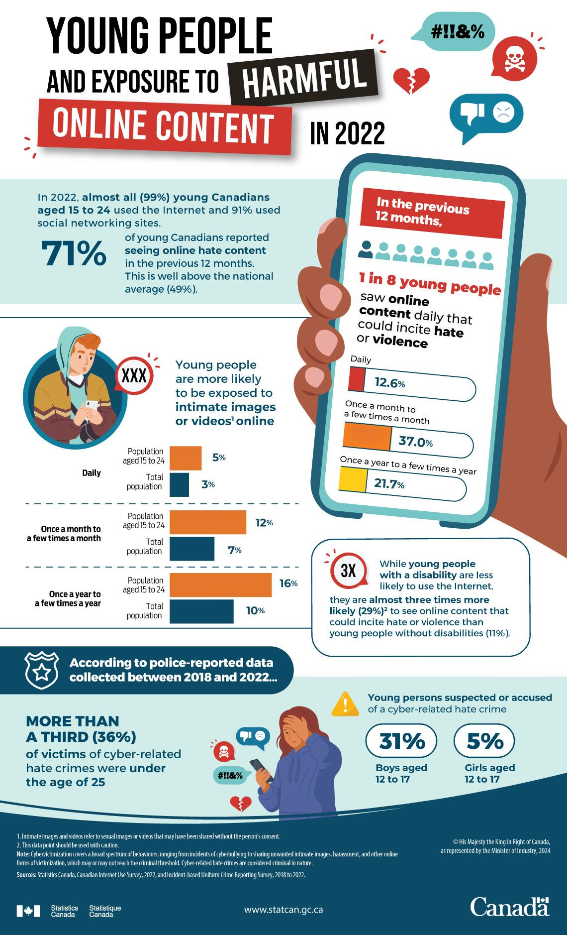
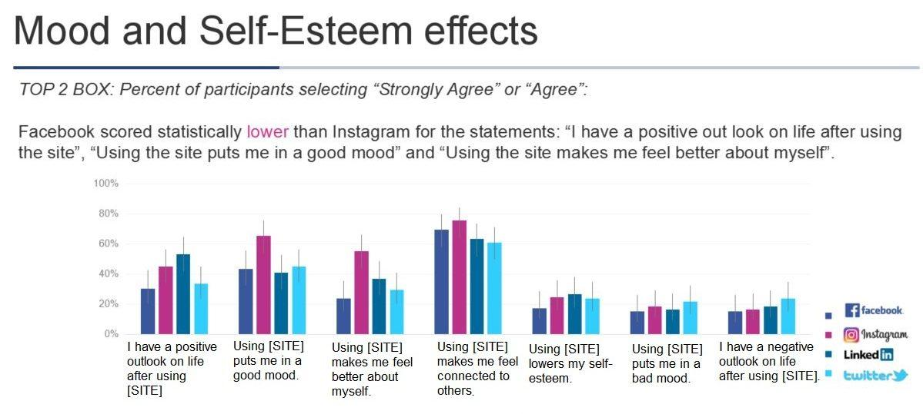
- Teen girls are more likely than boys to use visual platforms (TikTok, Instagram)
- 1 in 3 girls say social media makes them feel worse about their body
- Filters and editing tools create unrealistic beauty standards
- Influencer marketing is dominated by female creators, but content often reinforces beauty, fashion, and lifestyle roles
- Girls are more likely to experience appearance-based pressure online

Stereotypes & Sexualization
- Women are 3x more likely than men to be sexualized in media
- Female characters are more likely to be shown partially nude or in revealing clothing
- Men are more likely to be shown in positions of power (leaders, experts, decision-makers)
- Women are more likely to be portrayed as emotional, dependent, or focused on relationships
- Ads still disproportionately portray women in domestic roles (cleaning, caregiving)

News & Politics
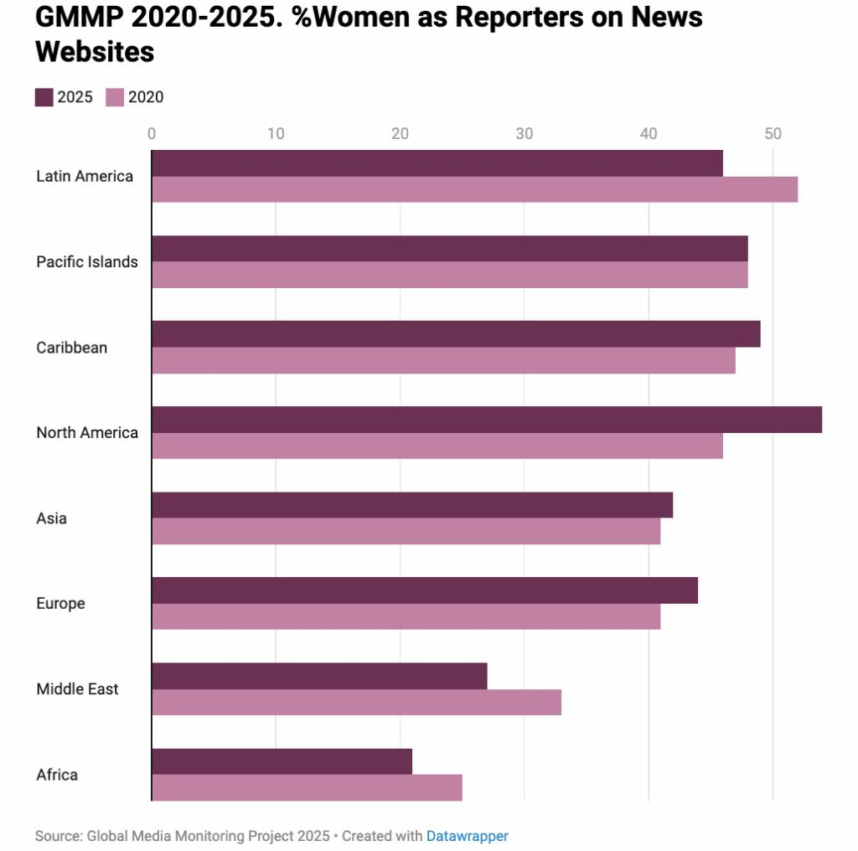
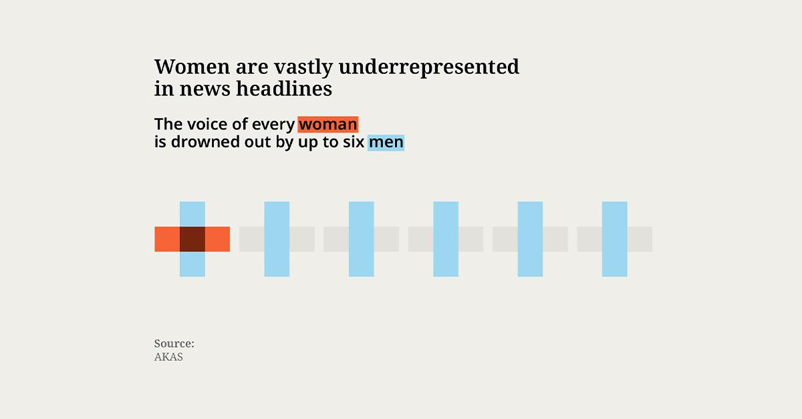
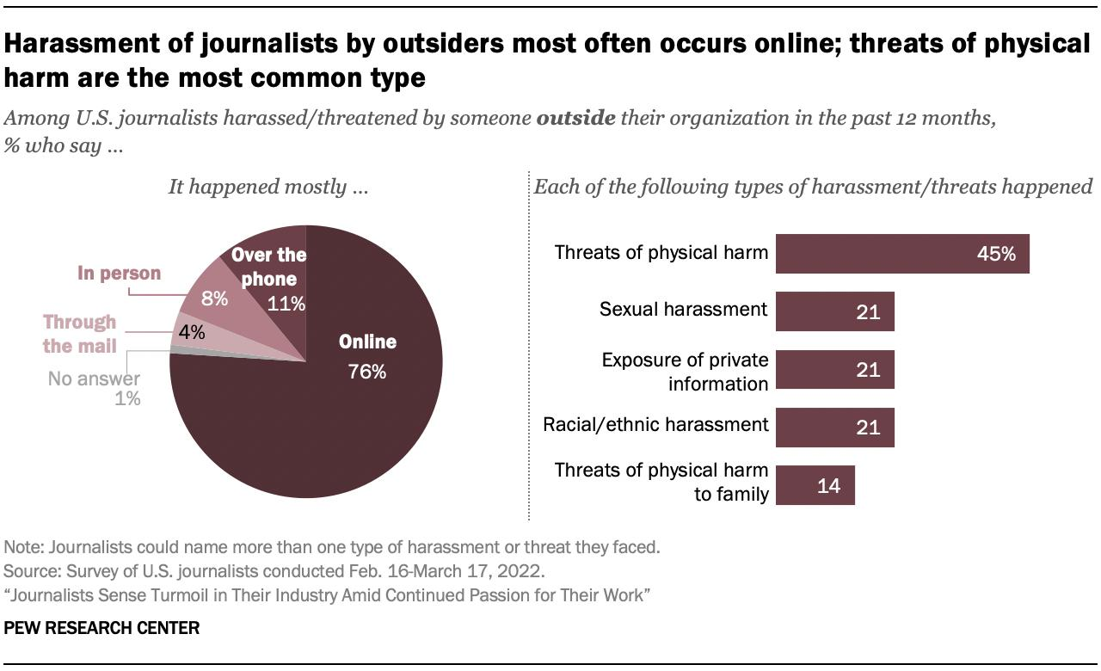
- Women are only ~26% of people featured in news stories globally
- Female politicians receive more focus on appearance, family, and personality
- Women journalists are significantly more likely to face online abuse and threats
- Men are more often framed as experts, while women are framed as individual stories

Workplace & Economic Representation in Media
- Women are underrepresented in portrayals of STEM careers
- Men are more likely to be shown as CEOs, scientists, or leaders
- Women characters are more often shown in lower-status or unpaid roles
- Media representation influences career aspirations, especially for young viewers

Intersectionality
- Women of colour are significantly underrepresented compared to white women
- LGBTQ+ women are still rarely represented, though increasing
- When included, marginalized women are more likely to be stereotyped

Clear Signs of Change
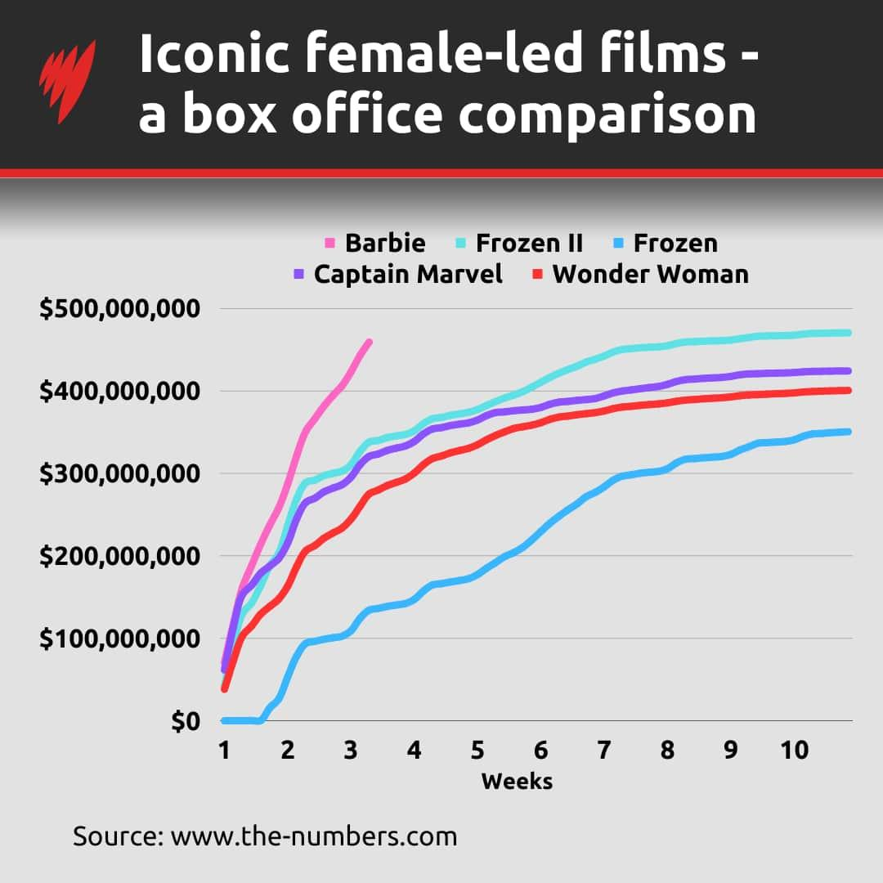
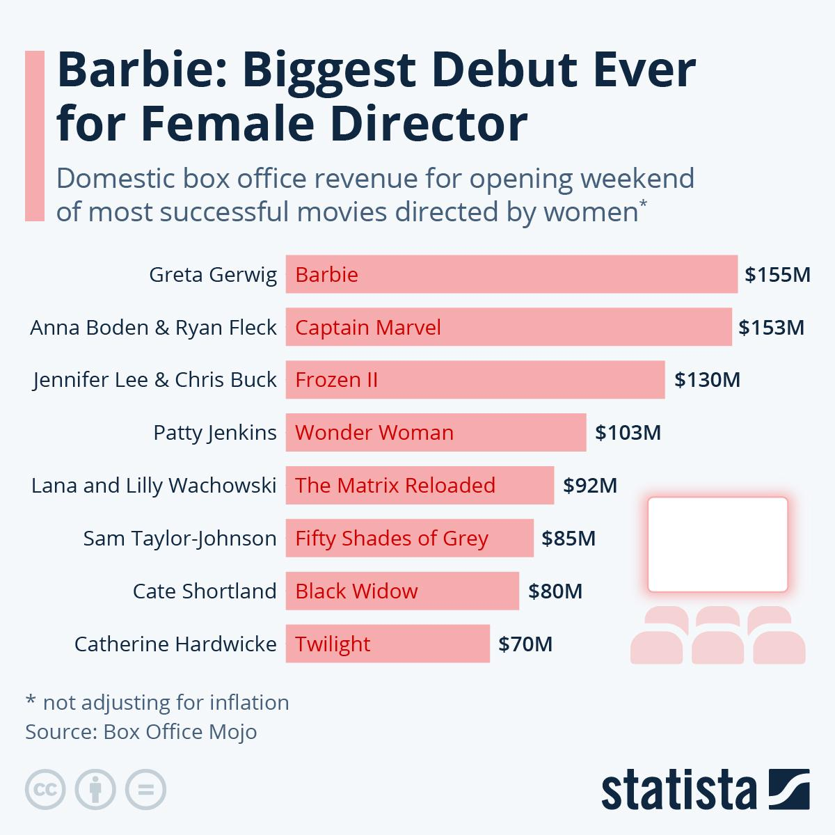
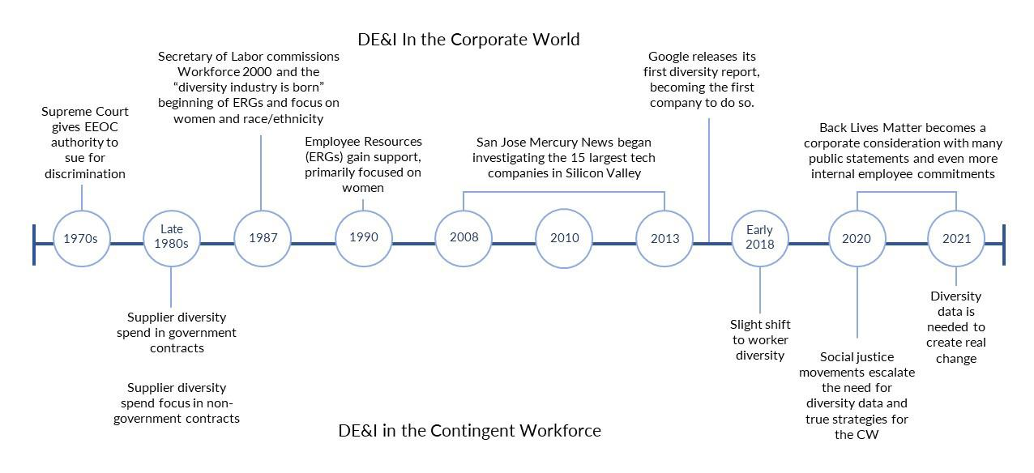
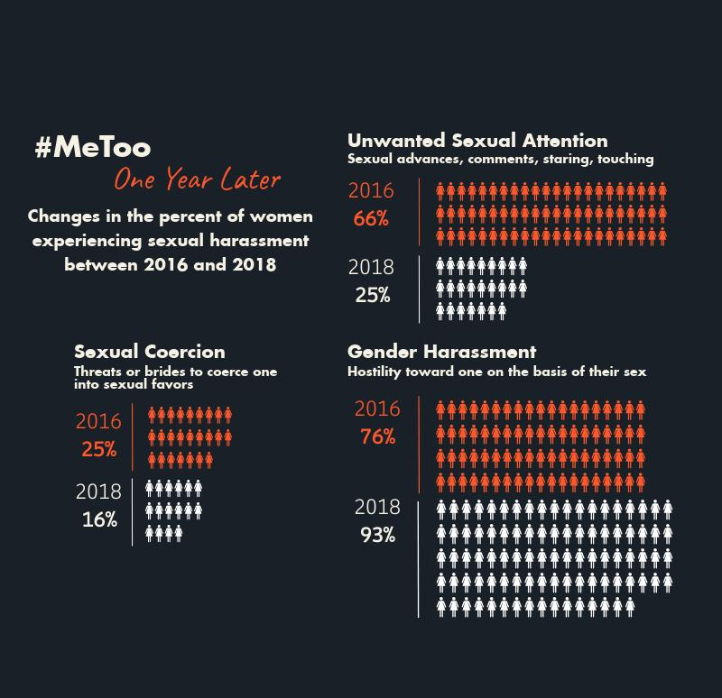
- Female-led films like Wonder Woman, Barbie, and others have had major box office success
- The #MeToo movement led to greater awareness of sexism in media industries
- More demand for diverse and realistic female characters
- Audiences increasingly support women-centered stories

