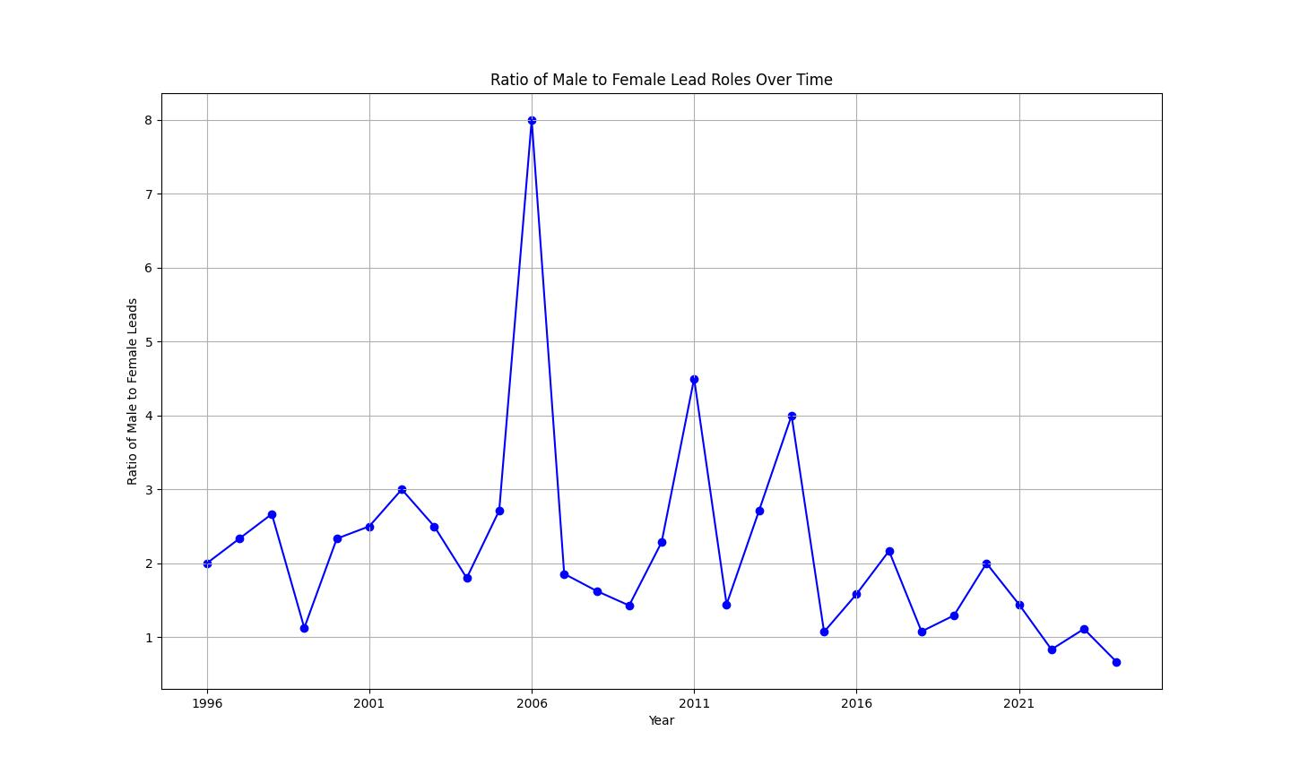
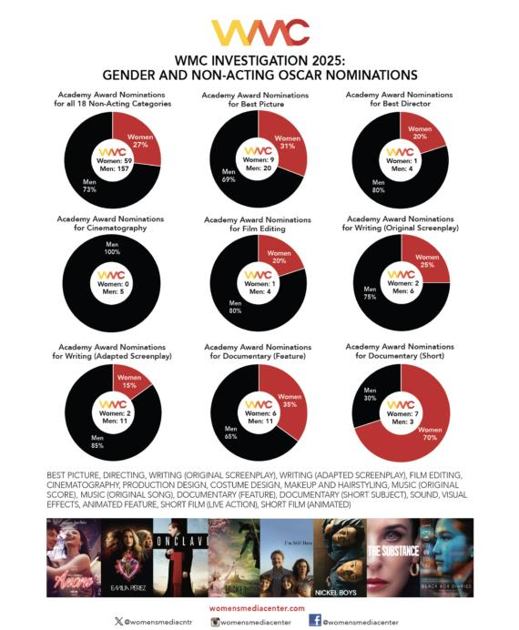
- Women were 42% of leads in top films in 2024 (first time reaching parity with men) (firstcoastnews.com)
- In 2025, that dropped sharply to 29% of films with female protagonists (Forbes)
- Women are still only ~36% of major characters (2025) (womenintvfilm.sdsu.edu)
- Speaking roles for women sit around 38% (womenintvfilm.sdsu.edu)

Types of Representation (Recent Detail)
- Only ~35% of film leads are women overall (Geena Davis Institute)
- Female characters are ~5x more likely to be objectified than male characters (Geena Davis Institute)
- Women are 3x more likely to wear revealing clothing (Geena Davis Institute)
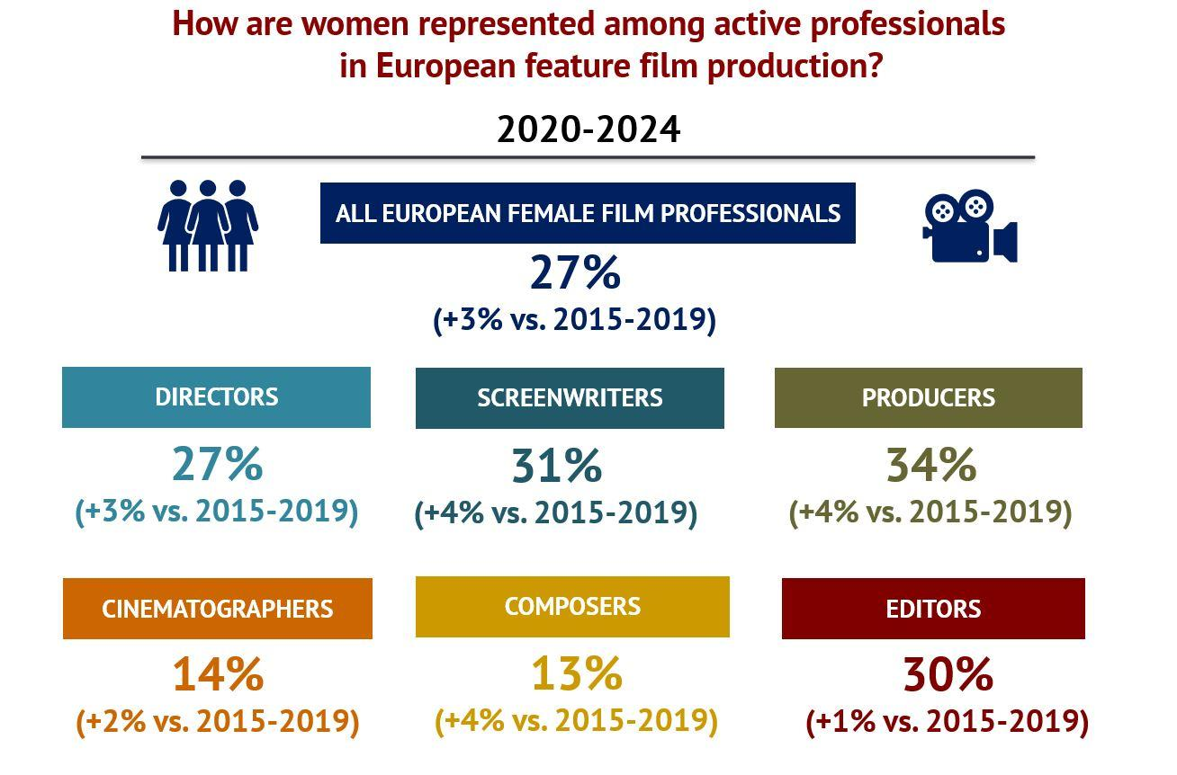
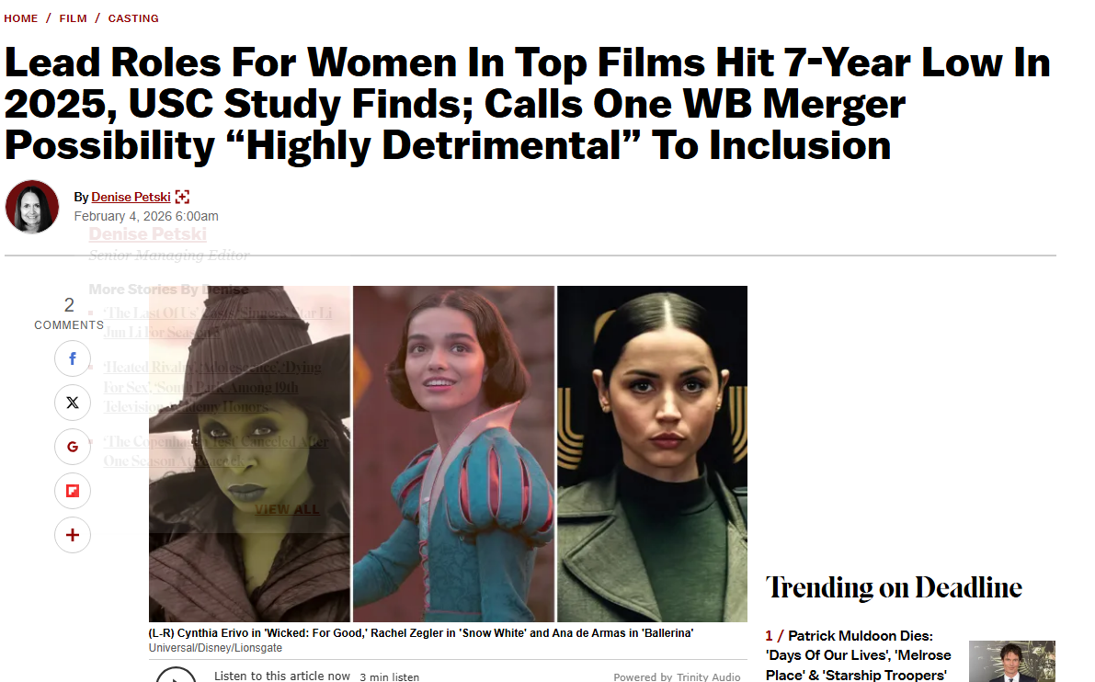

Behind-the-Scenes Power (2024–2025)
- Women directed only ~16% of top films (2024) (RALIANCE)
- Only 8% of films had strong female representation in key production roles, compared to 70% dominated by men (RALIANCE)
- Women made up 27% of Oscar nominees in non-acting categories (2025) (womensmediacenter.com)

Streaming vs Traditional Media
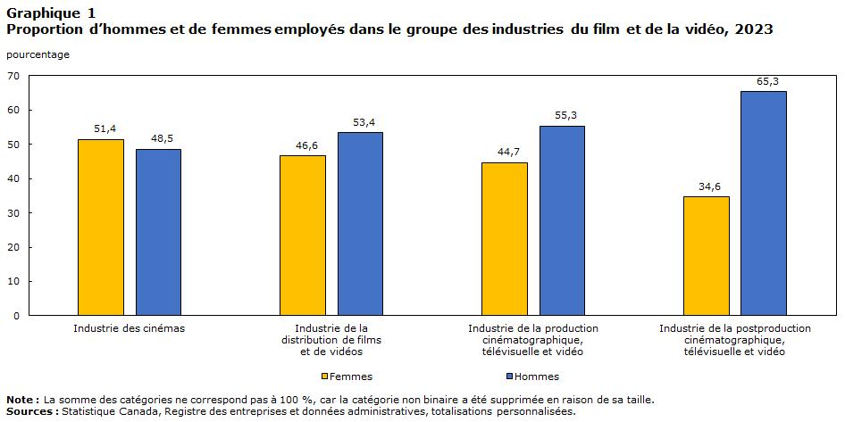
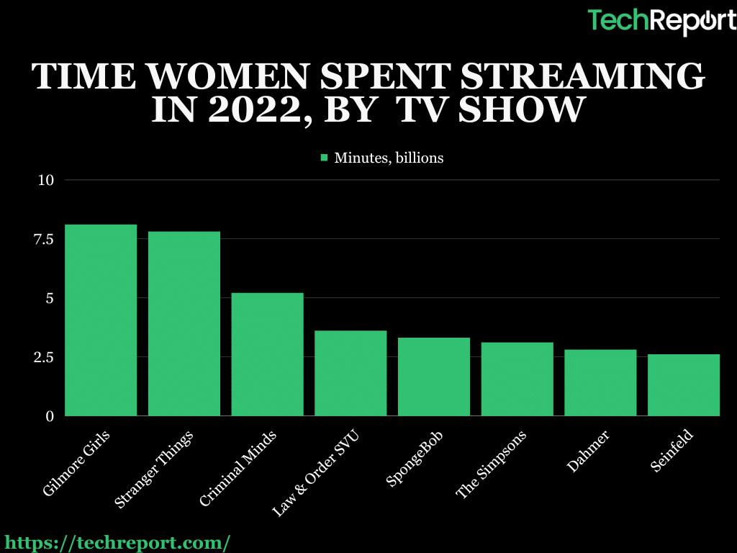
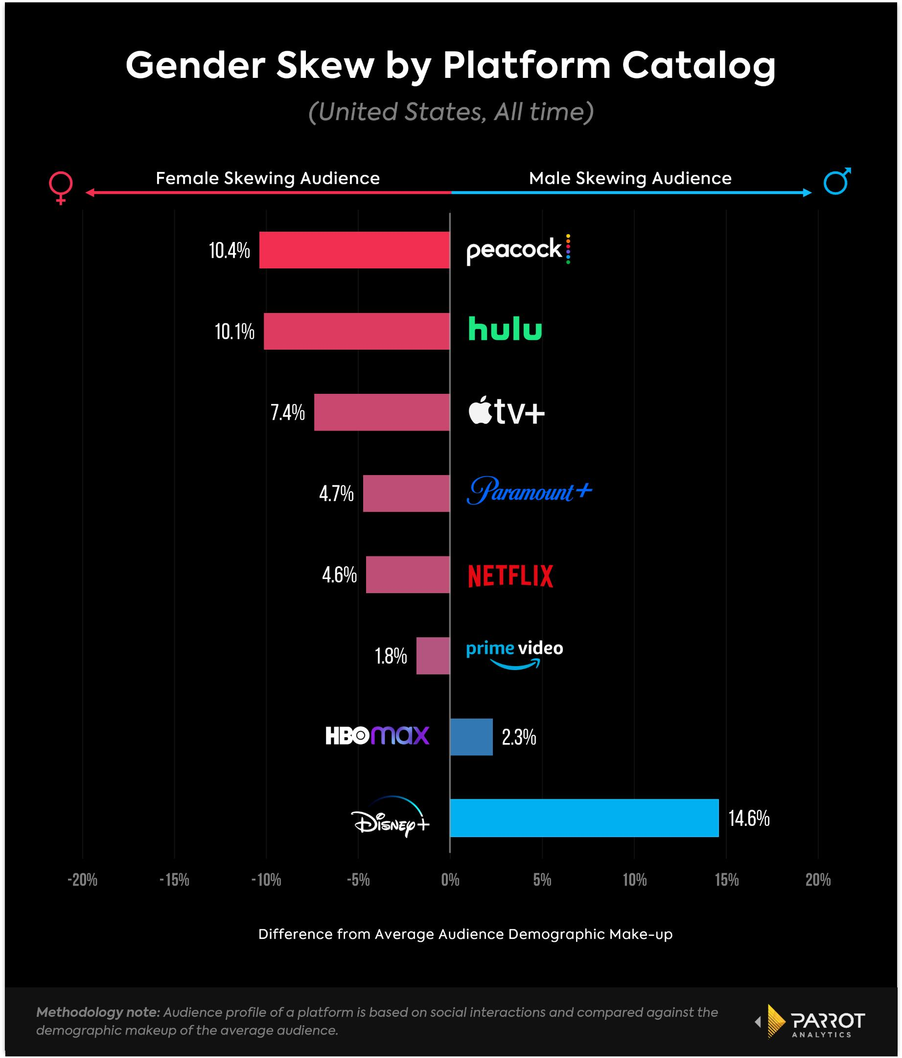

- Streaming content shows higher gender inclusion than theatrical films (Scroll.in)
- About 46% of streaming series meet strong female representation benchmarks (Scroll.in)
- Gender-balanced TV shows attract 1.33 million more viewers on average (Women's Voices Now)

News Media
- Women are only 26% of people featured in news stories globally (South Asian Herald)
- Women hold only 24% of top editorial leadership roles (2024) (womeninnews.org)
Intersectionality
- Women of colour remain significantly underrepresented, even when overall female representation improves (Reuters)
- In Canadian media leadership, most top roles are still held by white journalists (Canadian Association of Journalists)

