Anatomy & Physiology 12
Organic Molecules & Carbohydrates

Learning outcomes
- I can identify the different parts of organic molecules.
- I can describe how organic molecules form and break apart.
- I can identify different types of carbohydrates and state what they are used for in the body.

Organic Molecules
- always contain carbon and hydrogen, often contain oxygen
- carbon atoms form the backbone of the organic molecules
- covalently bonded to other carbon atoms to form long chains or rings
- only carbon and hydrogen a hydrocarbon
- other types of atoms may bond to carbon to form functional groups

Group Name | Structure | Used in
Hydroxyl | 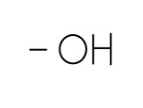 | Sugars, amino acids
Carboxyl | 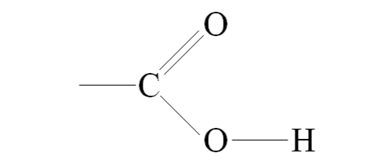 | Fatty acids & amino acids
Amino | 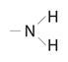 | Amino acids
Sulfhydryl | 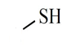 | Amino acids
Phosphate | 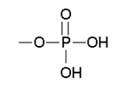 | Nucleotides & phospholipids

Monomers
- simple organic molecules
- different for different types of nutrients
- can bond with other monomers to create larger polymers using a process called a dehydration reaction

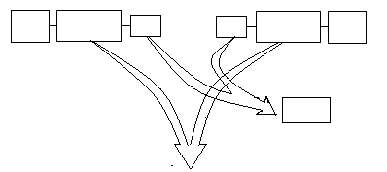
Monomer
Monomer
H-OH
OH
H
OH
H
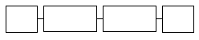
Monomer
Monomer
OH
H

- large polymers can be broken down using water through a hydrolysis reaction

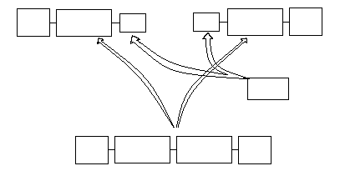
Monomer
Monomer
H-OH
OH
OH
OH
Monomer
Monomer
H
H
H

Carbohydrates
- molecules identified by the atomic grouping H-C-OH they always have a chemical formula based on CH₂O

Simple Carbohydrates
- monosaccharides are the monomers of carbohydrates
- named based on the number of carbon atoms in their structure
- 3 carbon sugar = triose
- 4 carbon sugar = tetrose
- 5 carbon sugar = pentose
- 6 carbon sugar = hexose
- examples:

Glucose | Fructose | Galactose
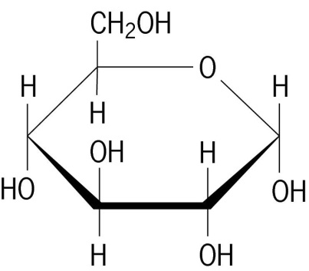 | 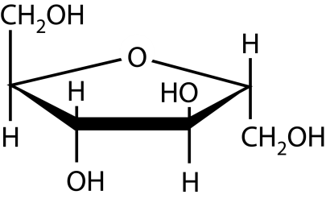 | 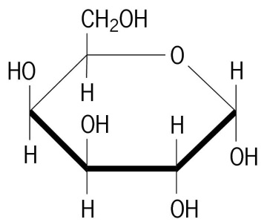

- disaccharides are double sugars
- made up of two monosaccharide molecules joined together by dehydration synthesis (see figure 2.18 on page 32).
    - maltose = glucose + glucose
    - sucrose = glucose + fructose

Complex Carbohydrates
- polysaccharides are complex carbohydrates
- contain many monosaccharide molecules and are usually chains of glucose
- examples:
    - Starch
- relatively straight chain of glucose molecules up to 4000 glucose molecules long
- storage unit of glucose in plants
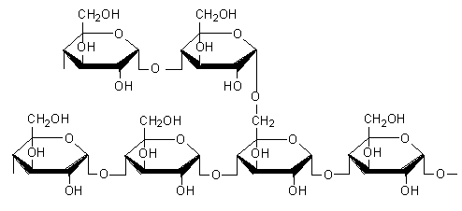
    - Glycogen
- highly branched chain of glucose molecules
- storage unit of glucose in animals
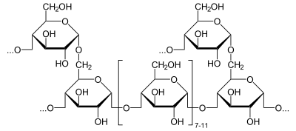
    - Cellulose
- straight chain of glucose molecules with a different linkage between them
- alternating up/down oxygen linkage cannot be digested by use
- found in plant cell walls acting as a structural component

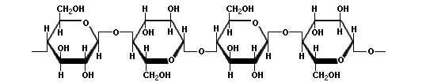

Monomer | Polymer
- glucose | - starch (plants)  - glycogen (animals)  - cellulose (plants)

