Anatomy & Physiology 12
Lipids

Learning Outcomes
- I can identify the component parts of a lipid.
- I can identify the different types of lipids and what they are used for.
- I can describe where in the body lipids are found or used for.

- three main types – fats & oils, phospholipids and steroids
- an important energy source in nature
- contain approximately twice as much energy per gram as any other biological molecule

Fats & Oils
- formed from a glycerol molecule and three fatty acids
- sometimes referred to as a triglyceride
- also called neutral fats because they are non-polar

Type of Lipid Characteristics
Fats/Saturated | - found in animals  - solid at room temperature  - examples: lard and butter
Diagram of a saturated fatty acid | 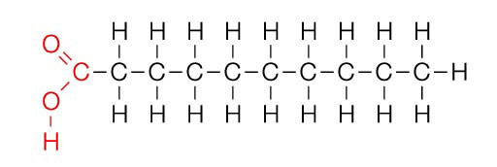
Oils/Unsaturated | - found in plants  - liquid at room temperature  - examples: corn oil, soybean oil
Diagram of an unsaturated fatty acid | 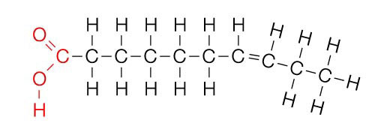
Trans-Fatty Acids | - found in chemically processed fats  - solids at room temperature  - examples: margarine, shortening, partially hydrogenated oils  - danger - trans-fats increase the amount of LDL cholesterol (bad cholesterol) and lower the amounts of HDL (good) cholesterol)
Diagram of a trans-fatty acid | 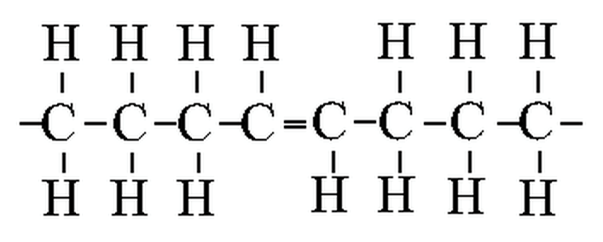

- the glycerol molecule joins with three fatty acids through dehydration synthesis

Diagram of a Fat or Oil
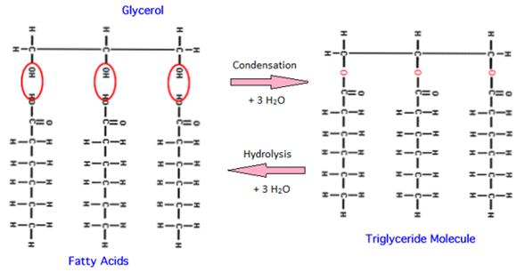

Emulsification
- any substance that will cause a fat or oil to mix with water
- have a non-polar end that projects towards the fat or oil
- have a polar end that projects towards a water molecule
- surround the fat or oil allows the fat or oil to disperse in water
- examples: soaps, detergents and bile (in the digestive system).

Phospholipids
- structurally similar to fats and oils except that one of the fatty acid groups is replaced with a phosphate group
- causes them to have a polar head and a non-polar tail
- primary component of cell membranes - they naturally form a bilayer in which the heads (hydrophilic) face outwards and the tails (hydrophobic)face inwards

Diagram of a phospholipid
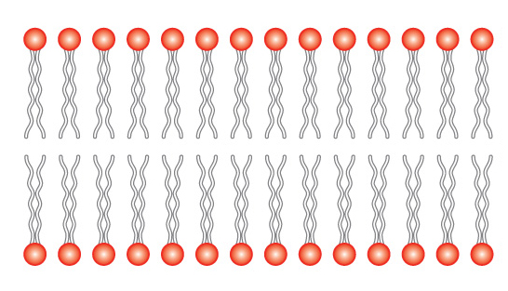
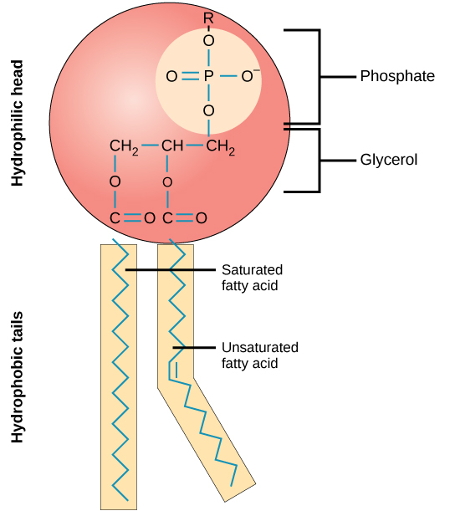

Steroids
- made of four carbon rings - three 6-carbon rings and one 5-carbon ring
- differ by the arrangement of the rings and the functional groups that are attached to them
- cholesterol is an important steroid it is a component of animal cell membranes and is a precursor to other steroids
- examples: bile salts, testosterone and estrogen
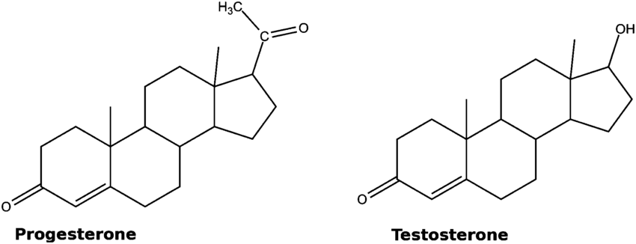
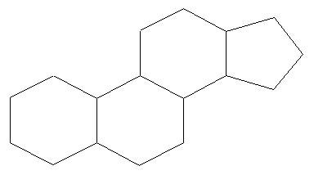

Monomer | Polymer
- glycerol & 3 fatty acids | - fat  - oil  - triglyceride  - phospholipid

