Anatomy & Physiology 12
Proteins

Learning Outcomes
- I can identify the component parts of a protein.
- I can identify the different levels of protein construction.
- I can describe where in the body proteins are found or used for.

Roles in the human body
- structural – keratin, collagen
- enzymes – lipase, maltase
- hormones – antidiuretic hormone (ADH)
- cell movement – actin (filament protein) & myosin (motor protein)
- transport – hemoglobin
- antibodies – blood type antibodies
- cell membrane – channel proteins

- amino acids are composed of three functional groups built around a central carbon and hydrogen atom
Amine Group -NH2
Acidic Group -COOH
R Group varies depending on type of amino acid
- four basic elements of all amino acids are carbon, hydrogen, oxygen and nitrogen
- there are 20 different amino acids designated their different R groups
- peptides are formed when two or more amino acids use dehydration synthesis to form a peptide bond
- dipeptide – two amino acids
- tripeptide – three amino acids
- polypeptide – chain of amino acids

Drawing of an Amino Acid
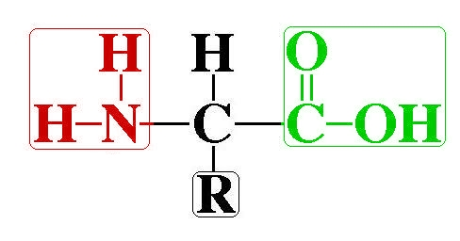

Drawing of a Dipeptide

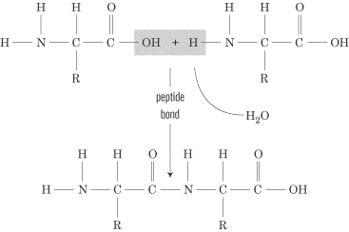

Levels of Protein Organization
All proteins have three levels of organization.
- Primary Structure
- the linear sequence of amino acids that form a polypeptide
- result of RNA translation a ribosome
- range in size from 10 AA to 34,350 amino acids (titin in muscles)

- Secondary Structure
- the folding of the amino acid chain into an alpha helix and/or beta pleated sheet (fan shaped) using hydrogen bonds

- Tertiary Structure
- final three-dimensional shape of the active protein
- held in place by ionic, covalent and hydrogen bonds
- example – myoglobin in mammalian muscle cells

- Quaternary Structure
- two or more tertiary structures joined together
- example – hemoglobin in mammalian red blood cells

Damaging a Protein
- when a protein is subjected to changes in heat or pH, they can become denatured
- the bonding between R groups is altered and the tertiary shape of the proteins are irreversibly changed
- causes a protein to become non-functional

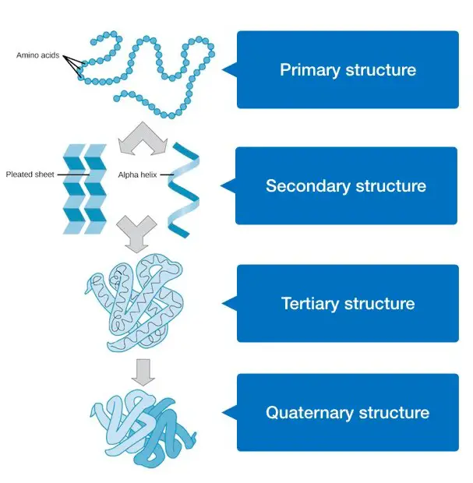

Monomer | Polymer
- amino acid | - protein  - polypeptide

