Anatomy & Physiology 12
Nucleic Acids

Learning Outcomes
- I can identify the component parts of a nucleic acid.
- I can identify the different types of nucleic acid and what they are used for.

Two main types
- DNA genetic code
- RNA messenger, transfer amino acids into ribosome, make up subunits of
ribosomes

Monomer of a nucleic acid is the nucleotide.
The three components or subunits of a nucleotide:
- a phosphate group
form backbone of the nucleic acid
- a pentose sugar
- a nitrogenous base forms genetic information of the molecule

The basic shape of a nucleotide is:
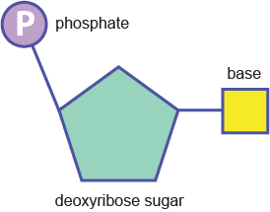

The main differences between DNA and RNA are:
 |  | DNA | RNA
 | Sugar | deoxyribose | ribose
 | Bases | A, C, G, T | A, C, G, U
 | # Strands | 2 | 1
 | Shape | double helix | single stranded

A strand of nucleic acid (DNA) looks like:
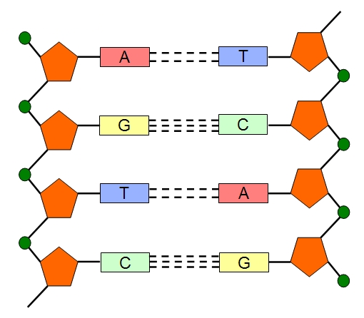

Base Bonding
- A forms two H-bonds with T C forms three H-bonds with G
- called complimentary base pairing and ensures that the sequence of DNA remains constant during replication
- A and G are double-ring bases called purines
- C and T are single ring bases called pyrimidines

Adenosine Triphosphate (ATP)
- a special type of nucleic acid is ATP
- main purpose is to act as an energy molecule in cells
- composed of the adenine nucleotide bonded to three phosphate groups
- energy is released when the third phosphate group is hydrolyzed (broken off)
- ATP is converted into ADP (adenosine diphosphate)
- energy is used by cells for synthesizing new macromolecules, transport substances across the cell membrane, cellular movement (intracellular and extracellular movements), etc.

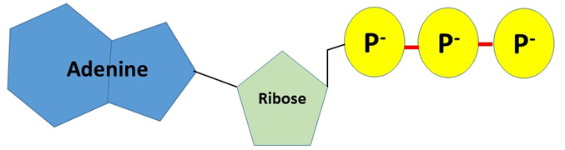

Monomer | Polymer
- nucleotide | - DNA  - RNA  - nucleic acid

