Hazard Identification Systems
Key Concepts
- I can identify the three types of Hazardous Information Systems.
- I can identify the danger posed by a chemical or product based on the warning label.

Hazard Identification System (HIS)
- colour-coded set of four boxes arranged either as a diamond or box
- blue = health, red = flammability, yellow = reactivity, white = specific hazards
- uses a scale of 0-4 to indicate the hazard level
- 0 = no hazard
- 1 = low hazard risk
- 2 = medium hazard risk
- 3 = high hazard risk
- 4 = extreme hazard risk
Fire Hazard (Red)

F
Health Hazard (Blue)
R
H
Reactivity Hazard (Yellow)
SC

Specific Hazard (White)

Health (Blue)
4 Can cause death or major injury despite medical treatment.
3 Can cause serious injury despite medical treatment.
2 Can cause injury; requires prompt treatment.
1 Can cause irritation if not treated.
0 No hazard.

Fire (Red)
4 Very flammable gases or very volatile flammable liquids.
3 Can be ignited at all normal temperatures.
2 Ignites if moderately heated.
1 Ignites after considerable preheating.
0 Will not burn

Reactivity / Stability (Yellow)
4 Readily detonates or explodes.
3 Can detonate or explode, but requires a strong initiating force or heating under confinement.
2 Normally unstable but will not detonate.
1 Normally stable; unstable at high temperature and pressure; reacts with water.
0 Normally stable; not reactive with water.

Special Comments (White)
C May be carcinogenic with chronic exposure (cancer causing)
SC Suspected carcinogen
Exp Risk of explosion
W Reacts with water
Cor corrosive
Oxy oxidizing agent
T toxic

Household Hazardous Products Symbols (HHPS)
- uses a set of four symbols and two borders to identify potential dangers

 |  |  | 
poisonous | flammable | explosive | corrosive
Danger posed by container. |  | Danger posed by contents.

- Poisonous ingesting or smelling will cause illness or death
- Flammable product or fumes easily lights on fire
- Explosive product or container can explode if heated or punctured
- Corrosive contents cause chemical burns

WHMIS 2015 (GHS)
- Workplace Hazardous Materials Information System updated in 2015
- provides detailed information about how to store, handle, disposal and first aid of chemicals
- information listed on a Material Safety Data Sheet (MSDS)

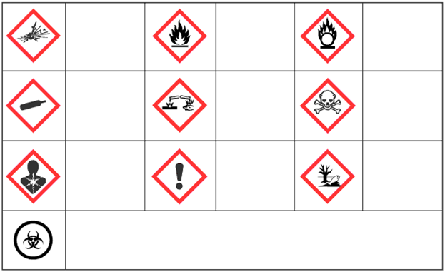
Biohazardous Infectious Material
Environmental Toxin
Immediate Toxic to Health
Flammable Oxidizer
Flammable
Corrosive
Less Serious Health Issues or Ozone Depletion
Serious Toxic to Health With Prolonged Exposure
Compressed Gas
Explosive or Extreme Reactivity

Assignment
SDS Activity
HIS Worksheet
Page 90 Q 1, 3
Page 93 Q 1-3

