Hazardous Identification Systems
Worksheet

Identify the hazards associated with each of the following symbols.

 |  | System: ______________________________________________________  Hazard: ______________________________________________________
 | 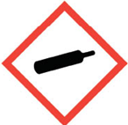 | System: ______________________________________________________  Hazard: ______________________________________________________
 |  | System: ______________________________________________________  Hazard: ______________________________________________________
 | 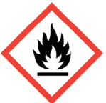 | System: ______________________________________________________  Hazard: ______________________________________________________
 |  | System: ______________________________________________________  Hazard: ______________________________________________________
 |   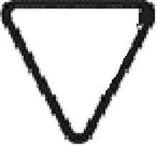 | System: ______________________________________________________  Hazard: ______________________________________________________
 | 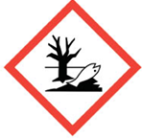 | System: ______________________________________________________  Hazard: ______________________________________________________
 |  | System: ______________________________________________________  Hazard: ______________________________________________________
 | 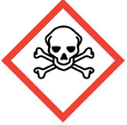 | System: ______________________________________________________  Hazard: ______________________________________________________
 | 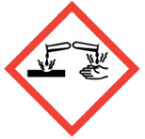 | System: ______________________________________________________  Hazard: ______________________________________________________
 | 2  3 1  W | System: ______________________________________________________  Hazard: ______________________________________________________  ______________________________________________________  ______________________________________________________  ______________________________________________________

