Science 10
Calculating Slope Worksheet

Show all work for each calculation. Round all answers to one decimal place.

For lines A – C
- Calculate the slope.

- Use the slope to calculate the volume when the mass is 45 grams.

- Use the slope to calculate the mass when the volume is 27 mL.

For Lines D – E
- Calculate the slope.

- Use the slope to calculate the volume when the mass is 45 grams.

- Use the slope to calculate the mass when the volume is 8 mL.

Volume (mL) vs. Mass (g)

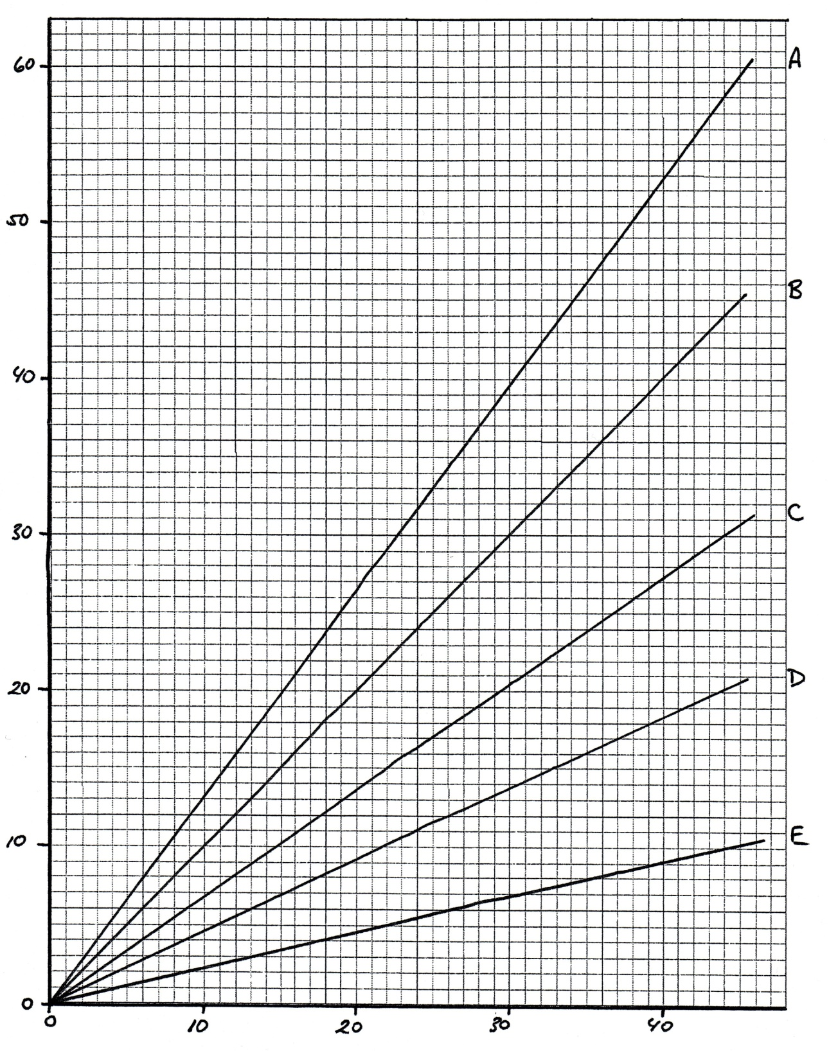
Volume (mL)
Mass (g)

