Life Science 11
Mitosis

Learning Outcomes:
- I can describe the process of mitosis.
- I can explain why mitosis is used by living organisms.

Mitosis is used for:
- growth
- repair
- asexual reproduction

- DNA containing structures in the nucleus are called chromosomes.
- Human cells have 46 chromosomes 23 from each parent. These cells are called diploid / somatic.
- Cells that contain only half the number of chromosomes are called haploid. In humans, these are the sex cells or gametes, and they are formed by a process called meiosis.

Terminology
- Chromatin
- uncondensed form of DNA used for making mRNA

- Chromosome
- condensed form of DNA after replication
- identified by having one centromere

- Chromatid
- one half of a replicated chromosome
- replicated pair are called sister chromatids
- sister chromatids are joined at the centromere

- Homologous Chromosomes
- one chromosome from each parent that contain DNA sequences for the same traits
Homologous Chromosomes
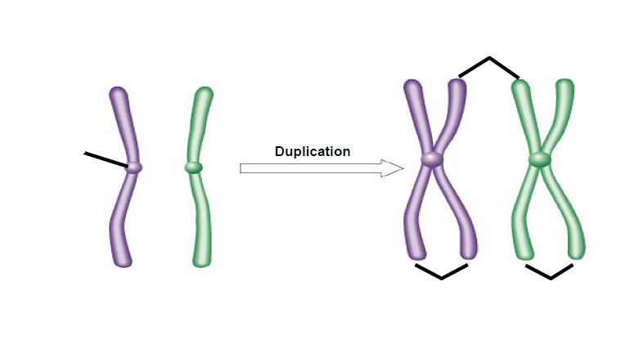
Homologous Chromosomes
Parent 2 Chromosome
Parent 1 Chromosome
Parent 2 Chromosome
Sister Chromatids
Two Duplicated Chromosomes
Sister Chromatids
Two Unduplicated Chromosomes
Centromere
Interphase  - G1  - First Growth Phase  - Normal growth and functioning of the cell  - S  - Synthesis Phase  - DNA replication occurs to form paired sister chromatids joined at centromere  - G2  - Second Growth Phase  - Continued growth and normal functioning of the cell | 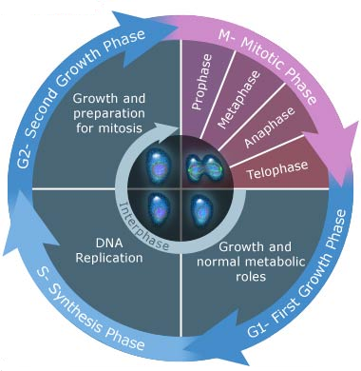
(Mitosis Starts)  Prophase  - Centrioles move to opposite poles  - Chromatin condenses into chromosomes  - Nuclear membrane disintegrates  - Centrioles start to form spindle fibres that attach to chromosomes at centromere | 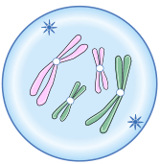  Chromosome  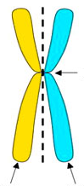  Centromere  Sister Chromatids
Metaphase  - Spindle fibers pull chromosomes to line up at the middle (equator) or the cell  - 46 separate sets of chromosomes | 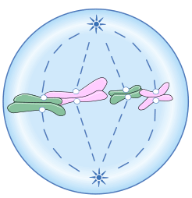
Anaphase  - Sister chromatids pulled apart | 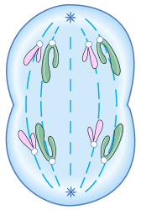
Telophase  - Nuclear membrane reforms to create two nuclei  - Chromosomes relax back into chromatin  Mitosis Ends | 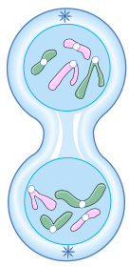
Cytokinesis  - Division of the cytoplasm and organelles into two new cells | 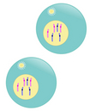

The end result of mitosis is the formation of two genetically identical nuclei. Cytokinesis usually starts during telophase and the process is often included as part of the outcome of mitosis.

Two Differences in Mitosis in Plant Cells
- no centrioles – spindle fibres form in the region of the centrosomes, but without the centrioles
- cell plate – because plant cells have a cell wall that cannot be pinched together during cytokinesis, plant cells have to form a cell plate in the middle of the cell that will grow into a piece of cell wall separating the two new plant cells

Cancer
- uncontrolled growth and/or division of abnormal cells due to a failure in the regulation of the cell cycle
- growth crowds out normal cells and either impedes in their functioning or destroys normal body cells

Cell Apoptosis
- normal programmed death of cells
- ex: death of cells between fingers and toes during fetal development
- can also occur in cells that are damaged beyond repair

Stem Cells
- unspecialized or undifferentiated cells that can develop into specialized cells
- Embryonic Stem Cells
- pluripotent – can differentiate into any type of cell
- Adult (Somatic) Stem Cells
- multipotent or unipotent – can only differentiate into a limited number of cell types

