Life Science 11
Meiosis

Learning Outcomes:
- I can describe the process of meiosis.
- I can explain why meiosis is used by living organisms.

Meiosis is used for:
- formation of sex cells or gametes

Human cells contain 23 pairs of chromosomes – half from each parent. The paired chromosomes are similar to each other – they contain version of the same genes (called alleles). These paired chromosomes are called homologous chromosome pairs.

Haploid cells contain half of the genetic material. Examples of haploid cells are sperm and egg cells. The end result of meiosis is the formation of 4 haploid cells that are genetically similar, but different from each other.

Meiosis involves 2 rounds of cell division.
Meiosis I
Prophase 1  - Chromosomes condense and link to the duplicate copy homologous chromosome pairs (4 chromatids or tetrad) join at synapse  - Crossing over can occur parts of each homologous chromosome pair can swap location  - The only homologous set of chromosomes that cannot crossover gene sequences are an XY pairing | 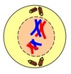
Metaphase 1  - Homologous chromosome pairs line up at equator of cell  - 23 homologous pairs or tetrads lined up | 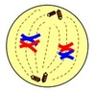
Anaphase 1  - One chromosome from each pair is pulled to opposite ends – random sorting | 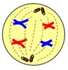
Telophase 1  - Nuclear membrane reforms and chromosomes relax | 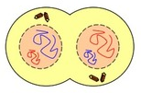
Cytokinesis
- Division of cell into 2 genetically similar but different cells

Meiosis II
Prophase 2 to Telophase 2
- No chromosome replication
- Chromosome separation like mitosis
- Ends with 4 genetically different daughter cells

