Anatomy & Physiology 12
Plasma Membrane & Cytoskeleton

Learning Outcomes
- I can describe the functional makeup of the plasma membrane.
- I can explain how each part of the plasma membrane contributes to its overall functions.
- I can identify 4 parts to the cytoskeleton of a cell and describe their purpose.

Plasma Membrane
- three main roles
- separates internal from external environment
- regulates the entrance and exit of molecules from the cell
- allows the cell to interact with the external environment

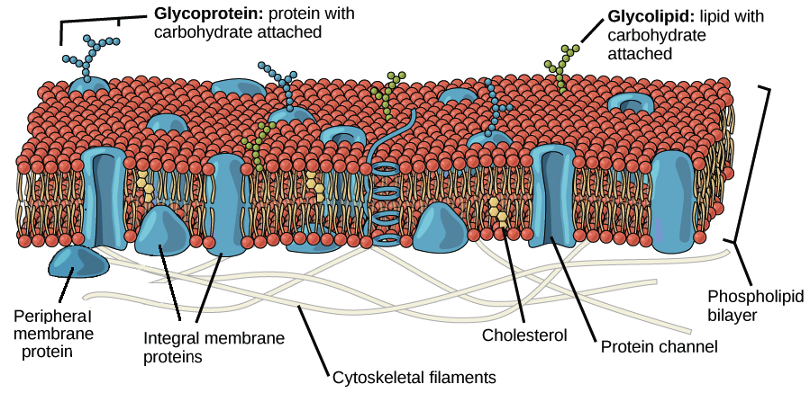

- composition
- phospholipid bilayer
- outer head region – hydrophilic – allows cytoplasm on the inside or extracellular fluids on the outside to come right up to the plasma membrane
- inner tail region – hydrophobic – prevents water (fluids) from freely moving through the plasma membrane
- cholesterol
- strengthen and stiffen the membrane to maintain membrane fluidity
- create H-bonds to phospholipids and fill the space cause by the bent tails
- proteins
- transport of molecules across the plasma membrane – channel and carrier proteins
- enzymatic proteins – used to catalyze reactions such as the conversion of NAD+ to NADH
- receptor proteins that bind to chemical messengers (hormones)
- cell-adhesion molecules (CAM’s) that bind cells to each other
- glycoproteins
- cell recognition markers – identify “self” or ABO +/- blood type
- cell binding – allow a sperm cell to bind to an egg

Six functions of cell membrane proteins.
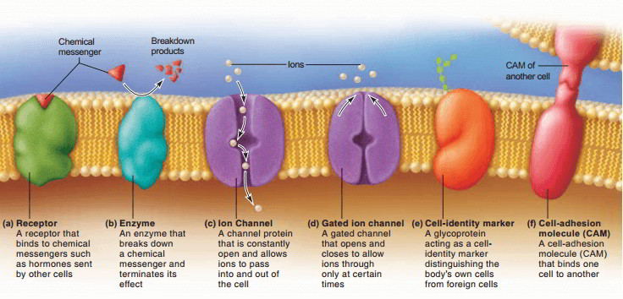

Cytoskeleton
- network of interconnected tubules and filaments that provide a framework within a cell for structure (shape) of a cell and movement of the cell and organelles
- dynamic structure that is constantly assembling and disassembling parts of it as required

- Microtubules
- small, hollow cylinders composed of tubulin (a globular protein)
- 25 nm in diameter and 0.2 to 25 um in length
- during normal cell function, microtubules act as the pathways along which organelles can move
- motor molecules (kinesin and dynein) attach the organelle to the microtubule and then “walks” it along the length of the microtubule
- different types of motor molecules move different types of organelles
- during cell division, microtubules form the spindle fibres that separate the chromosomes after duplication

- Microfilaments
- 2 chains of globular proteins twisted around each other
- form long, thin fibres about 7 nm diameter
- form a dense web just under the cell membrane to which proteins can attach
- form pseudopods in amoeba for movement
- help form microvilli in small intestines to increase the surface area
- form pathways in plant cells to move chloroplasts
- form actin filaments that myosin (a motor molecule) moves along
- causes muscle cell contraction
- pinches off the cell membrane for cytokinesis

- Intermediate Filaments
- fibrous proteins formed into ropelike structures
- 8-11 nm in diameter
- support the nuclear and cell membranes
- keratin in skin cells that provide mechanical strength

Microtubule Organizing Centres (MTOC)
- short cylinders with a 9 + 0 pattern of microtubules (ring of 9 sets of triplets with 0 in the middle)
- 2 main types
- centrioles
- pairs called centrosomes
- form spindle fibres for mitosis & meiosis
- basal bodies
- organize and anchor microtubules in cilia and flagella

Cell Movement
- Cilia and Flagella
- hair-like projections from a cell
- composed of microtubules in a 9 + 2 pattern (9 pairs on the outside with 2 in the middle)
- cilia
- cilia found on cells on upper respiratory tract cells used to sweep foreign particles trapped by the mucus lining back into throat so that it can be swallowed
- flagella
- used by sperm cells for locomotion

