Anatomy & Physiology 12
Movement Across The Plasma Membrane

Learning Outcomes
- I can define diffusion, osmosis, exocytosis, endocytosis, pinocytosis, and phagocytosis.
- I can identify the factors that affect the rate of diffusion and osmosis.
- I can explain the difference between active and facilitative transport.
- I can describe what happens to plant or animal cells when placed in a hypotonic, hypertonic or isotonic solution.

Passage Across the Cell Membrane

- Diffusion
- the movement of particles through the cell membrane from an area of high concentration to an area of low concentration
- diffusion rate affected by concentration difference and membrane surface area

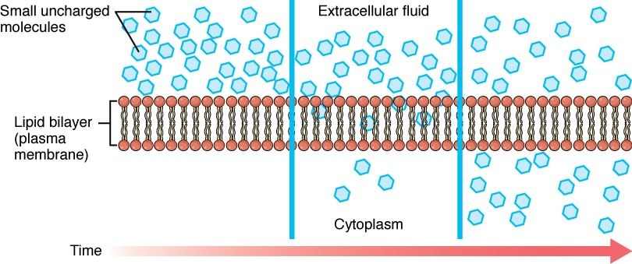
- only gases and small non-charged molecules
- gasses (O₂ and CO₂)
- lipid soluble molecules (glycerol)
- small, uncharged polar molecules (alcohol)

- Osmosis
- the movement of water through a channel protein (aquaporin) to dilute a higher concentration of solute
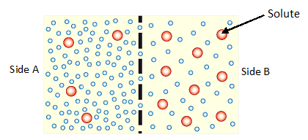
- solute is too large to pass through membrane pores
- water moves to Side B to dilute the higher concentration of solute
- change towards isotonic solutions equal concentrations
- osmotic pressure - the force exerted by water due to osmosis

- Facilitated Transport
- also called facilitated diffusion or passive transport
- movement of molecules across the membrane through channel or carrier proteins
- proteins are highly specific to the molecules they will move
- carrier proteins may move one type of molecule one direction and a different molecule in the opposite direction
- movement of molecules with the concentration gradient no energy required
- ex: movement of glucose into cells

- Active Transport
- carrier protein must be used
- movement of molecules against the concentration gradient energy required
- e.g. the sodium/ potassium pump maintains sodium levels higher outside the cell

 | Direction [Solute] | Protein Used | ATP Required
Diffusion | H L | No | No
Osmosis | L H | Water Channel | No
Facilitated | H L | Channel or Carrier | No
Active | L H | Carrier | Yes

- Endocytosis
- the movement of large particles into a cell by folding in and pinching off of the cell membrane
- requires energy
- two types
- Phagocytosis (cell eating)
- the engulfing of larger particles e.g. food particles
- this process is employed by white blood cells, a macrophage (phagocyte)

- Pinocytosis (cell drinking)
- the engulfing of large molecules (e.g. proteins)
- may be receptor mediated
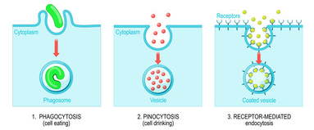

- Exocytosis
- the reverse of endocytosis
- the removal of proteins or waste materials by a vacuole merging with the cell membrane

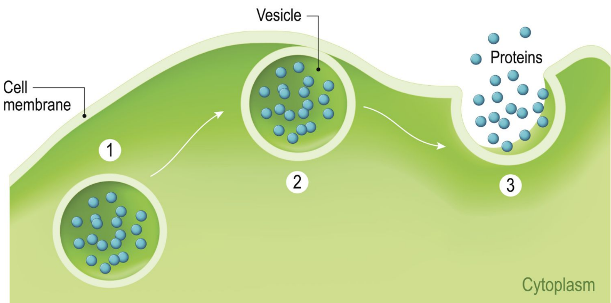

Effects of Hypertonic, Hypotonic and Isotonic Solutions on Plant and Animal Cells
- tonicity refers to the differences in relative concentration of solutes across a membrane

- Hypertonic
- higher solute concentration
- if outside a cell water moves out of cell
- animal cell cell shrinks
- plant cell plasmolysis
- cell membrane pulls away from cell wall and plant wilts
- (extra info) many foods are preserved in hypertonic solutions to cause desiccation of bacterial or fungal cells
- ex: salted ham, sugared fish, fruit jams
- Hypotonic
- lower solute concentration
- if outside cell water moves into cell
- animal cell cell swells and could burst
- plant cell large central vacuole fills and increases turgor pressure
- cell pushes against cell wall and plant becomes stiff

- Isotonic Solutions
- equal solute concentrations inside and outside of the cell
- there would be no net movement of molecules – water moves into and out of cell equally
- called dynamic equilibrium

