Anatomy & Physiology 12
Enzymes

Learning Outcomes
- I can define metabolism, enzyme, catalyst, coenzyme and substrate.
- I can explain how enzymes work using the Lock & Key Theory of Enzymes.
- I can explain why enzymes are important to sustaining life.
- I can explain how co enzymes and inhibitors speed up or slow down reactions.
- I can identify different factors that control the rate of enzyme reactions.

Enzymes
- organic catalysts that speed up chemical reactions

Lock and Key Theory of Enzyme Action
- substrate must match the shape of the active site on an enzyme
- results in enzyme specificity
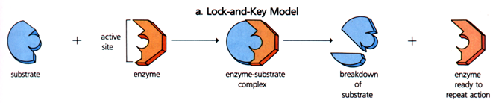
Enzyme + substrate → Enzyme-substrate → Enzyme + Product

- Active Site - the region on the enzyme molecule where the substrate(s) attach
- Substrate – the reactants or what is being acted upon
- Product – what is produced

- Induced Fit Model
- when the substrate attaches to an enzyme, the enzyme shape is altered slightly to allow for a better fit
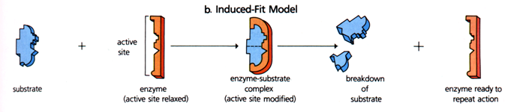

Role in Biochemical Reactions
- act to lower a reaction’s activation energy
- can determine whether a reaction occurs or occurs fast enough to sustain lilfe
- Metabolic Pathways
- Linear Pathway specific enzyme may be used for each step

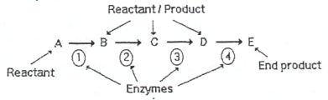

- Split Pathway specific enzyme can determine which pathway is used
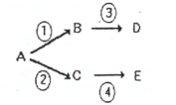

Co-Enzymes
- a non-protein molecule that binds to the active site to change the shape of the active site
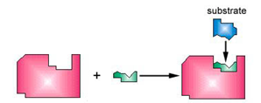

Enzyme + coenzyme

- often are vitamins that cannot be made by the body
- have to be acquired through our diet
- ex: niacin, riboflavin, thiamine (B vitamins)

Other Factors That Affect Reaction Rates
- Substrate Concentration
- the greater the concentration of substrates the greater the rate of reactions

- Enzyme Concentration
- the greater the number of active sites available, the faster the rate of reaction

- Competitive Inhibitors
- inhibitor molecule occupies the active site on the enzyme making it unavailable to the substrate
- if low amount of substrate, the reaction rate slows down
- if lots of substrate, reaction takes longer to reach maximum rate
- inhibitor may permanently attach to the enzyme can stop the reaction
- inhibitor may temporarily attach to the enzyme slows down reaction
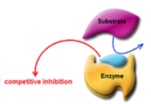

- Non-Competitive Inhibitors
- inhibitor attaches to the enzyme at a place other than the active site
- alters the active site shape inactivates the enzyme
- reaction rate slows down in all cases
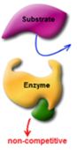

- Denaturation
- tertiary bonds are altered changing the shape of the enzyme
- causes temperature, changes in pH, heavy metals and radiation

- Temperature
- changes speed of molecules changes the rate of collisions between molecules

- Surface Area
- increasing surface area of substrate exposes more to the enzyme

Feedback Loops
- used to control the rate or direction of a chemical reaction

- Positive Feedback Loop
- the product of a metabolic pathway increases or stimulates the functioning of the pathway
- example – labour contractions
- the hormone oxytocin stimulates the uterus to contract during labour
- contraction of the uterine muscles causes the body to release more oxytocin

- Negative Feedback Loop
- the product of a metabolic pathway inhibits the functioning of the pathway
- example – stomach acid
- presence of food in the stomach causes the release of the hormone gastrin
- gastrin in the blood stream causes the release of hydrochloric acid into the stomach
- low pH in the stomach inhibits the production of gastrin

Enzyme Activity Graphs
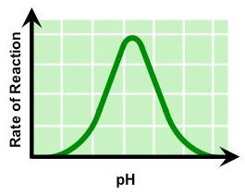
Enzyme functions ideally at optimal pH. Change in pH denatures enzyme and functioning stops.
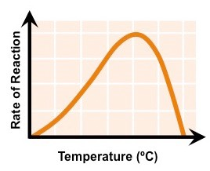
Enzyme has an optimal temperature for functioning. If temperature increases above this point, the enzyme denatures and reaction rate drops quickly. Below this temperature, reaction rates slows down more slowly since molecules are moving slower.
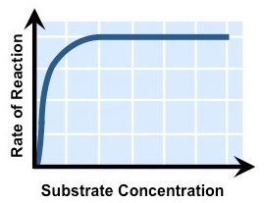
Reaction rates increases as more substrate is added (more enzyme than substrate). When there is more substrate than enzyme reaction rate plateaus all enzyme is in use at any given time.

Amount of product increases until inhibitor is added. Since substrate production only slows down, this indicates that the inhibitor binds to and then releases from the enzyme. If the amount of substrate produced did not increase any more (flat line on graph), this would indicate that the inhibitor bound to the enzyme permanently.
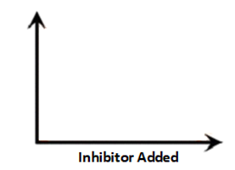
Amount of Product

