Anatomy & Physiology 12
DNA Replication

Deoxyribonucleic Acid
- makes up the chromosomes found in all cells
- codes for all of the traits and timing of traits in an organism
- structure first described in the early 1950's by James Watson and Francis Crick
- built off of discoveries by Erwin Chargraff, and by Rosalind Franklin and Maurice Wilkins
- composed of two strands of repeating monomers called nucleotides
- form a double helix
- nucleotide has three parts a phosphate group, a pentose sugar (deoxyribose) and a nitrogenous base
- the two strands are held together by hydrogen bonds between opposite bases
- the four bases are adenine, cytosine, guanine and thymine
- complimentary base pairing
- adenine binds to thymine with two hydrogen bonds
- cytosine binds to guanine with three hydrogen bonds

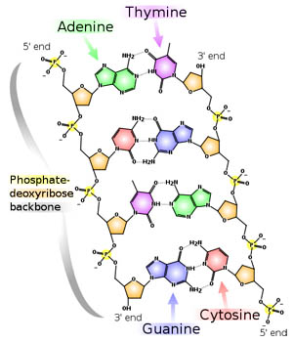
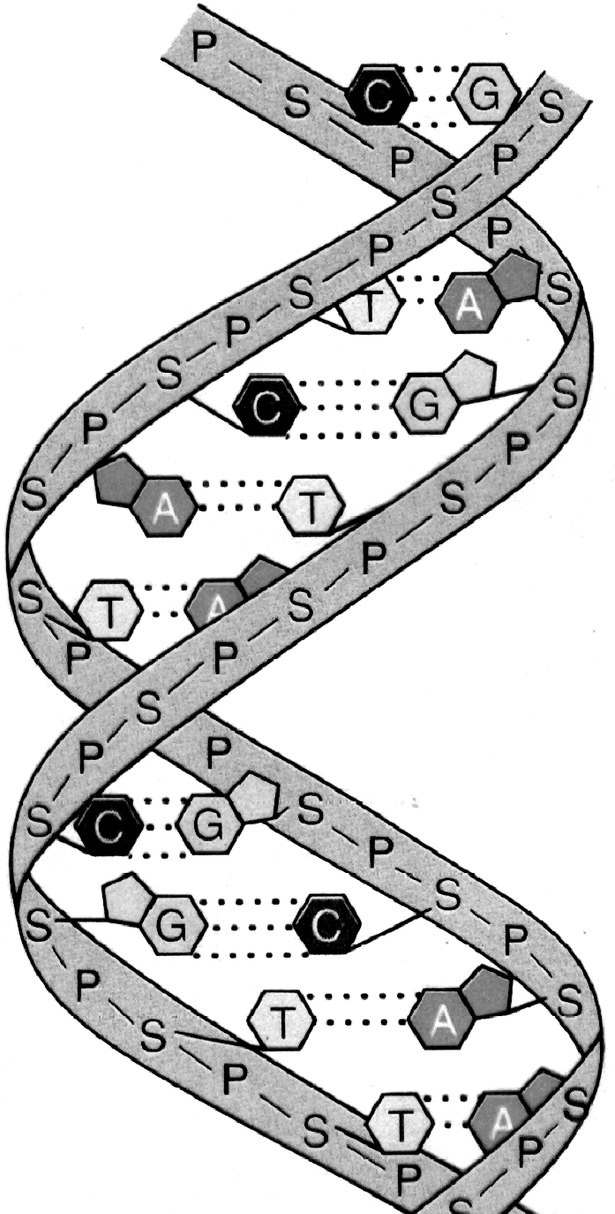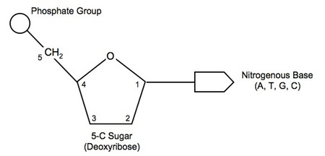

DNA Replication
- DNA is directional
- each strand has a 5' leading end and a 3' trailing end
- strands run opposite to each other called antiparallel
- the 5' and 3' designation comes from which carbon atom in the pentose sugar is uppermost in the strand (see numbering on nucleotide on previous page)
- Steps
- DNA helicase breaks the hydrogen bonds between bases
- RNA primase attaches a short section of RNA at 3’ end
- DNA polymerase III attaches at 3’ end of RNA piece and adds new DNA nucleotides in the 5’ direction only
- each strand of the original DNA molecule is used as a template for the new strands
- called semiconservative replication
- leading strand DNA polymerase follows behind DNA helicase attaching new nucleotides
- lagging strand DNA polymerase has to work in opposite direction to DNA helicase
- new DNA is replicated in short sections called Okazaki fragments
- DNA polymerase I both removes the RNA primer nucleotides (exonuclease section) and replaces them with DNA nucleotides (polymerase section)
- DNA ligase joins Okazaki fragments
- results in two identical DNA strands

