The Nervous System

The Neuron (see figure 12.2 pg. 376)

Neuron: a cell which specializes in the conduction of electrical impulses

Structure: The neuron has three basic portions:
- the axon – a fibre (process) which takes the nerve impulse away from the cell body
- the dendrite – a fibre which takes the nerve signal to the cell body
- the cell body – the part of the neuron which contains the nucleus

- dendrites and axons are called neuron fibres or processes
- long fibres are covered with cells called neuroglial cells which service the neuron fibre

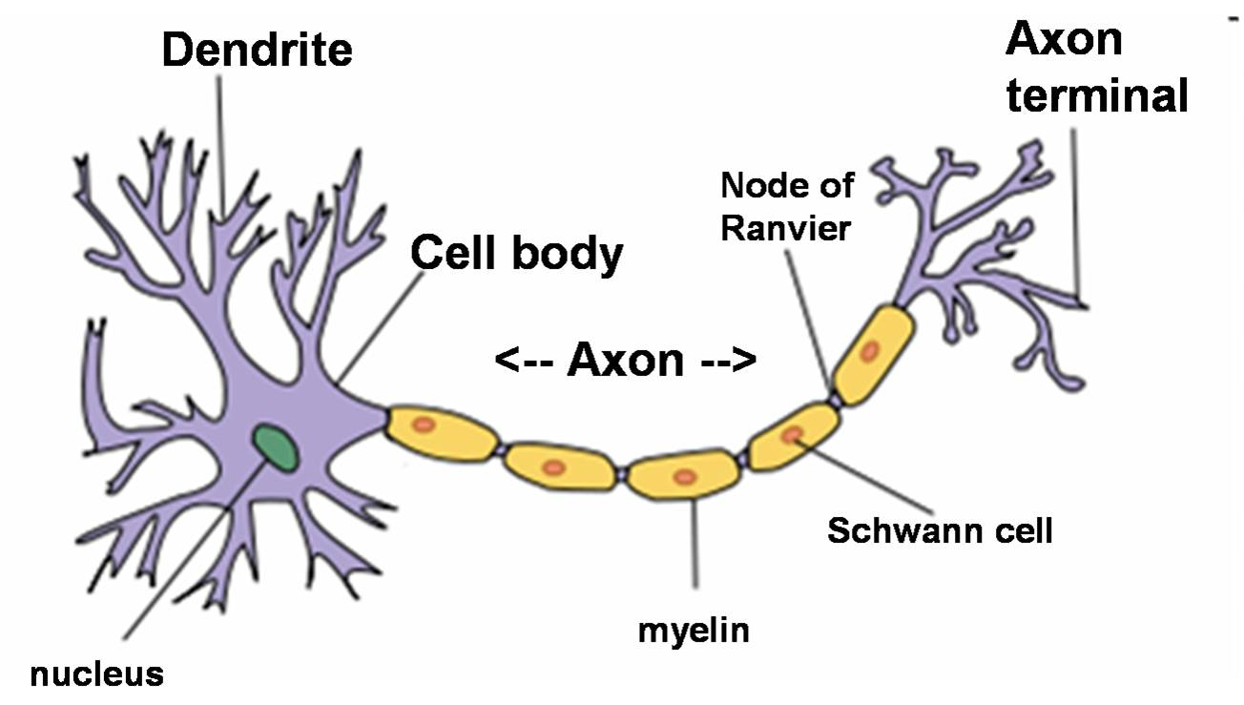

Types:
- Sensory (afferent) Neuron
- takes messages from the sensory cell in a sense organ to the central nervous system (CNS)
- these typically have a long dendrite and short axon

- Motor (efferent) Neuron
- takes the message from the CNS to innervate an affector (muscle or gland)
- these typically have a short dendrite and a long axon
- somatic motor neurons – one neuron acting on skeletal muscle
- autonomic motor neurons – two neurons acting on cardiac muscle, smooth muscle or a gland

- Interneuron (association neuron)
- located in the CNS (spinal cord or brain)
- they take messages from the sensory neuron and send it to other interneurons or to the motor neuron
Myelin Sheath
- protective sheath that covers some neurons
- cells wrap around the axon and/or dendrite non-continuously
- gaps between the myelin cells are called Nodes of Ranvier
- in the PNS
- myelin produced by Schwann cells
- gives the nerve fibres the white, glistening appearance
- if a nerve is severed, the Schwann cells can hold the severed nerve in position to facilitated nerve fibre regeneration
- in the CNS
- myelin produced by oligodendrocyte cells
- nerve regeneration does not naturally occur in the CNS
- two types of matter in the CNS
- Grey Matter – contains non-myelinated axons
- White Matter – contains myelinated axons that link different parts of the brain together

