The Nerve Impulse

- the nerve impulse is the method that a neuron transmits information
- this occurs by a traveling electrical potential (voltage) difference between the inside and outside of the neuron’s cell membrane

- Resting potential – see figure 12.4
- the inside of the neuron is -70mV compared to the outside
- a Na⁺/K⁺ pump run by active transport maintains a higher concentration of Na⁺ outside the neuron and a higher K⁺ concentration inside
- pump moves 3 Na⁺ out for every 2 K⁺ in more K⁺ leaks out than Na⁺ in
- large negatively charged proteins in the cytoplasm also helps make the electric potential –70mV

- Action Potential- see figure 12.4
- when a dendrite is stimulated by a pinch, pH change, temperature change, or electric shock, the “threshold” may be reached for an action potential
- once threshold stimulation is reached Na⁺ gates open Na⁺ rush into neuron depolarization from –70mV to + 40 mV Na⁺ gates closes and K⁺ gates open K⁺ rush out of the neuron starts repolarization process K⁺ gates closes Na⁺/K⁺ pump finishes the repolarization of the neuron

Refractory Period
- the time in which a fibre is unable to conduct an impulse because the Na⁺ gate cannot reopen until repolarization is complete

Schwann Cells - see figure 12.3
- found on long fibres of neurons
- produce a lipid insulator called myelin that wraps around the long fibres
- the myelin sheath has gaps between them called Nodes of Ranvier
- the electric impulse jumps from node to node which greatly increases the speed of the nerve impulse – called saltatory conduction
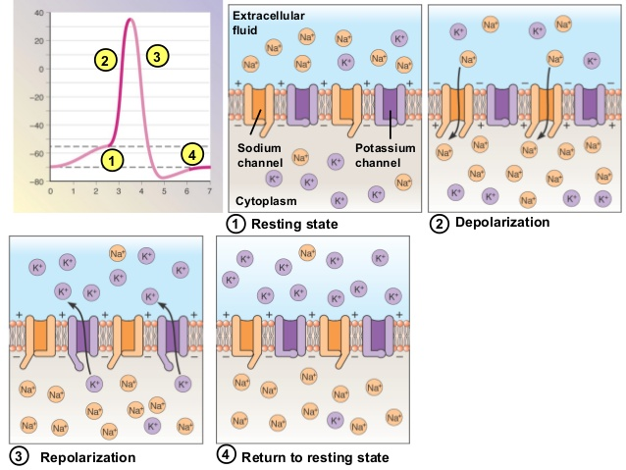

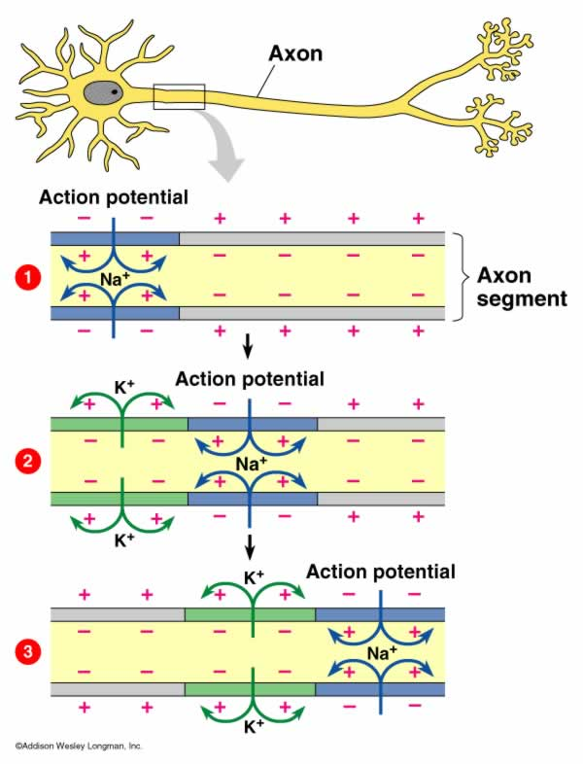
- Resting potential Na+/K+ pump moves 3 Na+ out and 2 K+ in

- Threshold Na+ gate opens Na+ rushes in depolarization

- K+ gates open K+ rushes out starts repolarization

- Na+/K+ pump finishes repolarization

- Depolarization of one part of neuron membrane depolarizes adjacent part of the membrane

Transmission across a synapse. (12.5)
- Axon Anatomy
- each axon is tipped by a swelling called an axon terminal
- a small space called the synaptic cleft lies between the axon bulb of one neuron and the dendrite of a different neuron
- the entire region is called a synapse
- the membrane of the first neuron (axon) in this region is called the presynaptic membrane
- the membrane of the second neuron (dendrite) is called the postsynaptic membrane

- Method of Transmission
- the neuron signal is carried across the synaptic cleft by chemicals called neurotransmitters stored in containers called synaptic vesicles
- action potential reaches axon bulb → Ca²⁺ gates open → Ca²⁺ enters bulb→ synaptic vesicles merge with presynaptic membrane → neurotransmitter is released into synaptic cleft → neurotransmitter molecules diffuse across cleft to the receptor molecules on postsynaptic membrane causing excitation of Na⁺ channels → Na⁺ gates open causing depolarization of dendrite
- Na⁺ channels neurotransmitter is removed, reabsorbed or destroyed to prepare postsynaptic membrane for the next signal
- acetylcholinesterase or AChE removes acetylcholine
- monoamine oxidase removes amine neurotransmitters (epinephrine, norepinephrine, serotonin and dopamine)
- removed neurotransmitters are either reabsorbed into the presynaptic membrane and repackaged or broken down into component parts

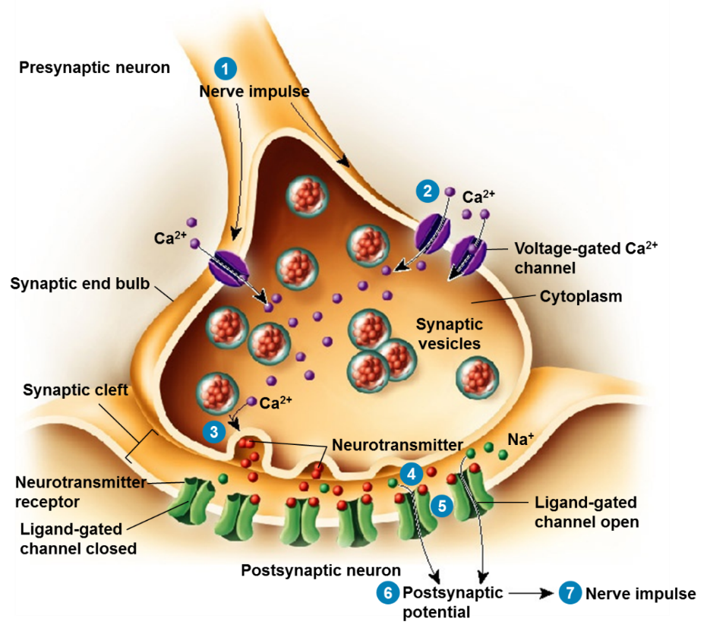

- Action potential reaches axon terminus Ca2+ gates open Ca2+ rushes in

- Ca2+ causes synaptic vesicles to release neurotransmitters into synaptic cleft

- Neurotransmitters diffuse across synaptic cleft

- Neurotransmitters bind to receptors on gated Na+ channels

- Na+ gates open Na+ rushes in depolarization

