Peripheral Nervous System

- Part of the nervous system that lies outside of the CNS
- Nerves are bundles of axons – most contain both sensory neurons and motor neurons
- A nerve fibre is composed of a single axon
- Ganglions are collection of nerve cell bodies

- Cranial Nerves
- 12 pairs of cranial nerves
- Located above the vertebral column
- Associated with the face, internal organs, and the neck

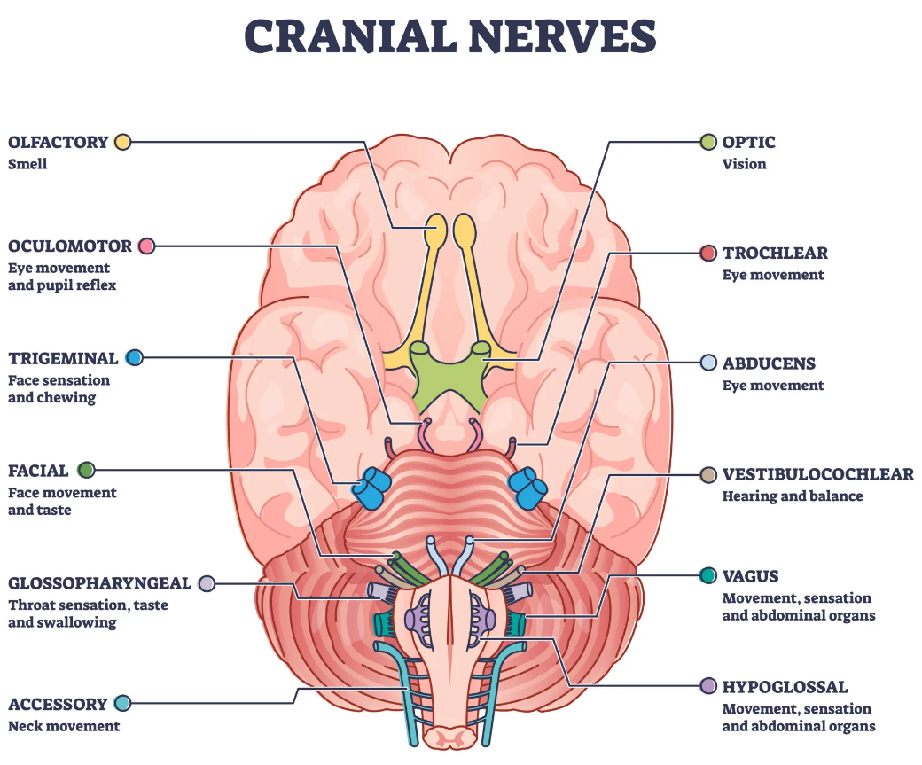
https://www.simplypsychology.org/12-cranial-nerves.html

- Spinal Nerves
- 31 pairs that transmit signals to and from the body region in which it is located
- Each spinal nerve is connected to the spinal cord by two branches or roots
- Dorsal Root – conducts sensory impulses to the CNS from sensory receptors (touch, digestive tract, etc.)
- Ventral Root – conducts motor impulses from the CNS to effectors (ie: muscles, glands, etc.)
- Exit the spinal cord through opening in the vertebral column

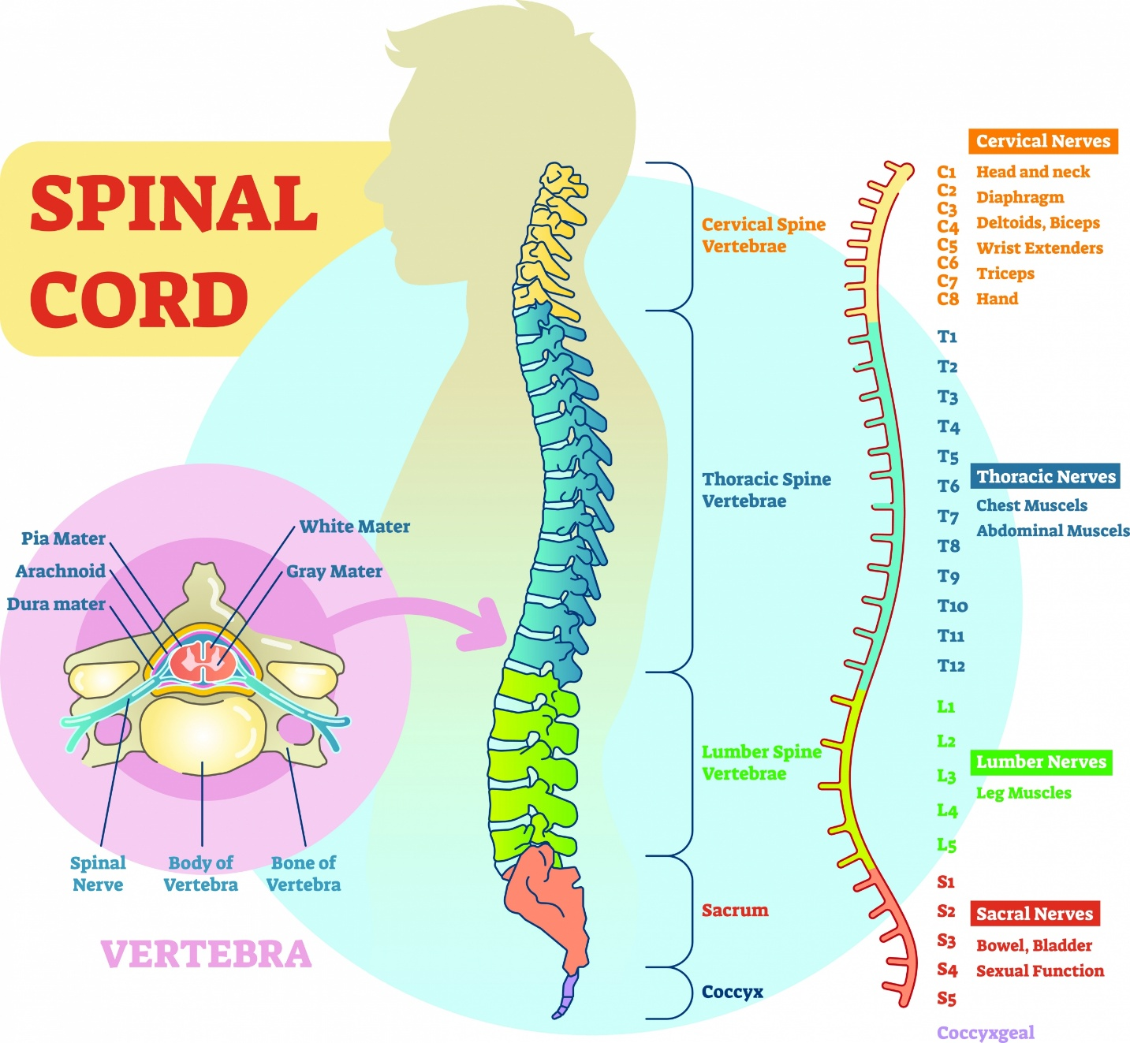
https://totalcommunitycare.co.uk/spinal-nerves-what-they-are-and-what-they-do/

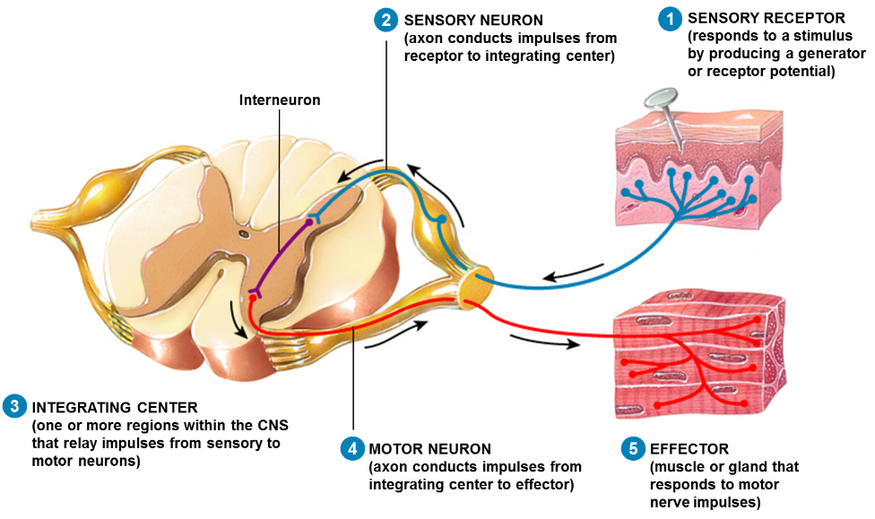
- Somatic System
- Part of the PNS that attaches to the skin, skeletal muscles and tendons
- Involved with voluntary muscle actions and reflex actions

- Autonomic System
- Part of the PNS that regulates cardiac muscle, smooth muscles and glands
- Involved with involuntary muscle movements – reflex actions that maintain homeostasis of the body

- Sympathetic Division
- Associated with “alert” reactions – driving, running, fight or flight reaction
- Stimulates the release of epinephrine (adrenaline) and norepinephrine (neurotransmitter)
- Increases heart rate and opens the bronchi, but slows down the digestive tract

- Parasympathetic Division
- Associated with “rest and digest” levels of the body
- Use the neurotransmitter acetylcholine

