Life Sciences 11
Viruses

Learning Outcomes
- I can explain what a virus is and identify its living and non-living characteristics.
- I can explain why most viruses are specific to groups of animals or plants.
- I can describe the lytic and lysogenic cycles of a virus.
- I can explain what a retrovirus is.

Definition
- a pathogenic non-cellular particle made up of genetic materials and protein

Living or non-living?
- Living Characteristics
- demonstrate continuity
- demonstrate diversity able to mutate
- have a nucleic acid (DNA or RNA)
- have structural proteins (protein coat)
- have enzymatic proteins
- can replicate

- Non-Living Characteristics
- cannot reproduce outside of a host cell
- are acellular contain no cytoplasm or cellular organelles
- do not contain both nucleic acids
- do not grow and divide new viral components are synthesized and assembled within the infected host cell
- do not respire does not break down glucose into CO₂ and water releasing energy
- can form a crystal

Structure
- range in size from 5 to 300 nm in diameter (ribosome to small bacteria sized)
- composed of a nucleic acid surrounded by a protein coat (capsid)
- extracellular phase is called a virion
- viral glycoproteins (spikes) extend from the membrane help the virus bind to the membrane of new host cells
- phage also means virus

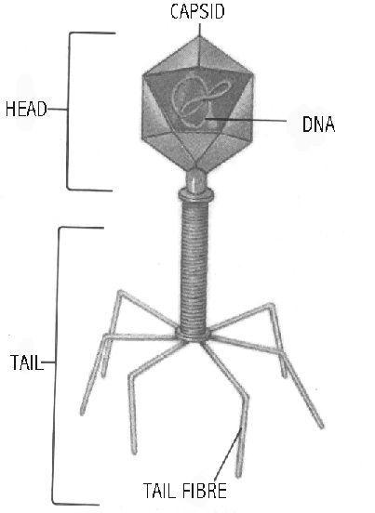

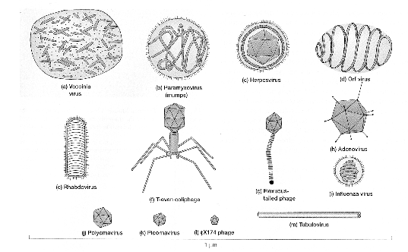

Origin of Viruses
- two schools of thought regarding the origin of viruses
- viruses evolved first
- structure of viruses is relatively simple compared to a living cell
- RNA could have been the first self-replicating genetic material
- viruses lost the ability to self-replicate when cells evolved
- viruses evolved second
- virus must utilize a living cell to reproduce
- viruses originated from a genetic fragment of living cells (similar to prions)

Viral Infections
- Specificity
- receptors on the viral capsid or envelope bind to matching receptors on the host cell
- one theory to explain this behavior is called the "Lock and Key Theory" of viral specificity it states that the molecular shape of a virus must "fit" into the molecular shape of receptors on host's cell membrane
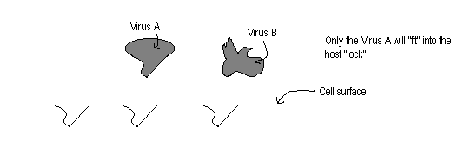
- Viral Entry
- Membrane Fusion
- viral envelope fuses with the host’s cell membrane and viral DNA/RNA is released into the host cell
- viral membrane left behind as part of host’s cell membrane
- ex: HIV, herpes simplex

- Endocytosis
- virus tricks host cell into engulfing it by endocytosis
- may be used for viruses with no viral envelope
- ex: poliovirus, Hepatitis C

- Genetic Injection
- virus creates a hole in host’s cell membrane and injects only its genetic material in the host cell
- viral capsid or envelop left outside the host cell
- ex: bacteriophages
Life Cycles of Viruses

Lytic Cycle
- examples are the T4 bacteriophage, influenza, rabies, AIDS mode of HIV
- steps
- virus attaches to host cell and inserts genetic material
- the viral DNA disassembles the host's DNA and instructs the host to produce new viral components
- the viral components are assembled into new viruses
- the cell membrane of the host cell ruptures (lyses) and releases the new viruses to infect nearby cells

Lysogenic Cycle
- examples are herpes, hepatitis B, chicken pox, HIV+
- steps
- virus attaches to host cell and inserts genetic material
- viral DNA gets inserted into the host DNA called a prophage
- cell undergoes normal cell division replicating the viral DNA as part of the host cell’s DNA
- given appropriate conditions, the viral DNA becomes active and sends the host cells into the lytic cycle
- UV light, temperature, weakened immune system, availability of nutrients

Retroviruses
- a retrovirus is a virus that works in an opposite manner as to living cells; as you studied last unit, most cells use their DNA to synthesis (make) RNA
- a retrovirus uses its RNA to make a copy of DNA this DNA is then inserted into the host's DNA
- an example of a retrovirus is HIV and human T cell leukemia virus

Recombinant DNA Technology
- uses lysogenic type viruses to incorporate useful DNA into a host’s cells
- viral genetic material is removed and the useful DNA inserted, which is then used to “infect” a host useful DNA then gets inserted into the host’s DNA

Icosahedral h, j-l
Helical m
Envelope b, c, i
Complex a, d, f, g

Lytic and Lysogenic Cycles
