Life Sciences 11
Bacteria

General Characteristics
- microscopic (1-10μm), unicellular, prokaryotic organisms
- often have one or more flagella for locomotion
- have a slime (gelatinous) coating (sheath)
- lack membrane bound organelles (except for ribosomes)
- a few autotrophic forms (photo and chemosynthetic) but most are heterotrophic (parasitic and saprophytic)
- have a cell wall composed of a carbohydrate and protein (peptidoglycan)
- reproduce most commonly by asexual means by a process called binary fission, some reproduce by a primitive form of sexual reproduction called conjugation

Phylum Eubacteria (True bacteria)
- the largest phylum
- cell wall composed of complex carbohydrates
- some live in the soil as decomposers, others are pathogenic, others are photosynthetic

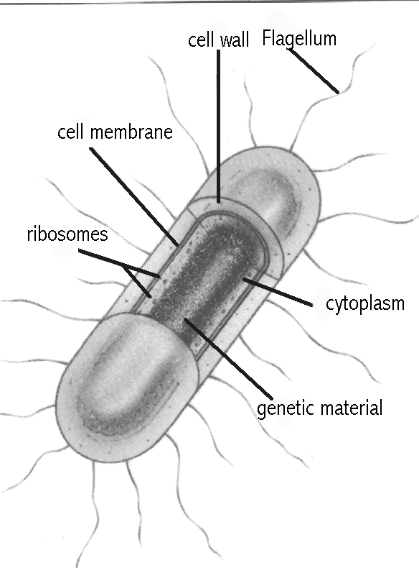 A Typical Eubacterium (E.coli)
Phylum Cyanobacteria (blue-green algae)
- photosynthetic autotrophs
- contain the pigment chlorophyll a as well as a pigment which give them their colour (phytocyanin)
- often filamentous (form a long chain of cells that appear hair-like)
- can live in a wide range of temperatures (in snow to hot springs)
- often a pioneer species (the first living things to colonize an area after a disaster)

Phylum Archaebacteria
- recently classified, this group often lives in very harsh environments
- for example, the methanogens (methane producing bacteria) live without oxygen in the digestive tract
- others live in extremely salty, hot, or cold environments

Phylum Prochlorobacteria (Prochlorophyta)
- autotrophic, photosynthetic bacteria
- these are newly discovered bacteria which are believed to an evolutionary link to photosynthetic protists
- they have chlorophyll a and b which is similar to that of chloroplasts in plants

The Role of Bacteria
- important decomposers
- symbiotic relationship with some plants help fix atmospheric nitrogen gas (N₂) into ammonia (NH₃) which is used by the plant to build amino acids (proteins)
- used to clean up oil spills
- help purify metal ores like copper
- food processing (cheese, yogurt, sour cream, and buttermilk)
- genetic research
- production of medicines (ex: insulin)
- used to make organic paints in some First Nations cultures – rock paintings at Babine Lake

Pathogenic Diseases Caused by Bacteria
- diphtheria, typhoid fever, syphilis, bubonic plague, cholera, Hansen’s disease (leprosy)

Means of Controlling Bacteria
- sterilization – use of extreme heat or chemical disinfectants
- refrigeration – low temperatures slow down the metabolic reactions necessary for life or reproduction
- canning – prevents the growth due to lack of oxygen and prevents bacteria from entering
- chemically preserving food – salt, vinegar and sugar can dehydrate bacteria
- antibiotics – use of medicines that prevent the normal development of the bacterial cell wall
- vaccination – a deactivated viral or bacterial protein used to stimulate the production of antibodies by the immune system
- good living conditions – sanitary living conditions, healthy food, exercise, rest, and treating wounds with an antiseptic

