Life Sciences 11
Identifying Bacteria

Identifying Bacteria
- Smell
- Colony morphology (appearance)
- colony size, elevation and edge shape
- cell shape


- cell arrangement

- Gram's stain
- specific staining technique
- bacteria are stained with a purple stain called crystal violet lightly washed and counter stained with a red stain called safranin
- if the bacterium appears purple Gram's positive (one thick layer in cell wall)
- if it is pink or red Gram's negative (two thin layers in cell wall)


- Motility
- bacteria can be motile (can move) or sessile (cannot move)
- 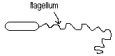most bacteria move by the whip-like motion of one or more flagella
- Type of Nutrition
- some autotrophs – make their own food
- phototrophs – use light energy
- chemotrophs – use energy stored in chemical bonds
- some heterotrophs – get food from another source
- herbivores, carnivores and detrivores (saprophytes)

- Means of Reproduction
- binary fission (asexual)
- pro – fast, 1 parent, less energy required
- con – no genetic diversity
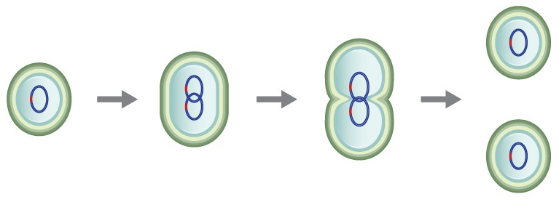

- conjugation (sexual)
- transfer of a plasmid – a small piece of DNA separate from the chromosomal DNA that provides an advantage like antibiotic resistance
- pro – creates genetic diversity
- con – slower, need 2 parents, requires more energy
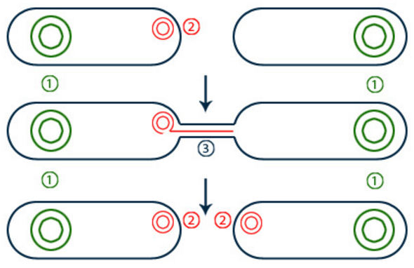

- Oxygen Tolerance
- Obligate Aerobes
- require oxygen for cellular respiration to make ATP
- Obligate Anaerobe
- cannot live in oxygen
- use fermentation to produce ATP
- Facultative Anaerobe
- prefer oxygen but can also use fermentation

