Chemistry
Atomic Theory

Learning Outcomes:
- I can define what matter is and identify what physical properties are.
- I can list the name, symbol, location in an atom, and the atomic mass units of the three sub-particles of an atom.
- I can relate the atomic number, atomic mass and nuclear charge t the number of each sub-atomic particle in an atom or ion.

Classification of Matter
- matter is anything that has mass and volume
- physical properties are the characteristics of a substance
- e.g., colour, density, state at room temperature, etc.
- can be an element, compound or mixture
- element
- made up of only one type of atom (hydrogen gas, oxygen, sulphur)
- cannot be chemically separated into simpler substances
- compound
- made up of two or more elements bonded in a fixed ratio (H₂O, CO₂)
- can be chemically separated into simpler substances
- mixture
- made up of elements and/or compounds that are not bonded together (gravel, air, salt water)
- can be physically separated into its components

Atom
- the smallest unit of matter that retains the properties of a given element

Atomic Theory
- atoms are made up of smaller, subatomic particles
 | Symbol | Charge | Location | Relative Mass | Atomic Mass Units
Proton | p | +1 | nucleus | 1836 | 1
Neutron | n | 0 | nucleus | 1837 | 1
Electron | e | -1 | orbits nucleus | 1 | 0*

* Because the mass of electrons is so small compared to the mass of protons and neutrons, they are considered to have a mass of zero; therefore, only the nucleus of an atom is considered to have mass.

- indicates the symbol, atomic number, atomic mass and charge of all elements
- Atomic Number = number of protons
- Atomic Mass = # protons + # neutrons
- Nuclear Charge = # protons (since neutrons have no charge)
- Ion Charge = # electrons gained or lost

- Example: Beryllium

Atomic Number = 4 # protons = 4
4 2+
Be
Beryllium
9.0
Atomic Mass = 9 # electrons = 4
Nuclear Charge = 4 # neutrons = 5

Ions
- an atom that has a positive or negative charge in a chemical reaction due to a transfer of electrons
- metals tend to lose electrons and become positive ions called cations
- non-metals tend to gain electrons and become negative ions called anions

ion charge = number of protons – number of electrons

Periodic Table
- elements are arranged in rows (periods) based on their atomic number
- elements in a column (group or family) have common characteristics
- example – all of the elements in family 1 react with water
- Group #1
- alkali metals
- very reactive metals that form +1 ion
- Group #2
- alkaline Earth metals
- reactive metals that form +2 ion
- Group #17
- halogens
- very reactive non-metals that form -1 ion
- Group #18
- noble gases
- non-reactive non-metal gases

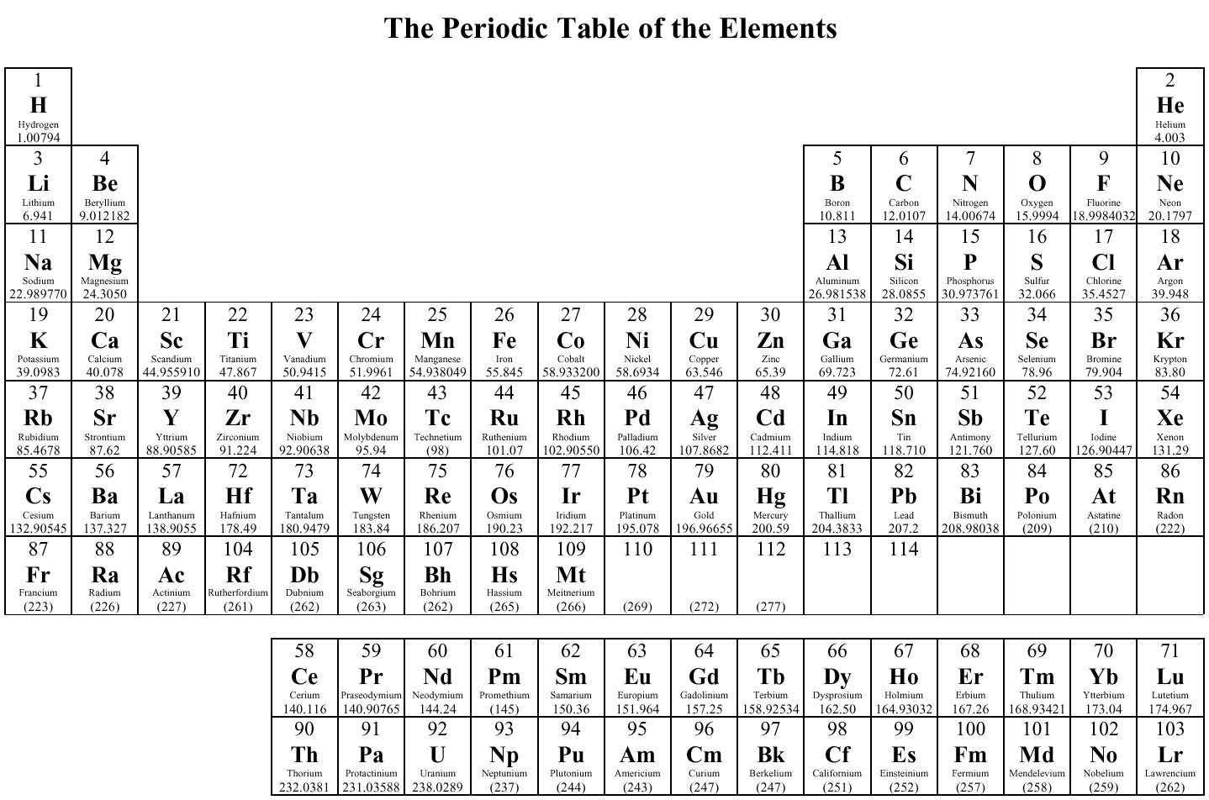
Columns
Groups
Families

Rows
Periods

- Go over the Periodic Table highlighting:
- Metalloids
- Liquid elements at room temperature
- Gaseous elements at room temperature
- Diatomic elements (We will come back to this later in the course)

Activity Periodic Table Scavenger Hunter (BC Science10 BLM Chapter 4:2-8)
Assignment: worksheets on atom and ions.

