Chemistry
Bohr Diagrams

Learning Outcomes:
- I can draw Bohr diagrams of atoms and ions.

Structure of the Bohr Model
- protons and neutrons are tightly packed together in a central mass called the nucleus
- often referred to as nucleons
- nucleons are held together by the strong nuclear force
- the strong nuclear force acts over a very small distance but is strong enough to overcome the repulsions from one proton to another
- electrons orbit the nucleus at specific distances called orbits or shells
- Neils Bohr discovered that the electrons must be in specific locations around the nucleus of the atom using light emission spectroscopy
- there is a relationship between the position of the electrons and their energy
- the further the electron is from the nucleus the more energy the electron has

Orally: The specific wavelengths of light given off by a sample of atoms provided the clue that Bohr needed to prove that electron locations are “quantized”. The quantization of electron location means that electrons may only be in specific locations. For example, you can rest yourself on a specific stair on a staircase but you may not be at rest at potential energies between stairs on a staircase.

Bohr Model – Atom
- Example: phosphorus
paired electrons

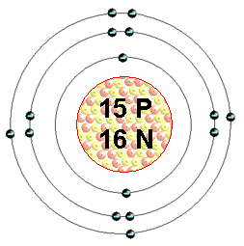
Remember that each electron orbit or shell can only hold a certain number of electrons:
1st = 2
2nd = 8
3rd = 8
4th = 18
5th = 18
6th = 32
7th = 32

15 3-
P
Phosphorus
31.0

unpaired electron

Bohr Model – Ion
- atoms do not have a full outer shell (valence shell) of electrons
- try to fill it by either gaining or losing electrons
- metals lose electrons
- non-metals gain electrons

- Example: phosphorus will attract 3 more electrons
gains a charge of -3 (one for each electron gained)
represented by the ion charge on the Periodic Table for each element
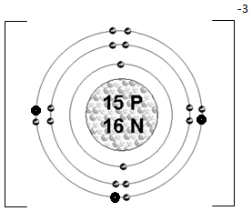
when the phosphorus atom gains 3 more electrons, it becomes an ion
Square brackets used to show the atom is now an ion and the charge is written just outside the bracket

Directed practice: Show students how to draw Bohr diagrams for the following atoms and have them predict what the ion charge will be based on the atom gaining or losing electrons.

- Sodium atom and sodium ion
- Magnesium atom and magnesium ion
- Sulfur atom and sulfide ion
- Neon atom (NO ION!)

Q: Why will Neon not form an ion?
A: Neon has a full outer shell which is non-reactive (i.e., stable).

Homework Bohr Diagram worksheet

