Life Sciences 11
Photosynthesis

Learning Outcomes
- I can identify the organelle responsible for photosynthesis and describe its composition.
- I can write the chemical equation for photosynthesis.
- I can describe the two parts of photosynthesis and identify where in the chloroplast each occurs

- the transformation of solar energy into the chemical energy of carbohydrates
- two types of pigments used to absorb light energy
- chlorophyll a and b
- green coloured pigment
- absorb violet, blue and red
- carotenoids
- yellow and orange pigments
- absorb light in the violet-blue-green range

Chloroplasts
- structure responsible for photosynthesis
- double-membrane organelle
- chlorophyll contained in the thylakoids flattened sacs that found within a chloroplast that can form stacks (called granum)
- thylakoids located in the central space inside a chloroplast called the stroma
- stroma contains an enzyme-rich solution that produces glucose
- glucose can be stored in plants as starch
light
Photosynthesis

CO₂ + H₂O C₆H₁₂O₆ + O₂

- Light-Dependent Reaction (1st Stage)
- solar capture step
- chlorophyll used to absorb light energy to energize electrons
- takes place in the thylakoids
- Photosystem II
- light energy used to split a water molecule
H₂O 2 H⁺ + 2 e⁻ + ½ O₂

- H+ ions stay in the thylakoid space
- electron carried by electron carrier molecules in membrane of thylakoid releasing energy
- energy used to move H+ from stroma into the thylakoid space
- creates a higher concentration of H+ inside the thylakoid
- as H+ move out of thylakoid through a membrane protein, ADP is converted into ATP
ADP + P ATP

- Photosystem I
- electron is reenergized and transported by another series of electron carrier molecules
- electron is used to attach a H+ from the stroma to NADP+ to make NADPH
NADP⁺ + H⁺ + 2 e⁻ NADPH

- Calvin Cycle (2nd Stage)
- called synthesis step
- light-independent reaction because it does not require light
- CO₂ taken up by a 5-carbon sugar to produce a 6-carbon molecule
- 6-carbon molecule breaks down to from two 3-carbon molecules that are then used to produce one glucose molecule (C₆H₁₂O₆)
- requires energy that is supplied by the ATP and NADPH from the light-dependent reactions

Chloroplasts

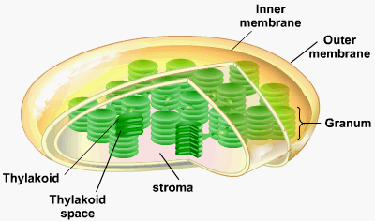

Light Reactions
Photosystem II and I
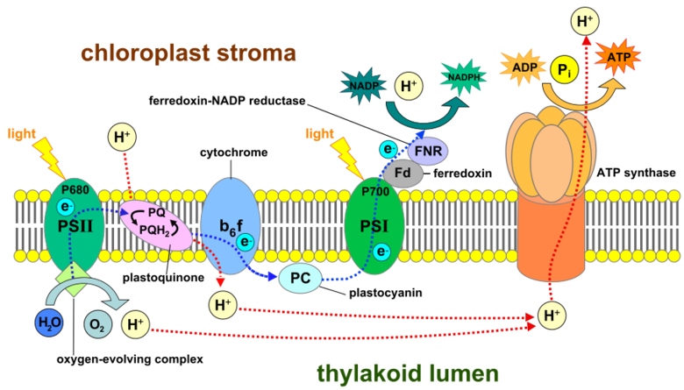

Calvin Cycle
CO₂
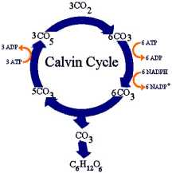
C₆H₁₂O₆

Photosystems & Calvin Cycle
