Life Sciences 11
Cellular Respiration & Fermentation

Learning Outcomes
- I can identify the organelle responsible for cellular respiration and describe its composition.
- I can write the chemical equation for cellular respiration.
- I can identify where the four different steps of cellular respiration occur and what each step produces.
- I can describe the difference between cellular respiration and fermentation in terms of where it occurs and what the final outcome is.

Cellular Respiration
- all plants and animals use the energy stored in glucose to drive the metabolic processes that sustain life
- cellular respiration is the breakdown of glucose using O₂ to produce CO₂, H₂O and energy (in the form of ATP)
ADP + P ATP

C₆H₁₂O₆ + O₂ CO₂ + H₂O

- 36 to 38 ATP molecules are produced for every glucose molecule
- approximately 40% of the energy stored in a glucose molecule; rest is lost to heat

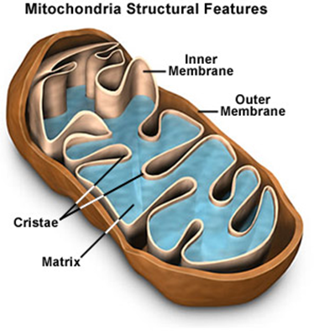

- Phases
- Glycolysis
- breakdown of glucose to two molecules of pyruvate (a 3-C compound) inside the cytoplasm
- results in the production of 2 ATP molecules and 2 NADH molecules (used in electron transport system)
- does not require the presence of O₂

- Transition Reaction
- movement of pyruvate molecules across the mitochondrial membrane
- oxidation of pyruvate to a 2-C acetyl group attached to coenzyme A (acetyl-CoA)
- occurs twice per glucose molecule
- results in the production of 2 CO₂ and 2 NADH molecules

- Citric Acid Cycle (Kreb’s Cycle)
- cyclical series of reactions that give off CO₂ and produce 2 ATP molecules
- 4-C compound attaches to one of the acetyl-CoA molecules to form a 6-C molecule
- 6-C molecule is oxidized to form a 5-C molecule releasing one molecule of CO₂, then oxidized again to a 4-C compound releasing another molecule of CO₂
- 4-C compound is recycled to join with another acetyl-CoA molecule
- results in the production of 4 CO₂, 6 NADH, 2 FADH₂ and 2 ATP

- Electron Transport System
- series of electron carrier molecules that move electrons to O₂ allows it to combine with H⁺ ions to become H₂O
- occurs on the cristae (folds) within the mitochondria
- location where the NADH and FADH₂ molecules are reduced to NAD⁺ and FAD, and then recycled back to the first 3 phases
- results in the production of 32 – 34 ATP molecules
- 3 ATP for each NADH
- 2 ATP for every FADH₂

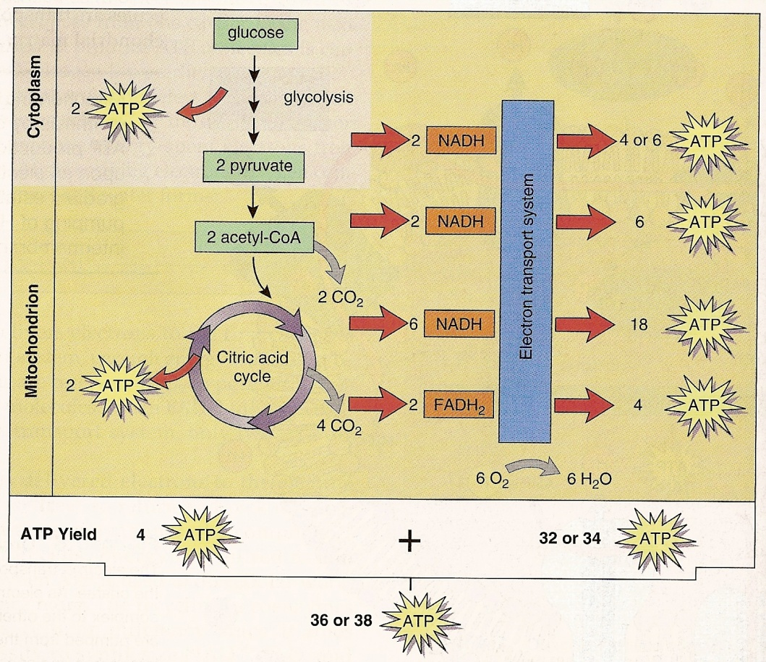
Fermentation
- used to produce ATP, especially in muscle cells, when O₂ is limited (ie: during strenuous exercise)
- similar to glycolysis, but the electrons gained by NAD⁺ to form NADH are used to reduce pyruvate to either lactic acid or alcohol
- lactic acid
- 3-C molecule produced by animals
- alcohol
- 2-C molecule (ethanol) produced by plants
- also makes one CO₂
- not as efficient only 2 ATP produced per glucose

Photosynthesis and Cellular Respiration

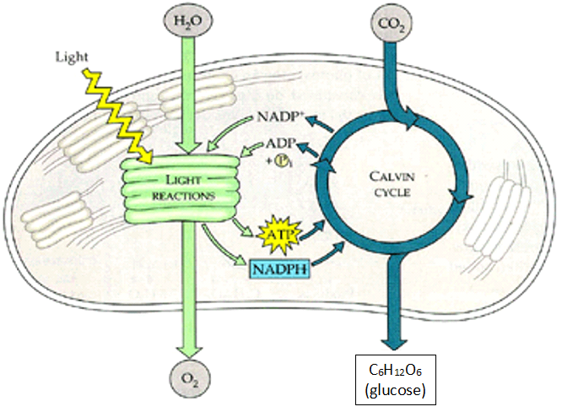
Photosynthesis

Step 1
Glycolysis
Step 4
Electron Transport System
Step 3
Citric Acid or Kreb’s Cycle
Step 2
Transition Reaction
Cellular Respiration
CO₂
H₂O

ATP
(energy)

