KOMAGATA MARU – 1914 SOURCES EXERCISE

SOURCE A: The Komagatu Maru arrived in Vancouver, having sailed from China with 376 Indians aboard, who were refused admittance to Canada. After two months in the harbour, and following an unsuccessful appeal to the BC Supreme Court, the boat sailed back to India. Between 1914 and 1920 only one Indian was admitted to Canada as an immigrant.
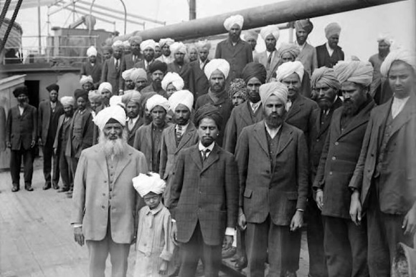
SOURCE C:

SOURCE F: “The landing of these Hindus would be much more likely to cause riots than keeping them where they are…. It is probable that the Vancouver citizens will turn out and prevent such a landing. They had experience of this proposition on a previous occasion, (anti-Asian race riot of 1907) and do not want that experience to be repeated.”
H.H. Stevens, Member of Parliament for Vancouver Centre, and the province’s leading advocate of Asiatic exclusion.
SOURCE D: Resolution proposed Vancouver City Councilor Woodside.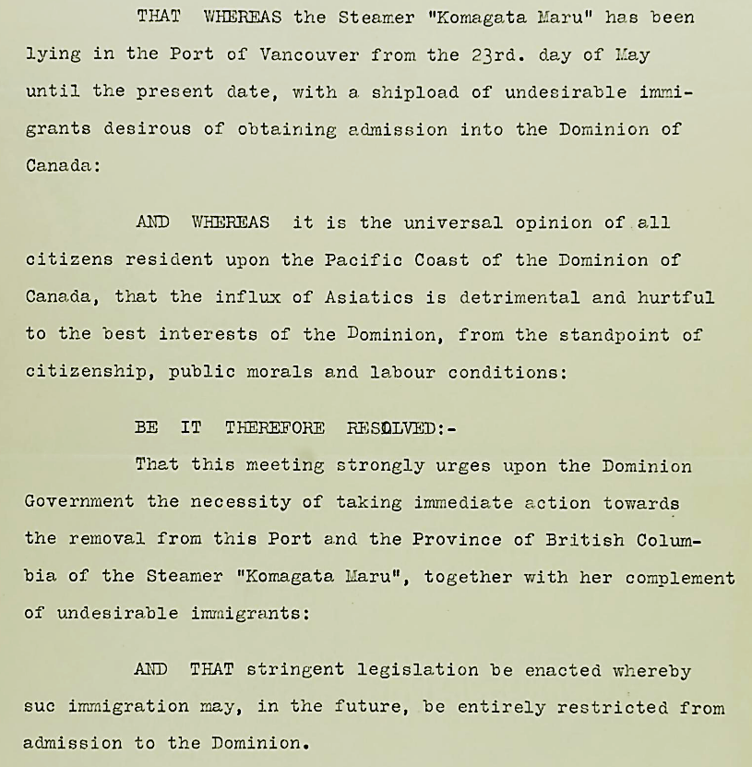
SOURCE E: Letter sent to Editor, The Daily News Advertiser, by passengers on board the Komagata Maru. 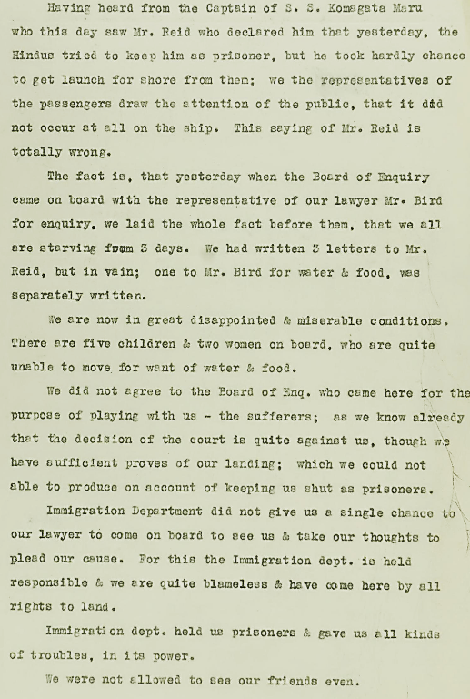
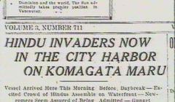
SOURCE B: “Hindu” was a generic term – as is East Indian.
SOURCE K: SKILLED WORKERS POINT SYSTEM
Today Canada assesses immigration applications based on six selection factors.
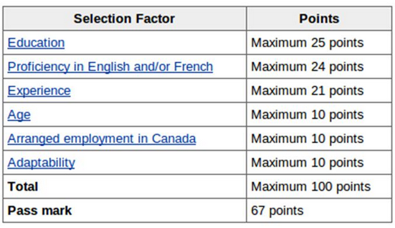
SOURCE H:
SOURCE G:
SOURCE J: Prince George City Councilor Kyle Sampson and MLAs Shirley Bond and Coralee Oakes participate in Vaisakhi parade – 2024.
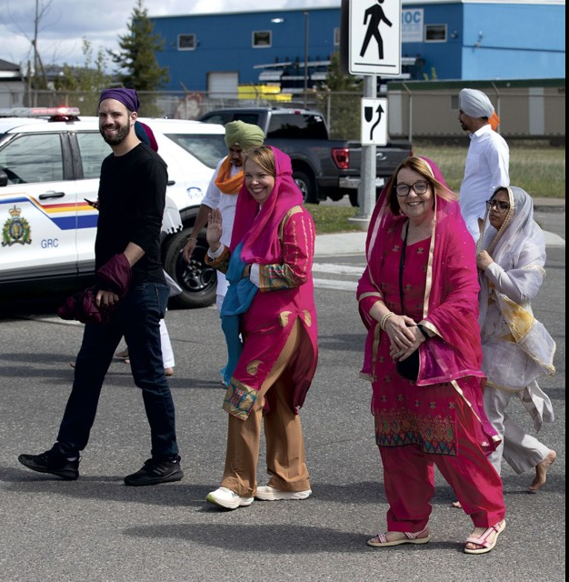
SOURCE I: PM Trudeau offering a formal apology to the Sikh community in the House of Commons in May of 2016.
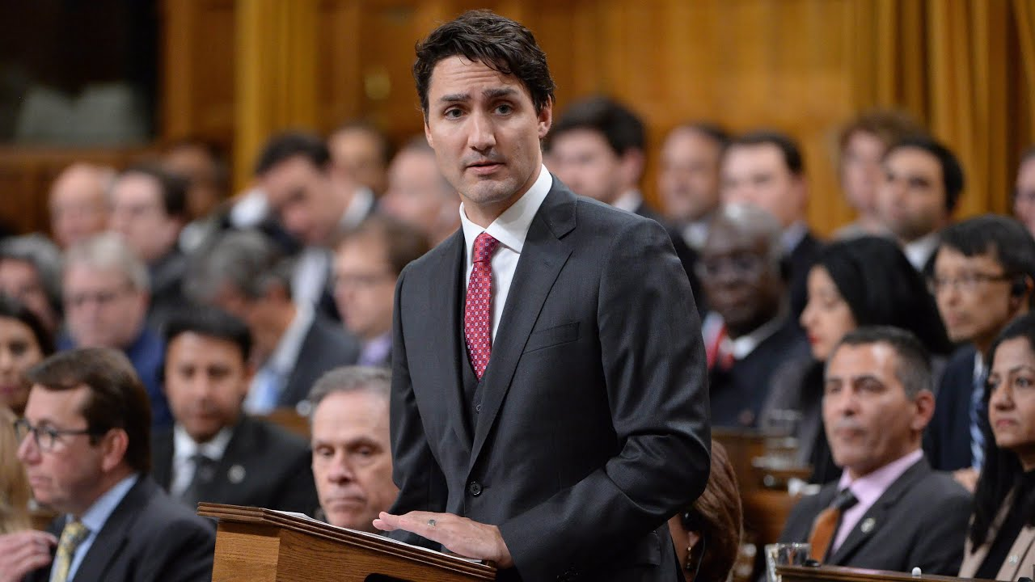
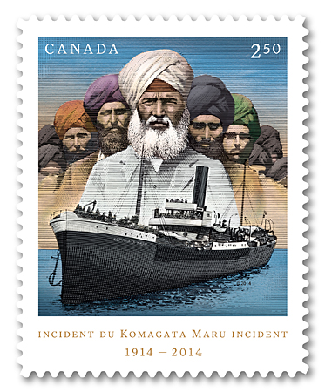Canada Post stamp – released May 6, 2014.

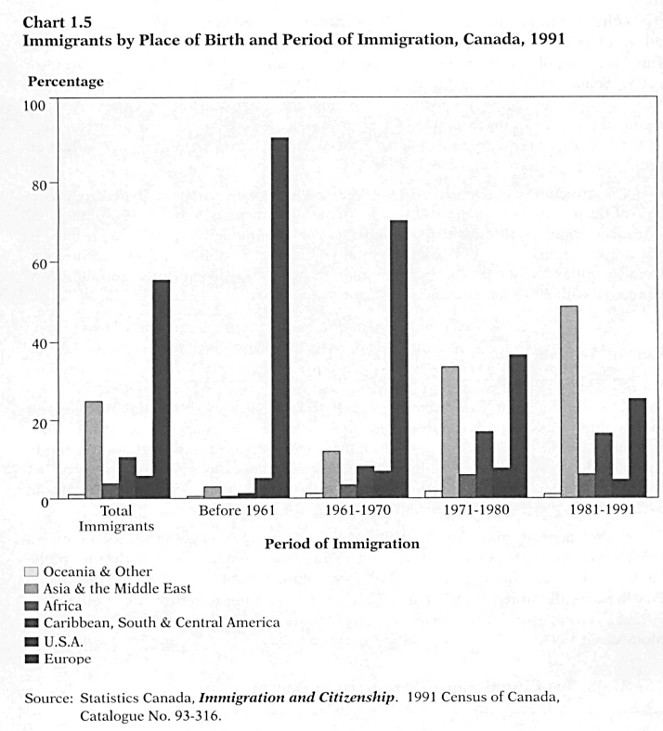

.

SKILLED WORKERS POINT SYSTEM
Today Canada assesses immigration applications based on six selection factors.

