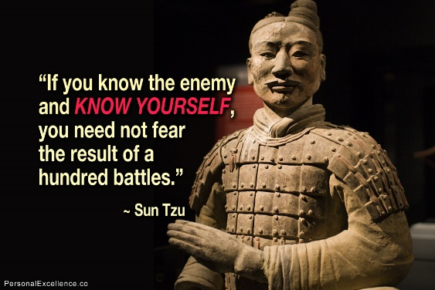 | History through Film 12  The Art of War  Name: _________________________________  Date: __________________________________

Sun Tzu’s The Art of War is widely considered to be the most important book ever written on warfare. Sun Tzu’s strategies and tactics were brilliantly executed and are still studied by generals, coaches, and CEOs today. As you watch The Art of War, answer the questions below.

Important definitions:
War of Attrition: a prolonged war or period of conflict during which each side seeks to gradually wear out the other by a series of small-scale actions.

Casualty: a person killed or injured in a war or accident.

Tet: the Vietnamese New Year observed during the first several days of the lunar calendar beginning at the second new moon after the winter solstice.

Chess vs. Go
What is the goal in the game of Chess? | What is the goal of the Chinese game of Go?
Sun Tzu’s Principles
Sun Tzu says…

- Understand The Art of War lessons and you will prevail, ignore them and you fight in _____________.

- If the orders are unclear it is the fault of the ____________ that the troops do not obey. However if the orders are clear it is the fault of the subordinate ______________.

- Know your enemy and know ________ and in 100 battles you will never be in peril

- To win 100 battles is not the height of ________, to subdue the enemy without fighting is.

- Avoid what is ___________, attack what is ________.

- In war ___________ alone confer no advantage, do not advance on sheer military power.

- Let your plans be as dark as ________ and then strike like a _______________.

- In battle, use a __________ attack to engage and ____________ attack to win.

- Put the army in the face of death where there is no escape and they will not _________ or be afraid. There is nothing they _____________ achieve

- ALL WARFARE IS ___________________.

- It is essential to seek out enemy agents who have come to spy against you and _________ them to _________ you.

- The way a wise general can achieve greatness beyond ordinary men is through ________________.

- It is essential for victory that _____________ are unconstrained by there _____________.

- Make your enemy prepare on his left and he will be __________ on his __________.

- The winning army understands the ____________ for victory first, then fights. The losing army fights first, then __________ _______________.

- Those skilled in war bring the enemy to the _________ ___ _________, they are not brought by him.

- Move only when you see an ________________ and only when you have something to gain. Only fight if a position is _____________.

- When the enemy occupies high ground do not __ __________ ________. If he attacks downhill do not ____________ ___________.

- One of the things you never want to do in war is never throw good money after bad. Use an attack to _____________ a victory. Never use an attack to ______________ a _____________.

- When troops flee, are insubordinate, collapse or are defeated in battle, it is the fault of the ________.

- War is a matter of vital importance to the _________. It is a matter of ________ and ____________ survival or ruin.

- What is Sun Tzu's greatest lesson/ultimate secret?

- The angry can be made _________ happy again but the Dead cannot be brought __________ ____ ________.

American Wars and Sun Tzu
Describe how Sun Tzu’s principles apply to the US war in Vietnam:

Describe how Sun Tzu’s principles apply to World War II:

Describe how Sun Tzu’s principles apply to the Civil War:

Reflection
Write a 4-5 sentence reflection on The Art of War.
(Thoughts to consider: What were your biggest takeaways? How relevant is Sun Tzu today?)

