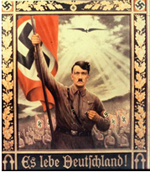 | History 12  Nazi Use of Propaganda  Answer Sheet  Name:

Print Propaganda (Use as much room as necessary to fully address each example you are providing.)
Example 1:

Poster Propaganda (Use as much room as necessary to fully address each example you are providing.)

Example 1:

